UNITED STATES
SECURITIES AND EXCHANGE COMMISSION
Washington, D.C. 20549

______________________

Form 6-K

REPORT OF FOREIGN PRIVATE ISSUER PURSUANT TO RULE 13a-16 OR 15d-16
UNDER THE SECURITIES EXCHANGE ACT OF 1934

For the month of July, 2026
Commission File Number: 001-43297

AIR Global PLC

(Translation of registrant’s name into English)

Festival Office Tower
Dubai Festival City, 7th Floor
Dubai
United Arab Emirates

(Address of principal executive office)

Indicate by check mark whether the registrant files or will file annual reports under cover of Form 20-F or Form 40-F.

Form 20-F  Form 40-F □

EXPLANATORY NOTE

On July 29, 2026, AIR Global PLC (NASDAQ: AIIR) (the “Company”) announced a strategic equity investment in Greentank Innovations Corp. (“Greentank”), a global leader of advanced vaporization hardware and technology. The investment deepens the strategic partnership the two companies formed in 2023 and reflects AIR’s continued strategy of investing in product innovation, with a particular focus on its Crown Switch electronic vapes.
Under the terms of the agreement, AIR has invested USD $20 million in Greentank through the purchase of preferred shares, based on a pre-money valuation of approximately USD $170 million. AIR has also secured a warrant giving it the option to increase its ownership stake in Greentank by another 20% over the next 24 months, at a valuation of USD $250 million, reflecting AIR’s confidence in Greentank’s growth trajectory. As part of the transaction, AIR will gain the right to nominate a director to Greentank’s board, along with enhanced commercial terms, access to new technologies and long term supply assurances.
On July 29, 2026, the Company issued a press release in relation to the Company’s strategic investment in Greentank, a copy of which is furnished as Exhibit 99.1 hereto.

SIGNATURE

Pursuant to the requirements of the Securities Exchange Act of 1934, the registrant has duly caused this report to be signed on its behalf by the undersigned, thereunto duly authorized.

Date: July 29, 2026
AIR Global PLC

By: /s/ Stuart Brazier
Name: Stuart Brazier
Title: Chief Executive Officer

EXHIBIT INDEX
Exhibit Description
99.1 | AIR Global PLC press release, dated July 29, 2026

Exhibit 99.1
AIR Announces Strategic Investment in Greentank Innovations to Accelerate Growth
Investment expands AIR's strategic partnership with Greentank, reinforcing its position as a leader in established and emerging social inhalation technologies
New pilot study shows Greentank-powered Crown Switch has low or non-detectable levels of certain harmful or potentially harmful constituents
DUBAI, United Arab Emirates — July 29, 2026 — AIR Global PLC (“AIR” or the “Company”) (NASDAQ: AIIR), a global leader in advanced flavored inhalation technologies and pioneer of next-generation nicotine delivery systems, today announced a strategic equity investment in Greentank Innovations Corp. (“Greentank”), a global leader of advanced vaporization hardware and technology. The investment deepens the strategic partnership the two companies formed in 2023 and reflects AIR’s continued strategy of investing in product innovation, with a particular focus on its Crown Switch electronic vapes. The investment both strategically positions AIR for the next chapter of the tobacco and nicotine industry and unlocks its potential ability to accelerate its growth strategy.
Under the terms of the agreement, AIR has invested USD $20 million in Greentank through the purchase of preferred shares, based on a pre-money valuation of approximately USD $170 million. AIR has also secured a warrant giving it the option to increase its ownership stake in Greentank by another 20% over the next 24 months, at a valuation of USD $250 million, reflecting AIR’s confidence in Greentank’s growth trajectory. As part of the transaction, AIR will gain the right to nominate a director to Greentank’s board, along with enhanced commercial terms, access to new technologies and long term supply assurances.
“This investment underscores our commitment to category leadership and product innovation as part of our broader growth strategy,” said Stuart Brazier, CEO of AIR. “As the largest player in flavored shisha molasses worldwide, our devices, led by Crown Switch, are powered by Greentank’s innovative Quantum Chip atomization platform to deliver a cleaner, more enjoyable inhalation experience. The independent results we share today reflect the real opportunity in front of us in expanding our foothold in the expanding vape and nicotine markets.”
Mr. Brazier continued: “The tobacco industry is evolving to cater to consumer preferences for both established formats such as vapes and pouches and new form factors yet to emerge. With our portfolio of reduced-risk innovations, AIR is an industry leader in cleaner platforms, positioning us at the forefront of industry trends. We are focused on achieving Pre-Market Tobacco Authorisation in the U.S. and addressing consumer needs that enable us to solve real pain points, advance our proprietary technologies and develop strategic partnerships to help us unlock growth while we continue delighting consumers.”
Pilot Study Overview
As part of the announcement, AIR has also shared results of a new pilot study evaluating aerosol emissions from AIR’s Crown Switch electronic vaping product, which is powered by Greentank’s Quantum Vape platform and currently available in Germany. Conducted by McKinney Specialty Labs, LLC, an independent, specialty analytical laboratory in Richmond, Virginia, the study measured the tiny droplets, called aerosol, that people breathe in when using Crown Switch, and looked for several harmful chemicals that can form during heating. Based on the results of the study, McKinney Specialty Labs then evaluated whether Crown Switch makes fewer harmful chemicals than other electronic vaping products that have been authorized by the U.S. Food and Drug Administration (FDA) and regular cigarettes based on published data from a

scientific study by Smith and colleagues on harmful and potentially harmful constituents (HPHCs) in North American vape products1. The results showed that Crown Switch produced lower amounts of these harmful chemicals than the FDA-authorized vape products in the published study, and almost none compared with cigarette smoke (see Figures 1 and 2).
Figure 1: Reductions in Crown Switch 9000505 VT 5% aerosol HPHCs compared to an FDA authorized Tobacco flavored ENDS

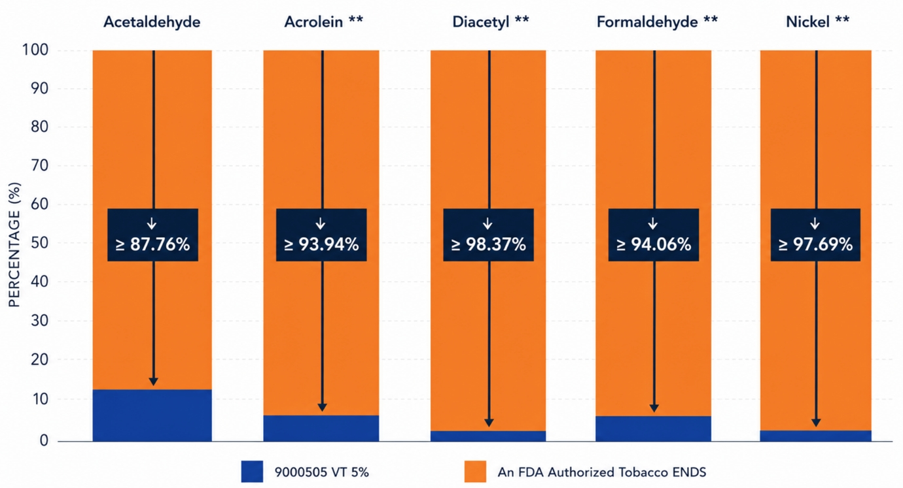
**Constituent was below Limit of Detection (LOD) or Limit of Quantification (LOQ) in the Crown Switch product – for comparison the analytical LOD/LOQ was used as the value

1 Cameron Smith, Brian Jamison, Candice Jongsma, Karen Carter, Jiaming Wang, Austin Bates, Sifat Ullah, David Cook, and I. Gene Gillman (2024). Harmful and Potentially Harmful Constituents Analysis
of North American ENDS. Volume 33 No. 4 September 2024 DOI: 10.2478/cttr-2024-0008

Figure 2: Reductions in Crown Switch 9000511 Arctic Mint 5% aerosol HPHCs compared to an FDA authorized Menthol flavored ENDS.

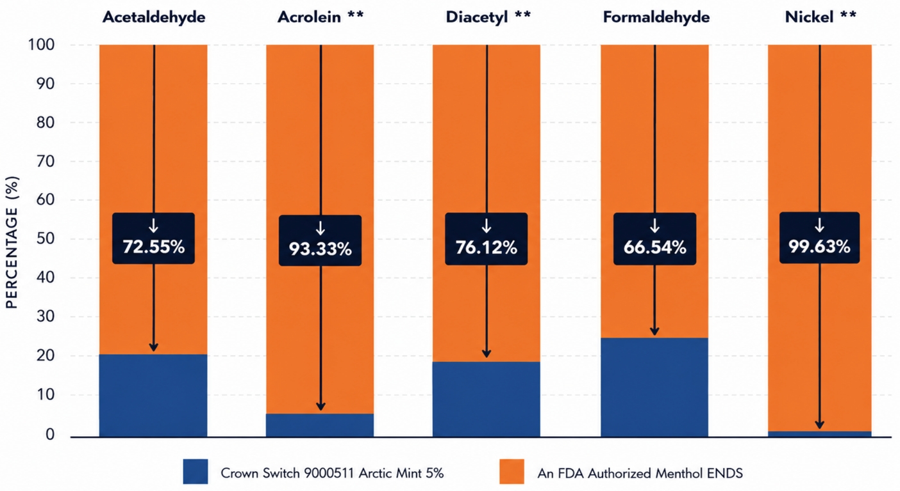

**Constituent was below Limit of Detection (LOD) or Limit of Quantification (LOQ) in the Crown Switch product – for comparison the analytical LOD/LOQ was used as the value
If future studies continue to show the same results, Crown Switch could help reduce people's exposure to harmful chemicals by using a different way to create aerosol. However, this does not mean the product is safe. It means it may have the potential to reduce exposure to some harmful chemicals compared with certain currently available products and cigarettes.
Based on the comparison with published data, Crown Switch Arctic Mint pods produced aerosols with carbon monoxide below detection limits, approximately 94% less formaldehyde and 97% less nickel metal than other popular mint-flavored e-cigarette products in the Smith study.
“This independent testing reflects what both AIR and Greentank envisioned when we set out to build our products together, providing a cleaner aerosol profile without compromising on flavor or performance,” said Corey Koffler, CEO and Co-Founder of Greentank. “This pilot study is an early validation of the vaporization platform our two teams have designed, which offers the potential to reduce consumer exposure to HPHCs. We’re proud to build on that key principle and foundation as we strengthen our partnership with AIR.”
AIR will present the pilot study results at the 79th Tobacco Science Research Conference (TSRC), taking place September 20-23, 2026, in Charlotte, North Carolina. The pilot study was commissioned by AIR as part of a dossier it is preparing to submit a Pre-Market Tobacco Application (“PMTA”) in the US. AIR has commissioned further testing as it continues to compile its dossier to be included in its PMTA application, and while the pilot results are promising, the results of such further testing may differ from the pilot study results presented here, potentially even in a material manner.

Key Pilot Study Findings:
The following results are based on McKinney Specialty Labs’ pilot analytical reports and are preliminary in nature. The complete study is available here: https://www.air.global/blog/crown-switch. It measured concentrations of selected analytes in aerosol generated from Crown Switch across two e-liquid flavors, Velvet Tobacco and Arctic Mint, each containing 5% nicotine, in addition to two device power settings, 4.5W and 5.5W, using an intense vaping regime (50-puff replicates, triplicate collections per sample, and other standardized testing parameters). The results reflect testing conducted under a specific intense vaping regime. Results may vary under different testing conditions or with different sample lots. “Not detected” indicates levels below the method’s limit of detection. These pilot results constitute the first of a number of further planned testing and verification studies, and the accumulated final data may differ materially from the results of the pilot study presented here, potentially even in a material manner.
● Carbon monoxide: not detected in Crown Switch aerosol across either flavor or power setting tested
● Tobacco-specific nitrosamines (NNK, NNN): NNN quantifiable at low levels in Arctic Mint variant whilst levels of both NNK and NNN were not detected or below the limit of quantification across all other samples
● Heavy metals: arsenic, cadmium, chromium, lead, nickel, silver and tin were predominantly not detected or below the limit of quantification
● Benzo[a]pyrene: not detected in any sample
● Volatile organic compounds: 1,3-butadiene and benzene were not detected
● Carbonyls: acetaldehyde and formaldehyde were quantifiable at low levels while acrolein and diacetyl were not detected or below the limit of quantification
The Crown Switch device evaluated in the pilot study is powered by Quantum Chip, an advanced atomization technology developed by Greentank in combination with AIR’s flavor expertise. Crown Switch is AIR’s first rechargeable, pod-based vape system.
About AIR
Founded in 1999 and headquartered in Dubai, AIR is a global consumer brands and innovation company with a presence in more than 90 markets worldwide. Its portfolio reaches millions of adult consumers across social inhalation and modern nicotine categories through brands including Al Fakher (flavored shisha molasses), Crown Switch (closed system pod vaping platform), Crown Gems, and Al Fakher nicotine pouches.
AIR's strategy combines category-leading brands, scientific research, and in-house innovation capabilities. Strategic investments such as Greentank and royalty-generating intellectual property partnerships such as Crown Bar enhance its participation in fast-growing nicotine and inhalation categories. The company develops next-generation technologies and products, including OOKA.
By connecting brands, technology, science, and commercial partnerships, AIR is building a differentiated platform positioned to shape the future of adult consumer experiences.

About Greentank Technologies
Greentank is a cutting-edge technology company pioneering atomization and advanced material science across multiple industries. At the forefront of innovation, Greentank’s Quantum Chip technology is engineered to deliver a superior user experience while advancing reduced-risk solutions in the inhalable industry. This groundbreaking heating technology generates optimal particle size distribution and aerosol mass, ensuring exceptional taste and consistency over an extended lifespan. Supported by a robust patent portfolio dating back to 2014, Greentank continues to invest heavily in its fully owned and operated, semi-automated chip manufacturing and R&D facility, driving the future of vaporization products and technology.
Forward-Looking Statements
This press release contains “forward-looking statements” within the meaning of the U.S. Private Securities Litigation Reform Act of 1995 and other U.S. federal securities laws. These forward-looking statements can generally be identified by the use of forward-looking terminology, including the terms “anticipate,” “believe,” “contemplate,” “estimate,” “expect,” “intend,” “may,” “plan,” “predict,” “potential,” “seek,” “should,” “target,” “will,” or, in each case, their negative or other variations or comparable terminology.
Such forward-looking statements are based on available current market material and management’s expectations, beliefs and forecasts concerning future events impacting the Company. These statements are subject to risks and uncertainties that could cause actual results to differ materially from those expressed or implied by the forward-looking statements, including, among others: the Company’s ability to realize the anticipated benefits of the Greentank investment and partnership; the potential exercise of warrants to increase ownership in Greentank; the Company’s U.S. market expansion strategy; the timing and outcome of regulatory submissions, including PMTA applications to the FDA; regulatory changes and enforcement trends in the tobacco and nicotine industries; the Company’s ability to execute its product development and commercialization strategy; the results of scientific studies and their acceptance by regulatory authorities; the preliminary nature of the McKinney pilot study data, which is subject to further testing and verification and may change materially as additional data becomes available; the potential presentation of study results at the Tobacco Science Research Conference; supply chain constraints and costs; changes in consumer preferences; competition in the hookah, vaping and nicotine product markets; macroeconomic, geopolitical, and industry conditions; tax, legal, and accounting developments; and other risks described in the Company’s filings with the SEC, including the Company’s Form 20-F for the year ended December 31, 2025 and subsequent furnished or filed reports.
Nothing in this press release should be regarded as a representation by the Company that the forward-looking statements will be achieved. Forward-looking statements speak only as of the date they are made, and the Company undertakes no obligation to update or revise any forward-looking statements, whether as a result of new information, future events, or otherwise, except as required by law.
No Offer or Solicitation
This press release is for informational purposes only and does not constitute (and shall not be construed as) an offer to sell or the solicitation of an offer to buy any securities of the Company, nor shall there be any sale of securities in any state or jurisdiction in which such offer, solicitation, or sale would be unlawful prior to registration or qualification under the securities laws of any such state or jurisdiction.

Contacts

AIR Investor Relations:
Gaurav Jain: Gaurav.jain@air.global; +971-56-439-4296
Anuja Shendye: Anuja.shendye@air.global; +971-58-907-8782
investor@air.global

AIR Media Relations:
ICR for AIR
For more information, email inquiries to AIRglobal@icrinc.com

Greentank
For more information, email inquiries@greentanktech.com

