Filed by AIR Holdings Ltd.
pursuant to Rule 425 under the Securities Act of 1933
and deemed filed pursuant to Rule 14a-12
under the Securities Exchange Act of 1934
Subject Companies: AIR Limited
Cantor Equity Partners III, Inc., Commission File No. 001-42716
Date: January 21, 2026
As previously disclosed, on November 7, 2025, Cantor Equity Partners III, Inc. (“CAEP”), a Cayman Islands exempted company, and AIR Limited, a private limited company incorporated under the laws of Jersey (“AIR”), entered into a Business Combination Agreement (the “Business Combination Agreement”), with AIR Holdings Limited, a private limited company incorporated under the laws of Jersey (“Pubco”), Genesis Cayman Merger Sub Limited, a Cayman Islands exempted company (“Cayman Merger Sub”), and Genesis Jersey Merger Sub Limited, a private limited company incorporated under the laws of Jersey (“Jersey Merger Sub”).
On January 20, 2026, an interview of Stuart Brazier, Chief Executive Officer of AIR, by John Jannarone, Editor-in-Chief of Exec Edge, at the ICR Conference 2026, was published via the Exec Edge website. A transcript of this interview along with the associated webpage is included below.
Stuart Brazier, CEO of AIR (00:00):
For people who are enjoying Hookah, this gives them a reason to try something new, try a different flavor and come into our franchise.
John Jannarone, Editor-in-Chief, Exec Edge (00:21):
It’s John Jannarone. I’m with Exec Edge. We’ll be back here in Orlando, Florida. I have a very special guest with me today. I’ve got Stuart Brazier as the CEO of Air Global. Stuart, thanks for joining.
Stuart Brazier, CEO of AIR (00:30):
Thank you very much for having me. Great to be here.
John Jannarone, Editor-in-Chief, Exec Edge (00:32):
Stuart, this is a fascinating category, mainly hookahs. Now, this is a market which I think probably has deep roots in the Middle East, but it’s all over the place. I was just telling Stuart here in the green room, I went to this fun place in Manhattan, Casa La Fem, and he said that’s the kind of experience that they’re hoping to see more of in more parts of the western world. Isn’t that right, Stuart?

Stuart Brazier, CEO of AIR (00:50):
That’s right. Yeah. I mean, I’m based out of Dubai actually, and don’t know if anyone has had the opportunity to go there, but the hookah lounges in Dubai are the best in the world. I mean, it’s a fantastic experience.
John Jannarone, Editor-in-Chief, Exec Edge (01:03):
Great. And now, are the products that you’re providing, are they for hookah lounges or is it some to be used at home too?
Stuart Brazier, CEO of AIR (01:11):
Yeah, so two channels, very much like alcohol, actually. You have on trade and off trade.
John Jannarone, Editor-in-Chief, Exec Edge (01:16):
Yeah.
Stuart Brazier, CEO of AIR (01:17):
So on trade is in specific hookah lounges where they set themselves up for that. They’ll serve food, they’ll serve drinks. You have high tier, you have sort of mid-market as well, but also a lot of people buy it to consume at home. Have you ever tried putting a hookah together?
John Jannarone, Editor-in-Chief, Exec Edge (01:37):
No, it looks complicated.
Stuart Brazier, CEO of AIR (01:38):
It’s very complicated. You need a degree to do it. And it can take 20, 25 minutes and it’s a messy process and you’re dealing with charcoal and you can get it wrong as well. So that’s why a lot of people are quite happy just to go to a lounge and have their hookah experience there and get somebody else to prepare it for them because it’s an occasional thing to do. It’s not every day that you’re going to have a hookah. I mean, somebody who is very much into the category will likely have two a week. That’s the normal consumption rate.
John Jannarone, Editor-in-Chief, Exec Edge (02:12):
I got you. Well, that leads me to my next question. I was going to ask you, people are much more familiar with vapes. So people are taking nicotine through vapes and most folks are doing that every day, I think. So different frequency of usage. Also, maybe not as much nicotine. I’m not sure.
Stuart Brazier, CEO of AIR (02:29):
Yeah, I think that’s fair. That’s a fair thing to say. The product itself or the product that we make at air is actually the hookah molasses. And this is up to 20% tobacco.
John Jannarone, Editor-in-Chief, Exec Edge (02:42):

Got it.
Stuart Brazier, CEO of AIR (02:43):
About 70% glycerin. And then you have flavors and sweetness in there. And it’s a very specific tobacco as well. It’s a tobacco that is high in sugar and low in nicotine. So you’re right. And you can see through the consumption patterns that it has a relatively lower addictiveness than say vaping or cigarettes or other nicotine categories.
John Jannarone, Editor-in-Chief, Exec Edge (03:06):
Great. Now let’s talk about some exciting news. The company’s going public via merger with Cantor Equity Partners III. Now, folks at home or wherever you are, you can look up the ticker CAEP and that ticker will change to AIR later on after the deal closes. But if you were to buy that now and hang onto it, once it closes, you will own AIR Global, correct, Stuart?
Stuart Brazier, CEO of AIR (03:26):
That’s right.
John Jannarone, Editor-in-Chief, Exec Edge (03:26):
And a couple stats that I want to just mention here, if I can, really big numbers, a billion hookah servings a year, 150 million or so in adjusted EBITDA. So this is a very real business. Why are you going public? Is it because you want to reach a broader investor base or do you want to have an acquisition currency? What’s the motivation for it?
Stuart Brazier, CEO of AIR (03:46):
Yeah, it was always our ambition to go public and we’re a business that’s been preparing ourselves for that over the last few years. And we’re looking around at what is the right route to do that? And we met the guys from Cantor and they have a very strong SPAC franchise and the stars aligned and we thought now’s the time to do it. And of course, having a partner like Cantor gives us good visibility. It provides us ... The listing will provide us with a solid capital foundation, some more permanence. We’ll get our faces around, people will get to know us better. And of course, for future funding, it provides a really, really great platform for us.
John Jannarone, Editor-in-Chief, Exec Edge (04:31):
Now, Stuart, I want to ask you what your strategy is for tackling or getting into more Western markets. And I just noticed that about a month ago you acquired Nameless. It’s not nameless. It’s actually called Nameless. It’s a German hookah brand. So that’s one way is to acquire brands, but can you also enter new markets in a more organic fashion?
Stuart Brazier, CEO of AIR (04:48):
Yes, we certainly can. I mean, there is still white space out there. We’re at the moment focused on getting a more permanent position in India. India is obviously a huge market. Funnily enough, Hookah began in India about 600 years ago and then moved over to the Middle East. And it’s still very, very popular there. So we’re looking at expanding our business in India at the moment, but

in the Western markets. And again, every market is different. Hookah is enjoyed by many, many different types of demographic and everyone sort of has their own interpretation of it. And what we’ve done in the recent past actually is some very interesting collaborations. So we did a collaboration in the US, but started about six months ago with Cookies, which is quite a big brand over on the West Coast. And more recently, you might’ve seen in the press that we’ve entered a collab with Snoop.
John Jannarone, Editor-in-Chief, Exec Edge (05:46):
Alright
Stuart Brazier, CEO of AIR (05:47):
So there’s a number of Snoop flavors that you can get, and it’s Snoop by Al Fakher. And of course, for people who are enjoying Hookah, this gives them a reason to try something new, try a different flavor, and come into our franchise.
John Jannarone, Editor-in-Chief, Exec Edge (06:04):
Well talk about a brand ambassador. I think Snoop does the Olympics.
Stuart Brazier, CEO of AIR (06:07):
Exactly. Olympics and hookah. Perfect.
John Jannarone, Editor-in-Chief, Exec Edge (06:08):
On a slightly more serious topic, a regulatory scrutiny, obviously an industry like this, you’ve got to be careful. What do you tell investors who say, “I love the business model, the runway for growth, but it can be a little bit tricky.” So just tell us what your strategy is there to navigate that.
Stuart Brazier, CEO of AIR (06:26):
It can. And the nicotine category is heavily regulated, obviously all over the world. So you need to have the right people in management with the right experience who’ve had many decades of dealing with and engaging with regulators. And we find that if you do engage regulators early enough and you explain to them about your business and you can align over time in what the right thing is to do and how to efficiently regulate it. The category itself is actually seen quite differently from many other nicotine categories. I mean, we mentioned earlier about the usage patterns, which are much less, the relative lower addictiveness of the product. And also it’s a product that it doesn’t combust. It’s heated. And because it’s heated, it has much lower concentrations of potentially harmful toxicants in it. So simple science, the lower you heat something, the lower the reaction that you get.
(07:36):
And also finally, regulators really do look at youth usage.

(07:41):
And year on year, actually here in the US, the CDC runs a survey to see what high school kids are using. And year on year, hookah comes out right at the bottom of that table. And it’s pretty logical because as I said at the beginning, it’s a really tough thing to put together. So there’s easier ways to enjoy your nicotine. So these have helped us over the years, and we’ve had a number of successes around the world. I mean, one very notable one in the US is that in California where there’s a statewide ban on flavored tobacco products, hookah is exempted from that.
John Jannarone, Editor-in-Chief, Exec Edge (08:17):
How about that? Well, that’s a really thorough explanation. I like that, Stuart. Well, let’s wind it down here with one more question, if I can. What are you most excited about in 2026? Of course, going public, you just announced a deal with this German brand. Anything else that you’re really excited about?
Stuart Brazier, CEO of AIR (08:34):
Well, we’re heavily focused on growth. That’s growing share in the markets we’re already well established, growing share through these collaborations that I’ve talked about, growing share with different innovations as well. I mean, we’ve talked a lot about our core business, which is the hookah business, but also we are able to take our brand into other nicotine adjacencies as well.
John Jannarone, Editor-in-Chief, Exec Edge (09:00):
Ah, okay.
Stuart Brazier, CEO of AIR (09:00):
So very, very recently we launched a product in Germany called Crown Switch, which is a vape system with cartridges. So you buy the cartridges and plug it in there. And it’s really about the brands, the flavors, and the tech that we’re using. So we’re using a very advanced chip for vaping, and this actually means that you get the cleanest vaping experience possible. All
John Jannarone, Editor-in-Chief, Exec Edge (09:29):
Right. Well, I’m glad you worked that in. Of course, technology, big part of this. It is a 600-year-old technology, but still room to change.
Stuart Brazier, CEO of AIR (09:36):
And yeah, we’re modernizing it.
John Jannarone, Editor-in-Chief, Exec Edge (09:38):
All right. Well, Stuart, I’ve really enjoyed this. Thank you so much for joining the program. This has been Stuart Brazier, CEO of AIR Global. I’m John Jannarone, Editor-Chief of Exec Edge, signing off from Orlando, Florida.

AIR Global CEO Stuart Brazier on Hookah Lifestyle: ICR Conference 2026

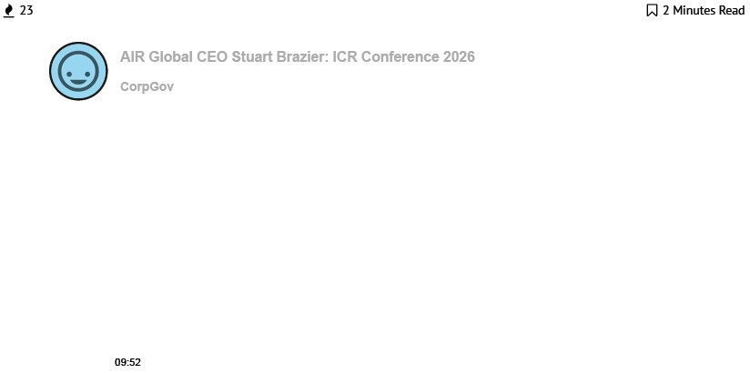

Exec Edge (https://executives-edge.com/) and PE Edge (https://executives-edge.com/pe-edge/) hosted a fireside chat at the ICR Conference 2026 with Stuart Brazier, Chief Executive Officer at AIR Global. The in-person interview was joined by Editor-in-Chief John Jannarone (http://twitter.com/jannarone), and they discussed what differentiates AIR from other hookah producers and lifestyle inhalation brands, the company’s investment in technology and digital innovation, AIR’s process of going public via SPAC with Cantor Equity Partners III, Inc. (Nasdaq: CAEP), among other topics.

Privacy - Terms

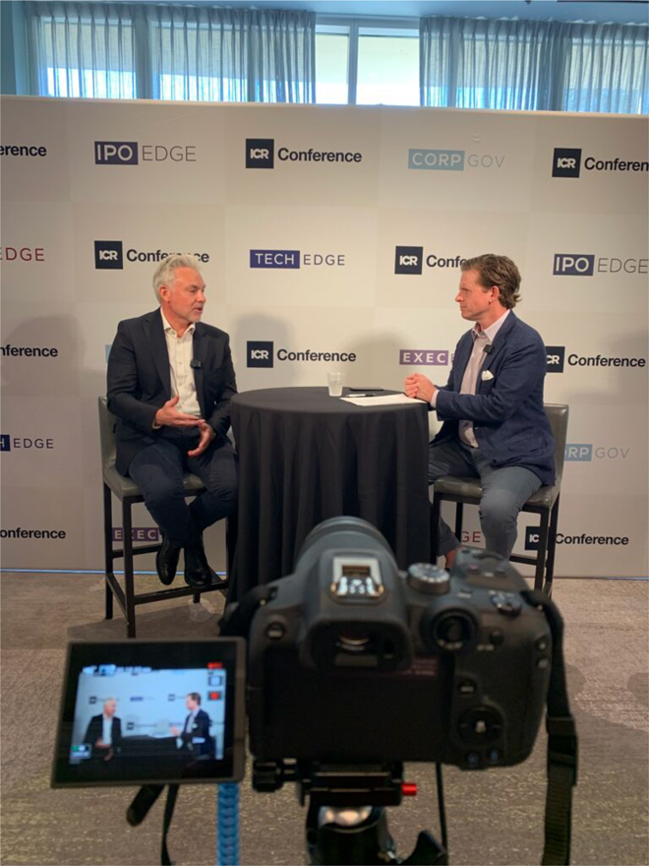

About Stuart Brazier
Stuart joined AIR in January 2019, bringing over 22 years of international business experience from British American Tobacco (BAT), where he held senior roles including Regional Head of Finance for Europe and North Africa, Area Director for North Africa and Regional Manager for Asia Pacific. He holds a degree in Economics and Accountancy and has completed executive studies at Harvard Business School and IMD. Stuart is also a Chartered Management Accountant.
About AIR Global
Launched in 1999 and headquartered in Dubai, AIR is a global innovation leader in social inhalation, with a multinational presence in over 90 markets worldwide. Its portfolio of companies and assets includes Al Fakher, the world’s leading hookah brand; Hookah.com, North America’s number one B2B e-commerce platform for hookah by market share; and OOKA, a highly innovative charcoal-free hookah device, among others. AIR’s science program, conducted in partnership with independent accredited laboratories, enables the development of innovative products that combine centuries of tradition with cutting-edge technology to minimize harm and maximize enjoyment for millions around the world.
AIR is currently in the midst of a business combination with SPAC Cantor Equity Partners III (Nasdaq: CAEP), which is expected to close in 1H 2026 at a pro forma enterprise value of $1.749 billion.
READ MORE
Exec Edge NYSE Firesides Scheduled Feb 3, 2026 (https://executives-edge.com/exec-edge-nyse-firesides-scheduled-feb-3-2026/)
Register for our weekly newsletter HERE (https://ipo-edge.us19.list-manage.com/track/click?
u=b868045b7a461b2f6275209f8&id=2d25f61b7b&e=b159dee64c)
Contact:
Exec Edge (https://executives-edge.com/)
Editor@executives-edge.com (mailto:Editor@executives-edge.com)
Click HERE (https://ipo-edge.us19.list-manage.com/track/click?
u=b868045b7a461b2f6275209f8&id=cc44590643&e=b159dee64c) to follow us on LinkedIn

Additional Information and Where to Find It
Pubco and CAEP intend to prepare, and Pubco intends to file with the Securities and Exchange Commission (the “SEC”), a Registration Statement on Form F-4 (as may be amended, the “Registration Statement”), which will include a preliminary proxy statement of CAEP and a prospectus (the “Proxy Statement/Prospectus”) in connection with the business combination pursuant to the Business Combination Agreement (the “Business Combination”) and any related transactions (together with the Business Combination, the “Transactions”). The definitive proxy statement and other relevant documents will be mailed to shareholders of CAEP as of a record date to be established for the CAEP shareholder meeting for voting on the Transactions and other matters as described in the Proxy Statement/Prospectus. CAEP and/or Pubco will also file other documents regarding the Transactions with the SEC. This communication does not contain all of the information that should be considered concerning the Transactions and is not intended to form the basis of any investment decision or any other decision in respect of the Transactions. BEFORE MAKING ANY VOTING OR INVESTMENT DECISION, SHAREHOLDERS OF CAEP AND OTHER INTERESTED PARTIES ARE URGED TO READ, WHEN AVAILABLE, THE PRELIMINARY PROXY STATEMENT/PROSPECTUS, AND AMENDMENTS THERETO, AND THE DEFINITIVE PROXY STATEMENT/PROSPECTUS AND ALL OTHER RELEVANT DOCUMENTS FILED OR THAT WILL BE FILED WITH THE SEC IN CONNECTION WITH CAEP’S SOLICITATION OF PROXIES FOR THE EXTRAORDINARY GENERAL MEETING OF ITS SHAREHOLDERS TO BE HELD TO APPROVE THE TRANSACTIONS AND OTHER MATTERS AS DESCRIBED IN THE PROXY STATEMENT/PROSPECTUS BECAUSE THESE DOCUMENTS WILL CONTAIN IMPORTANT INFORMATION ABOUT CAEP, PUBCO, AIR AND THE TRANSACTIONS. Investors and security holders will also be able to obtain copies of the Registration Statement and the Proxy Statement/Prospectus and all other documents filed or that will be filed with the SEC by CAEP and Pubco, without charge, once available, on the SEC’s website at www.sec.gov or by directing a request to: Cantor Equity Partners III, Inc., 110 East 59th Street, New York, NY 10022; e-mail: CantorEquityPartners@cantor.com, or upon written request to AIR Limited, via email at investor@air.global, respectively.
NEITHER THE SEC NOR ANY STATE SECURITIES REGULATORY AGENCY HAS APPROVED OR DISAPPROVED THE TRANSACTIONS DESCRIBED HEREIN, PASSED UPON THE MERITS OR FAIRNESS OF THE TRANSACTIONS OR ANY RELATED TRANSACTIONS OR PASSED UPON THE ADEQUACY OR ACCURACY OF THE DISCLOSURE IN THIS COMMUNICATION. ANY REPRESENTATION TO THE CONTRARY CONSTITUTES A CRIMINAL OFFENSE.
Participants in the Solicitation
CAEP, Pubco, AIR and their respective directors, executive officers, and certain of their shareholders and other members of management and employees may be deemed under SEC rules to be participants in the solicitation of proxies from CAEP’s shareholders in connection with the Transactions. A list of the names of such persons, and information regarding their interests in the Transactions and their ownership of CAEP’s securities are, or will be, contained in CAEP’s filings with the SEC, including the final prospectus of CAEP dated as of June 25, 2025 and filed by CAEP with the SEC on June 26, 2025 (the “IPO Prospectus”).

Additional information regarding the interests of the persons who may, under SEC rules, be deemed participants in the solicitation of proxies of CAEP’s shareholders in connection with the Transactions, including the names and interests of CAEP’s, Pubco’s and AIR’s directors and executive officers, will be set forth in the Registration Statement and Proxy Statement/Prospectus, which is expected to be filed by Pubco, AIR and CAEP, as applicable, with the SEC. Investors and security holders may obtain free copies of these documents as described above.
No Offer or Solicitation
This communication and the information contained herein are for informational purposes only and are not a proxy statement or solicitation of a proxy, consent or authorization with respect to any securities or in respect of the Transactions and shall not constitute an offer to sell or exchange, or a solicitation of an offer to buy or exchange the securities of CAEP or Pubco, or any commodity or instrument or related derivative, nor shall there be any sale of any such securities in any state or jurisdiction in which such offer, solicitation, sale or exchange would be unlawful prior to registration or qualification under the securities laws of such state or jurisdiction. No offer of securities shall be made except by means of a prospectus meeting the requirements of the Securities Act or an exemption therefrom. Investors should consult with their counsel as to the applicable requirements for a purchaser to avail itself of any exemption under the Securities Act.
Forward-Looking Statements
This Report contains certain forward-looking statements within the meaning of the U.S. federal securities laws with respect to the Transactions involving Pubco, CAEP and AIR, including expectations, intentions, hopes, beliefs, prospects, financial results and plans regarding Pubco, AIR, CAEP and the Transactions, statements regarding the anticipated benefits and timing of the completion of the Transactions, the anticipated time of the first confidential submission of a registration statement on Form F-4 with the SEC and the timeline for SEC’s review of the F-4 registration statement, anticipated use of proceeds, entry into certain agreements subsequent to the entry into the Business Combination Agreement, the satisfaction of closing conditions to the Transactions, objectives of management for future operations of Pubco, pro forma ownership of Pubco, the upside potential and opportunity for investors, investor benefits, regulatory conditions, competitive position, technological and market trends, future financial condition and performance and expected financial impacts of the Transactions, the satisfaction of closing conditions to the Transactions and the level of redemptions of CAEP’s public shareholders, and Pubco’s and AIR’s expectations, intentions, strategies, assumptions or beliefs about future events, results of operations or performance or that do not solely relate to historical or current facts. These forward-looking statements generally are identified by the words “believe,” “project,” “expect,” “anticipate,” “estimate,” “intend,” “strategy,” “future,” “opportunity,” “potential,” “plan,” “may,” “should,” “will,” “would,” “will be,” “will continue,” “will likely result,” and similar expressions. Forward-looking statements are predictions, projections and other statements about future events or conditions that are based on current expectations and assumptions and, as a result, are subject to risks and uncertainties. Many factors could cause actual future events to differ materially from the forward-looking statements in this Report, including, but not limited to: the risk that the Transactions may not be completed in a timely manner or at all, which may

adversely affect the price of CAEP’s securities; the risk that the Transactions may not be completed by CAEP’s business combination deadline; the failure by the parties to satisfy the conditions to the consummation of the Transactions, including the approval of CAEP’s shareholders; failure to realize the anticipated benefits of the Transactions; the level of redemptions of CAEP’s public shareholders which may reduce the public float of, reduce the liquidity of the trading market of, and/or maintain the quotation, listing, or trading of the CAEP Class A ordinary shares or the Pubco ordinary shares; the lack of a third-party fairness opinion in determining whether or not to pursue the Transactions; the failure of Pubco to obtain or maintain the listing of its securities on any securities exchange after closing of the Transactions; costs related to the Transactions and as a result of becoming a public company; changes in business, market, financial, political and regulatory conditions; risks relating to Pubco’s anticipated operations and business; risks related to increased competition in the industries in which Pubco will operate; risks that after consummation of the Transactions, Pubco experiences difficulties managing its growth and expanding operations; challenges in implementing Pubco’s business plan including due to operational challenges, significant competition and regulation; being considered to be a “shell company” by any stock exchange on which Pubco’s ordinary shares will be listed or by the SEC, which may impact Pubco’s ability to list Pubco’s ordinary shares and restrict reliance on certain rules or forms in connection with the offering, sale or resale of securities; the outcome of any potential legal proceedings that may be instituted against Pubco, CAEP or others following announcement of the Transactions, and those risk factors discussed in documents that Pubco and/or CAEP filed, or that will be filed, with the SEC.
The foregoing list of risk factors is not exhaustive. You should carefully consider the foregoing factors and the other risks and uncertainties described in the “Risk Factors” section of the IPO Prospectus, CAEP’s Quarterly Reports on Form 10-Q, and the Registration Statement that will be filed by Pubco and AIR and the Proxy Statement/Prospectus contained therein, and other documents filed by CAEP and Pubco from time to time with the SEC. These filings do or will identify and address other important risks and uncertainties that could cause actual events and results to differ materially from those contained in the forward-looking statements. There may be additional risks that none of CAEP, AIR and Pubco presently know, or that CAEP, AIR and Pubco currently believe are immaterial that could also cause actual results to differ from those contained in the forward-looking statements.
Forward-looking statements speak only as of the date they are made. Readers are cautioned not to put undue reliance on forward-looking statements, and none of CAEP, AIR and Pubco assumes any obligation and do not intend to update or revise these forward-looking statements, whether as a result of new information, future events, or otherwise. None of CAEP, AIR and Pubco gives any assurance that any of CAEP, AIR or Pubco will achieve its expectations. The inclusion of any statement in this communication does not constitute an admission by CAEP, AIR or Pubco or any other person that the events or circumstances described in such statement are material.

