UNITED STATES
SECURITIES AND EXCHANGE COMMISSION
Washington, D.C. 20549

______________________

Form 6-K

REPORT OF FOREIGN PRIVATE ISSUER PURSUANT TO RULE 13a-16 OR 15d-16
UNDER THE SECURITIES EXCHANGE ACT OF 1934

For the month of August, 2026
Commission File Number: 001-43297

AIR Global PLC

(Translation of registrant’s name into English)

Festival Office Tower
Dubai Festival City, 7th Floor
Dubai
United Arab Emirates

(Address of principal executive office)

Indicate by check mark whether the registrant files or will file annual reports under cover of Form 20-F or Form 40-F.

Form 20-F  | Form 40-F □

INFORMATION CONTAINED IN THIS REPORT ON FORM 6-K
On August 20, 2026, AIR Global PLC (the “Company”) issued a press release announcing its financial results for the six months ended June 30, 2026 (the “H1 results”), a copy of which is furnished as Exhibit 99.1 hereto. On the same date, the Company published a presentation in respect of its H1 results, a Shareholder Letter, as well as its unaudited interim condensed consolidated financial statements for the six-month period ended June 30, 2026, copies of which are furnished hereto as 99.2, 99.3 and 99.4 respectively.

SIGNATURE
Pursuant to the requirements of the Securities Exchange Act of 1934, as amended, the registrant has duly caused this report to be signed on its behalf by the undersigned, thereunto duly authorized.
Date: August 20, 2026

AIR Global PLC
By: |  | /s/ Stuart Brazier
Name: |  | Stuart Brazier
Title: |  | Chief Executive Officer

EXHIBIT INDEX

Exhibit |  | Description
99.1 |  | Press release of AIR Global PLC, dated August 20, 2026
99.2 |  | Presentation of AIR Global PLC, dated August 20, 2026
99.3 |  | Shareholder Letter of AIR Global PLC, dated August 20, 2026
99.4 |  | Unaudited Interim Condensed Consolidated Financial Statements for the Six-Month Period Ended June 30, 2026

Exhibit 99.1

PRESS RELEASE |  | AIR GLOBAL PLC.

AIR Global Reports 2026 First-Half Results
Revenue increased 3.7% to $206.9 million despite Strait of Hormuz disruptions
Adjusted EBITDA remained stable yoy at $71.7 million
Expects accelerating growth in the second half of 2026
DUBAI, UAE, August 20, 2026 – AIR Global PLC (NASDAQ: AIIR), the global leader in Flavored Shisha Molasses ("FSM"), today announces its first results as a public company for the six-month period ending June 30, 2026, post its listing on the Nasdaq on 18 May 2026. Unless otherwise specified, all comparative information in this release is presented by reference to the corresponding period of the preceding year.
Stuart Brazier, Chief Executive Officer of AIR Global, said:
“Our first half 2026 performance is a testament to the resilience of AIR’s business, the strength of our global brands and the depth of our organizational culture. Despite unprecedented challenges following the closure of the Strait of Hormuz, a route through which approximately 70% of our historical shipment volumes have been transported, we delivered revenue growth of 3.7% and stable adjusted EBITDA.
End-consumer demand held steady throughout the period and shipment volumes have staged a strong recovery since the acute supply chain disruptions we experienced in March, when shipment volumes declined 38.6%. Volume growth resumed in June, and we expect this positive momentum to continue into the second half of 2026.
I would like to thank every AIR employee for their commitment, agility and determination during an exceptionally challenging period. Their efforts enabled us to adapt rapidly, establish alternative supply routes and continue serving our customers around the world with minimal interruption. This execution reinforces our confidence in our strategy to drive sustainable long-term growth and value creation.”

Webcast and Q&A Session: AIR Global PLC will hold a live webcast for investors and analysts at 8:00AM ET on August 20, 2026, hosted by Stuart Brazier, CEO and Bassem Lotfy, CFO. The presentation will be followed by a Q&A session. The webcast and presentation slides will be available to view on our website at News/ Events. Conference call dial in details: +1 877 407 0752 or +1 201 389 0912. Alternatively, participants may use the Call Me service for immediate access to the event via the following link: Call ME. The Call Me service will be available 15 minutes prior to the scheduled start time.

Results Highlights – H1’26

Metric |  | H1’26 | H1’25 | YoY %
Revenue ($m) |  | 206.9 | 199.5 | 3.7%
Gross profit ($m) |  | 116.8 | 114.0 | 2.4%
Operating (loss) / profit ($m) |  | (63.6) | 51.5 | NM
(Loss) / profit for the period ($m) |  | (81.8) | 31.9 | NM
EBITDA ($m) |  | (52.1) | 61.0 | NM
Adjusted EBITDA ($m) |  | 71.7 | 71.7 | 0.1%
Basic EPS ($) |  | (0.57) | 0.22 | NM

•
FSM shipment volumes declined 9.0% in H1'26. Global Travel Retail (GTR) volumes declined 46.5% - excluding GTR, FSM shipment volumes declined 6.6%.
•
Revenue increased 3.7% to $206.9 million, driven primarily by FSM revenue growth of 3.4% to $204.7 million. Price/mix growth was very strong at 14.0% due to accelerated pricing actions in H1'26 to offset cost inflation. Price/mix growth was especially strong in the MEAA region at 17.1%.
•
Net loss for the period was $81.8 million in the first half of 2026, heavily impacted by several one-time items, including:
o
$48.2 million of a listing expense in accordance with accounting rules, mainly related to the 4.2 million shares issued to the SPAC sponsor at the time of listing (of which 2.7 million shares are vested, and 1.5 million shares remain subject to price-based earn-out provisions);
o
$47.7 million of IPO-related cash costs;
o
$12.4 million of non-cash share-based compensation expense;
o
$7.4 million of other public company readiness costs;
o
$3.8 million of supply chain-related costs resulting from the Strait of Hormuz disruption;
o
$2.0 million in costs associated with the acceleration of Pre-Market Tobacco Application (“PMTA”) filings in the U.S. following changes to FDA enforcement guidance relating to nicotine vapes and pouches.
Net loss was also impacted by a 5.5% increase in costs of sales, primarily driven by the increase in revenue but also impacted by higher logistics and raw material costs associated with the Middle

East conflict. Furthermore, net income reflects EBITDA1 loss of $52.1 million in the first half of 2026.
•
Adjusted EBITDA2 was $71.7 million in the first half of 2026, flat year-over-year, reflecting lower shipment volumes, higher logistics and raw material costs associated with the Middle East conflict, accelerated factory footprint changes resulting from the conflict, and incremental public company costs, partially offset by minor benefits from US tariff refunds and excise duty drawback.
•
Basic EPS was a loss of ($0.57) in H1'26.
•
FX impact was minimal. AIR operates its business largely in USD or USD pegged currencies.

2026 Full-Year Outlook

For FY'26, AIR expects:
•
Stable shipment volumes versus FY'25, despite an approximately 1.5% headwind from weaker Global Travel Retail (GTR) volumes resulting from the Middle East conflict, as well as the impact of above-normal pricing implemented to offset higher cost inflation.
•
Revenue growth of 4% to 6% (in USD).
•
Low- to mid-single-digit Adjusted EBITDA growth. Adjusted EBITDA growth in FY'26 is expected to be below AIR's historical high-single-digit growth trend, primarily due to:
o
Incremental public company costs following the Nasdaq listing;
o
Acceleration of the Company's factory footprint reorganization plan to reduce long-term dependence on the Strait of Hormuz;
o
Higher logistics and raw material costs associated with the Middle East conflict, notwithstanding the establishment of alternative supply routes to mitigate future disruptions;
o
Partially offset by modest benefits from US tariff refunds and excise duty drawback.
•
Excluding these cost headwinds, Adjusted EBITDA growth in FY'26 would be expected to be in line with AIR's historical high-single-digit growth trend.
•
Broadly stable net financing costs.
•
Broadly stable Net Debt-to-Adjusted EBITDA3 at FY'26 year-end compared to FY'25, reflecting cash outflows associated with the IPO and the Greentank investment.
•
An effective tax rate of approximately 15%.
•
Capital expenditures of $15 million to $18 million.

•
On August 24, 2026, AIR will hold an EGM of shareholders to vote on five proposals related to share repurchases, the details of which are available here. No share repurchases have been incorporated in the 2026 outlook or medium-term guidance below.

Medium-Term Outlook

For FY'27 and over the medium term, AIR expects:
•
Low-single-digit organic FSM shipment volume growth, driven by continued market share gains and expansion into new markets, assuming non-disruptive excise tax increases.
•
Mid-single-digit FSM revenue growth (in USD).
•
High-single-digit FSM Adjusted EBITDA growth (in USD).
•
The timing and scale of revenue and Adjusted EBITDA contribution from New Growth Categories (NGC) will depend on FDA acceptance of the Company's PMTA applications.
•
Continued deleveraging, with a consistent reduction in Net Debt-to-Adjusted EBITDA. AIR's long-term target leverage ratio is 2.5x Net Debt-to-Adjusted EBITDA*.
* No reconciliation to the most directly comparable IFRS financial measures has been provided due to the inherent difficulty in forecasting and quantifying certain amounts that would be necessary for such reconciliation.

Business Review

Segment Reporting
(in millions, except percentages) | H1'26 | H1'25 | YoY
Revenue
FSM-Americas | 42.8 | 41.4 | 3.4%
FSM-Europe | 25.2 | 25.1 | 0.4%
FSM-MEAA | 136.7 | 131.4 | 4.0%
NGC | 2.2 | 1.6 | 37.5%
Adjusted EBITDA
FSM-Americas | 19.8 | 16.9 | 17.2%
FSM-Europe | 0.1 | 1.8 | -91.7%
FSM-MEAA | 59.7 | 62.3 | -4.0%
NGC | (7.9) | (9.3) | NM

Americas
Americas revenue grew 3.4% driven by price-mix, offset by marginally lower volume. Adjusted EBITDA grew 17.2% due to revenue growth and strong cost control.
Europe
Europe remained challenging in the first half of 2026, continuing trends seen in recent years, as steep excise tax hikes and lack of enforcement have led to proliferation of illicit products. Revenue grew 0.4% and adjusted EBITDA declined to $0.1 million, as pricing gains were insufficient to offset excise-driven volume weakness.
MEAA
MEAA revenues grew 4%, driven by high teens price-mix growth. Adjusted EBITDA declined 4.0%. MEAA includes Global travel retail as well as our corporate headquarters. In the first half of 2026, costs were higher due to incremental public market costs, and higher supply chain costs due to the Middle East conflict.
Our market shares remain steady despite the significant pricing taken year-to-date, and in the key market of Saudi Arabia, we are seeing share growth.
NGC
NGC revenue grew 37.5%, albeit off a small base, due to growth in OOKA and launch of Crown Switch in Europe. NGC losses remain elevated due to investments behind new product launches in vapes and pouches. Adjusted EBITDA was a loss of $7.9 million, reflecting continued investment in new product development and commercialization.
Impact of the Strait of Hormuz Disruption
The sudden closure of the Strait of Hormuz created significant supply chain disruptions during the first half of 2026, affecting shipment timing across several key markets. While March shipments were materially impacted, end-consumer demand remained resilient and purchase orders were preserved. AIR acted quickly to develop alternative routes, mitigate supply chain risk, and support customer continuity. As logistics conditions improved, shipment volumes recovered, returning to growth in June.
Greentank Strategic Investment
On 29 July 2026, AIR announced a $20 million strategic investment into Greentank at a pre-money valuation of $170 million, with an option to increase the ownership stake by another 20% over the next 24 months at a valuation of $250 million. This partnership secures certain commercial advantages for AIR and accelerates our path towards launching Crown Switch in the US.
AIR also shared results of a new study evaluating aerosol emissions from the planned USA variants of AIR’s Crown Switch electronic vaping product, which is powered by Greentank’s Quantum Vape platform. Conducted by McKinney Specialty Labs, LLC, an independent, specialty analytical laboratory in Richmond, Virginia, the study found that Crown Switch aerosol contained substantially lower levels of several harmful

and potentially harmful constituents (HPHCs) than a range of FDA-authorized ENDS products already on the market.

Adjusted EBITDA Reconciliation

Reconciliation of operating (loss) / profit to adjusted EBITDA
 |  | Six month period ended June 30
 |  | 2026 |  | 2025
 |  | $000 |  | $000
(Loss) / profit for the period |  |  | (81,820) |  | 31,973
Add / (subtract):
Taxation |  |  | 3,832 |  | 5,431
Finance costs |  |  | 14,416 |  | 21,616
Finance income |  |  | (547) |  | (7,811)
Depreciation – property, plant and equipment |  |  | 2,492 |  | 2,494
Depreciation - right-of-use assets |  |  | 1,904 |  | 1,659
Amortization |  |  | 7,106 |  | 5,346
Share of results in joint venture |  |  | 240 |  | 329
Changes in fair value of derivative financial instruments |  |  | 283 |  | —
EBITDA |  | (52,094) |  | 61,037
Non recurring items:
Share-based compensations (i) |  |  | 12,439 |  | 1,007
Corporate restructuring costs |  |  | 703 |  | 1,184
Significant provisions, write-offs and associated legal costs |  |  | 1,675 |  | 6,506
Public company readiness cost (ii) |  |  | 7,365 |  | 1,925
Extra-ordinary costs caused by regional disruption (iii) |  |  | 3,795 |  | —
Regulatory costs (iv) |  |  | 1,980 |  | —
Expenses related to listing event (v) |  |  | 47,735 |  | —
Expense of equity issued at listing event (net) (v) |  |  | 48,150 |  | —
Adjusted EBITDA |  |  | 71,748 |  | 71,659

Please note that further details on Adjusted EBITDA are included in the Appendix.

Share Count and Capital Structure

As disclosed in our Report on Form 20-F filed on May 21, 2026, and further elaborated in our Report on 6-K filed on June 08, 2026, AIR has approximately 160.39 million ordinary shares outstanding. These include:
•
Approximately 5 million shares are subject to return to us pursuant to a Forward Purchase Agreement executed on May 11, 2026, as described in our SEC filings; and
•
Approximately 8.69 million ordinary shares that are subject to company and sponsor earnouts (the “Earnout Shares”), which vest only upon achieving specified share-price thresholds (US$12.50 and US$15.00) prior to May 31, 2031. As of August 20, 2026, these earnout shares had not vested.

Glossary

AIR defines EBITDA as earnings for the period before interest, taxation, depreciation and amortization. The most directly comparable IFRS measure is profit/ (loss) for the period. EBITDA is an intermediate step in AIR’s calculation of Adjusted EBITDA, as set out in the reconciliation in Appendix D.
2 AIR defines Adjusted EBITDA as earnings before interest, taxes, depreciation, and amortization, further adjusted to exclude items such as non-recurring expenses, share-based compensation and other non-operating expenses. Adjusted EBITDA is not a measure specifically defined under IFRS. The most directly comparable IFRS measure is profit/(loss) for the period. A reconciliation of profit/(loss) for the period to Adjusted EBITDA is set out in Appendix D.
3 AIR defines Net Debt as total borrowings (comprising current and non-current interest-bearing loans and borrowings) less cash and cash equivalents, each as reported on AIR’s IFRS statement of financial position. AIR defines the ratio of Net Debt to Adjusted EBITDA (“leverage”) as Net Debt divided by Adjusted EBITDA. Neither Net Debt nor the Net Debt to Adjusted EBITDA ratio is presented in accordance with IFRS; the most directly comparable IFRS measures are total borrowings and cash and cash equivalents, each as reported on AIR’s statement of financial position. AIR believes this ratio is a useful measure of AIR’s capital structure and progress toward its target leverage. A reconciliation of profit/(loss) for the period to EBITDA and Adjusted EBITDA and total borrowings to Net Debt is set forth in Appendix D.

See “Use of Non-IFRS Financial Measures” for further information regarding the non-IFRS financials measures included in this press release.

Appendix

Appendix A: Consolidated Statement of Financial Position
 |  |  | As at 30 June |  |  |  | As at  31 December
 |  |  | 2026 |  |  |  | 2025
 |  |  | $000 |  |  |  | $000
ASSETS
Non-current assets
Property, plant and equipment |  |  |  | 26,692 |  |  |  | 28,410
Right-of-use assets |  |  |  | 14,354 |  |  |  | 11,663
Intangible assets |  |  |  | 367,336 |  |  |  | 371,277
Trade and other receivables |  |  |  | 148 |  |  |  | 293
Investments in joint ventures |  |  |  | 2,015 |  |  |  | 2,255
Financial assets at FVOCI |  |  |  | 8,524 |  |  |  | —
Derivative financial instruments |  |  |  | 2,646 |  |  |  | —
Deferred tax assets |  |  |  | 43,763 |  |  |  | 41,071
 |  |  |  | 465,478 |  |  |  | 454,969
Current assets
Inventories |  |  |  | 61,622 |  |  |  | 55,331
Trade and other receivables |  |  |  | 127,809 |  |  |  | 93,160
Restricted deposit |  |  |  | 18,200 |  |  |  | —
Advance tax |  |  |  | 430 |  |  |  | 274
Derivative financial instruments |  |  |  | 185 |  |  |  | —
Cash and cash equivalents |  |  |  | 85,411 |  |  |  | 119,456
 |  |  |  | 293,657 |  |  |  | 268,221
Total assets |  |  |  | 759,135 |  |  |  | 723,190
LIABILITIES
Non-current liabilities
Derivative financial instruments |  |  |  | — |  |  |  | 1,216
Other interest-bearing loans and borrowings |  |  |  | 338,525 |  |  |  | 357,679
Lease liabilities |  |  |  | 12,782 |  |  |  | 9,935
Employee benefits |  |  |  | 6,660 |  |  |  | 6,542
Deferred tax liabilities |  |  |  | 635 |  |  |  | 436
 |  |  |  | 358,602 |  |  |  | 375,808
Current liabilities
Other interest-bearing loans and borrowings |  |  |  | 67,338 |  |  |  | 29,852
Derivative financial instruments |  |  |  | 339 |  |  |  | 558
Employee benefits |  |  |  | 1,344 |  |  |  | 1,320
Lease liabilities |  |  |  | 3,445 |  |  |  | 3,348
Trade and other payables |  |  |  | 127,033 |  |  |  | 99,121
Tax payable |  |  |  | 6,446 |  |  |  | 2,053
Payables relating to acquisitions |  |  |  | 1,760 |  |  |  | 1,760
 |  |  |  | 207,705 |  |  |  | 138,012
Total liabilities |  |  |  | 566,307 |  |  |  | 513,820
Net assets |  |  |  | 192,828 |  |  |  | 209,370

EQUITY
Capital and reserves
Share capital |  |  |  | 16 |  |  |  | 968,768
Treasury shares |  |  |  | (52,444 | ) |  |  | —
Share premium |  |  |  | 1,070,138 |  |  |  | 39,834
Merger reserve |  |  |  | (1,100,361 | ) |  |  | (1,100,361
Cash flow hedge reserve |  |  |  | 1,367 |  |  |  | (1,614
Translation reserve |  |  |  | 6,326 |  |  |  | 9,194
Other reserve |  |  |  | 42,658 |  |  |  | 31,101
Retained earnings |  |  |  | 225,128 |  |  |  | 262,448
Net equity |  |  |  | 192,828 |  |  |  | 209,370

Appendix B: Consolidated Statement of Comprehensive (Loss)/Income
 |  |  |  |  |  | Six month period ended June 30
 |  |  |  |  |  | 2026 |  |  |  | 2025
 |  |  |  |  |  | $000 |  |  |  | $000
Revenue |  |  |  |  |  |  | 206,898 |  |  |  | 199,467
Cost of sales |  |  |  |  |  |  | (90,134 | ) |  |  | (85,465 | )
Gross profit |  |  |  |  |  |  | 116,764 |  |  |  | 114,002
Distribution expenses |  |  |  |  |  |  | (23,504 | ) |  |  | (23,719 | )
General and administrative expenses |  |  |  |  |  |  | (67,073 | ) |  |  | (38,082 | )
Provision for expected credit losses on trade receivables |  |  |  |  |  |  | (991 | ) |  |  | (1,036 | )
Other operating (losses) / gains |  |  |  |  |  |  | (88,792 | ) |  |  | 373
Operating (loss) / profit |  |  |  |  |  |  | (63,596 | ) |  |  | 51,538
Share of net loss of investments accounted for using the equity method |  |  |  |  |  |  | (240 | ) |  |  | (329 | )
Changes in fair value of derivative financial instruments |  |  |  |  |  |  | (283) |  |  |  | —
Finance income |  |  |  |  |  |  | 547 |  |  |  | 7,811
Finance costs |  |  |  |  |  |  | (14,416 | ) |  |  | (21,616 | )
(Loss) / profit before taxation |  |  |  |  |  |  | (77,988 | ) |  |  | 37,404
Taxation |  |  |  |  |  |  | (3,832 | ) |  |  | (5,431 | )
(Loss) / profit for the period |  |  |  |  |  |  | (81,820 | ) |  |  | 31,973
Other comprehensive (loss) / income
Items that may be reclassified to profit or loss:
Foreign currency translation differences – foreign operations |  |  |  |  |  |  | (2,868 | ) |  |  | (454 | )
Changes in fair value of cash flow hedges |  |  |  |  |  |  | 2,771 |  |  |  | —
Amounts reclassified to profit or loss from cash flow hedges |  |  |  |  |  |  | 210 |  |  |  | (627 | )
Items that will not be reclassified to profit or loss:
Changes in fair value of financial asset at FVOCI |  |  |  |  |  |  | (35) |  |  |  | —
Other comprehensive income / (loss) for the period, net of income tax |  |  |  |  |  |  | 78 |  |  |  | (1,081 | )
Total comprehensive (loss) / income for the period |  |  |  |  |  |  | (81,742 | ) |  |  | 30,892
Earnings per share for profit attributable to the
ordinary equity holders of the Company:
Basic (loss) / earnings per share |  |  |  |  |  |  | (0.57 | ) |  |  | 0.22
Diluted (loss) / earnings per share |  |  |  |  |  |  | (0.57 | ) |  |  | 0.22

Appendix C: Consolidated Statement of Cash Flows
 |  |  |  | Six month period ended June 30
 |  |  |  | 2026 |  |  |  | 2025
 |  |  |  | $000 |  |  |  | $000
Cash flows from operating activities
(Loss) / profit for the period |  |  |  |  | (81,820 | ) |  |  | 31,973
Adjustments for:
Depreciation and amortization |  |  |  |  | 11,502 |  |  |  | 9,499
Income tax expense |  |  |  |  | 3,832 |  |  |  | 5,431
Finance income |  |  |  |  | (240 | ) |  |  | (107 | )
Finance costs |  |  |  |  | 14,416 |  |  |  | 21,616
Gain on write off of payables for acquisitions |  |  |  |  | — |  |  |  | (140 | )
Gain on derecognition of right of use asset |  |  |  |  | — |  |  |  | (49 | )
Gain on disposal of property, plant and equipment |  |  |  |  | — |  |  |  | (77 | )
Expenses related to listing event |  |  |  |  | 95,885 |  |  |  | —
Loss on write-off of intangible assets |  |  |  |  | 675 |  |  |  | —
Reversal of slow-moving items - net |  |  |  |  | (2,507 | ) |  |  | 6,635
Provision for expected credit losses on trade receivables |  |  |  |  | 991 |  |  |  | 1,036
Share of net loss of investments accounted for using the equity method |  |  |  |  | 240 |  |  |  | 329
Changes in fair value of derivative financial instruments |  |  |  |  | 283 |  |  |  | —
Equity settled share-based payments |  |  |  |  | 14,209 |  |  |  | 2,522
Exchange gain / (loss) – net |  |  |  |  | (1,661 | ) |  |  | (4,405 | )
Current service costs |  |  |  |  | 1,048 |  |  |  | 1,613
 |  |  |  |  | 56,853 |  |  |  | 75,876
Changes in working capital:
Increase in trade and other receivables |  |  |  |  | (58,832 | ) |  |  | (36,862 | )
Increase in inventories |  |  |  |  | (3,758 | ) |  |  | (12,614 | )
Increase / (decrease) in trade and other payables |  |  |  |  | 9,111 |  |  |  | (9,984 | )
Operating cash flows before payments for employee benefits and payments for income tax |  |  |  |  | 3,374 |  |  |  | 16,416
Income tax paid |  |  |  |  | (2,575 | ) |  |  | (6,511 | )
Employee benefits paid |  |  |  |  | (906 | ) |  |  | (896 | )
Cash (used in) / generated from operating activities |  |  |  |  | (107 | ) |  |  | 9,009

Unaudited interim condensed consolidated statement of cash flows (continued)
 |  |  |  | Six month period ended June 30
 |  |  |  | 2026 |  |  |  | 2025
 |  |  |  | $000 |  |  |  | $000
Cash flows from investing activities
Proceeds from sale of property, plant and equipment |  |  |  |  | 67 |  |  |  | 119
Payment made for acquisition of shares in joint venture |  |  |  |  | — |  |  |  | (155 | )
Acquisition of property, plant and equipment |  |  |  |  | (1,117 | ) |  |  | (1,509 | )
Acquisition of intangible assets |  |  |  |  | (4,162 | ) |  |  | (7,775 | )
Interest received on lease receivables |  |  |  |  | 144 |  |  |  | 93
Interest received |  |  |  |  | 233 |  |  |  | 100
Payment made for acquisitions |  |  |  |  | (5,000 | ) |  |  | (2,500 | )
Net cash used in investing activities |  |  |  |  | (9,835 | ) |  |  | (11,627 | )
Cash flows from financing activities
Interest paid on borrowings |  |  |  |  | (13,386 | ) |  |  | (15,585 | )
Proceeds from loans and borrowings |  |  |  |  | 27,500 |  |  |  | 405,200
Proceeds from interest rate swaps |  |  |  |  | 210 |  |  |  | 266
Repayment of borrowings |  |  |  |  | (10,130 | ) |  |  | (390,750 | )
Cash paid for expenses related to reorganization transactions |  |  |  |  | (28,933 | ) |  |  | —
Cash received related to reorganization transactions |  |  |  |  | 2,340 |  |  |  | —
Transactions with non-controlling interests |  |  |  |  | — |  |  |  | (1,680 | )
Payment of transaction costs related to loans |  |  |  |  | — |  |  |  | (10,375 | )
Employee shared based payments consideration received |  |  |  |  | 500 |  |  |  | —
Cash paid for shares bought back from shareholders |  |  |  |  | — |  |  |  | (322 | )
Interest paid on lease liabilities |  |  |  |  | (507 | ) |  |  | (378 | )
Proceeds from lease incentives |  |  |  |  | 162 |  |  |  | —
Principal payment of lease liabilities |  |  |  |  | (1,859 | ) |  |  | (1,655 | )
Net cash from / (used in) financing activities |  |  |  |  | (24,103 | ) |  |  | (15,279 | )
Net decrease in cash and cash equivalents |  |  |  |  | (34,045 | ) |  |  | (17,897 | )
Cash and cash equivalents at beginning of the period |  |  |  |  | 119,456 |  |  |  | 71,702
Cash and cash equivalents at the end of the period |  |  |  |  | 85,411 |  |  |  | 53,805
Non-cash transactions are as follows:
- Issuance of shares for BCA transactions (including share premium) (Note 17) |  |  |  |  | 48,150 |  |  |  | —
- Utilization of prepayments for acquisitions of Greentank |  |  |  |  | 5,000 |  |  |  | —

Appendix D: Reconciliation of operating (loss) / profit to adjusted EBITDA
 |  |  | Six month period ended June 30
 |  |  | 2026 |  |  | 2025
 |  |  | $000 |  |  | $000
(Loss) / profit for the period |  |  |  | (81,820 |  |  | 31,973
Add / (subtract):
Taxation |  |  |  | 3,832 |  |  | 5,431
Finance costs |  |  |  | 14,416 |  |  | 21,616
Finance income |  |  |  | (547 |  |  | (7,811
Depreciation – property, plant and equipment |  |  |  | 2,492 |  |  | 2,494
Depreciation - right-of-use assets |  |  |  | 1,904 |  |  | 1,659
Amortization |  |  |  | 7,106 |  |  | 5,346
Share of results in joint venture |  |  |  | 240 |  |  | 329
Changes in fair value of derivative financial instruments 283— |  |  |  | 283 |  |  | —
EBITDA |  |  | (52,094) |  |  | 61,037
Non recurring items:
Share-based compensations (i) |  |  |  | 12,439 |  |  | 1,007
Corporate restructuring costs |  |  |  | 703 |  |  | 1,184
Significant provisions, write-offs and associated legal costs |  |  |  | 1,675 |  |  | 6,506
Public company readiness cost (ii) |  |  |  | 7,365 |  |  | 1,925
Extra-ordinary costs caused by regional disruption (iii) |  |  |  | 3,795 |  |  | —
Regulatory costs (iv) |  |  |  | 1,980 |  |  | —
Expenses related to listing event (v) |  |  |  | 47,735 |  |  | —
Expense of equity issued at listing event (net) (v) |  |  |  | 48,150 |  |  | —
Adjusted EBITDA |  |  |  | 71,748 |  |  | 71,659

(i) During the six months ended June 30, 2026, the Group recognized $12,439 thousand in share-based compensation expense, primarily in relation to the Milestone Incentive Plan and Retention Awards, both equity-settled arrangements established for senior management in connection with a listing event. For the six months ended June 30, 2026, share-based compensation expense increased relative to the prior comparable period, reflecting the impact of beneficial modifications to the terms of certain participant awards made during the second half of 2025. Although these arrangements are one-time programs linked to the completion of an exit event and will not recur in future periods, the related charges will continue to be recognized over the remaining vesting period in accordance with IFRS 2 “Share-based Payments.”

(ii) During the six months ended June 30, 2026, the Group incurred non-recurring costs of $7,365 thousand directly related to public company readiness activities. These expenditures were incurred to assess and implement the Group's requirements as a publicly listed company, alongside other professional fees including, but not limited to legal, tax, and accounting. These costs would not otherwise have been incurred in the normal course of operations.
(iii) During the six months ended June 30, 2026, regional disruption rendered certain normal supply and logistics routes temporarily unavailable. As a result, the Group was required to enter into contracts for air-freighting materials and finished goods to maintain continuity of operations, a measure not employed in the ordinary course of business. In addition, the Group was unable to procure a key ingredient – glycerin - from contracted supply sources and was required to secure continuity of supply through a short-term contract at prices significantly above normal market conditions. Management has adjusted for the incremental cost of these ingredients, as it does not consider them reflective of the Group’s normalized cost base. Incremental costs in respect of re-routing of land and sea-based shipments, and other inflationary and situational increases, have not been adjusted and are considered operational and within the control of management.
(iv) During the six-month period ended 30 June 2026, the Group incurred regulatory costs of $1,980 comprising consulting, advisory, and research fees to support the preparation and submission of a U.S. Premarket Tobacco Product Application (PMTA) for one of its devices. Management considers PMTA applications to be infrequent and non-recurring in nature, with associated costs that are significant relative to the Group's normal operating activities. Accordingly, these costs have been adjusted in management's assessment of underlying performance.
(v) During the six-month period ended 30 June 2026, in accordance with the terms of the Business Combination Agreement, on 15 May 2026, the Group issued 4,408,369 shares (including 1,500,000 subject to earnout performance conditions) for an average fair value of $11.45 per share amounting to $50,490 in total share premium. While $2,340 of this share premium was received in cash (in consideration for 226,360 shares issued by the Group), $48,150 of issuance cost is taken as a charge to the unaudited interim condensed consolidated statement of comprehensive income in accordance with IFRS 2 "Share based payments".
Furthermore, during the six- month period ended 30 June 2026, as a result of the BCA transaction that took effect on 15 May 2026, the Group incurred expenses including sponsor marketing and advisory fees for a total of $32,635, satisfying redemption fees on shares redeemed of $4,106, and other advisory, legal and administrative fees of $10,994.

Reconciliation of total borrowings (current and non-current interest-bearing loans and borrowings) to Net Debt/Adjusted EBITDA
 |  | H1’26
 |  | ($ million)
Total borrowings (current and non-current interest-bearing loans, lease liabilities, accrued interest and other borrowings) |  |  | 430.2
Less: Cash and cash equivalents |  | (85.4)
Net Debt (2) |  |  | 344.8
Rolling 12 Months Adjusted EBITDA* |  |  | 139.3
Net Debt/Adjusted EBITDA |  |  | 2.48
*Note: Net Debt / Adjusted EBITDA is calculated based on rolling twelve-month Adjusted EBITDA. H1’26 is based on the latest available financial statements. The comparator period is H1’25. To ensure a like-for-like comparison, H2’25 Adjusted EBITDA was derived from FY 2025 Adjusted EBITDA as previously reported of $139.3 million, less H1’25 Adjusted EBITDA of $71.7 million, resulting in H2’25 Adjusted EBITDA of $67.6 million.
(i) Represents total borrowings (including “current and non-current borrowings” as shown in the consolidated statement of financial position) less cash and cash equivalents.

(ii) Represents earnings before interest, taxes, depreciation and amortization, further adjusted to exclude items such as non-recurring expenses, share-based compensation and other non-operational items.

(iii) Represents Net Debt divided by Adjusted EBITDA. Net Debt/Adjusted EBITDA is a non-IFRS leverage ratio and differs from the gearing ratio (net debt divided by total capital) presented in AIR’s historical financial statements.

Forward-Looking Statements
This press release contains forward-looking statements within the meaning of the U.S. Private Securities Litigation Reform Act of 1995 that relate to our current expectations and views of future events. We intend such forward-looking statements to be covered by the safe harbor provisions for forward-looking statements as contained in Section 27A of the Securities Act and Section 21E of the Exchange Act. AIR Global PLC is the public operating company that resulted from the business combination of AIR Limited with a special purpose acquisition company, which completed in May 2026, and is accordingly not a “blank check company” for purposes of these safe harbor provisions.

Any express or implied statements contained in this press release that are not statements of historical fact may be deemed to be forward-looking statements, including, without limitation, statements regarding our future results of operations and financial position as well as our FY2026 and FY2027 financial outlook and medium-term guidance, expected recovery in shipment volumes and accelerating growth in 2H26, our Greentank investment and the related option to increase our ownership stake, the timing of PMTA filings and FDA acceptance and the anticipated launch of Crown Switch, our expectations regarding cannibalization and next generation categories, our share count and the vesting of Earnout Shares, business strategy and plans and objectives of management for future operations, as well as statements that include the words “expect,” “intend,” “plan,” “believe,” “project,” “forecast,” “estimate,” “may,” “should,” “anticipate,” “will,” “aim,” “potential,” “continue,” “are likely to” and similar statements of a future or forward-looking nature.

Forward-looking statements are neither promises nor guarantees, but involve known and unknown risks and uncertainties that could cause actual results to differ materially from those projected, including, without limitation: disruptions to our supply chain and shipments, including as a result of the closure or disruption of the Strait of Hormuz; our dependence on distributors and suppliers; competition and cannibalization from next generation categories; our ability to obtain FDA acceptance and authorization of our PMTA applications on the timelines we expect, or at all; regulatory changes and enforcement trends in the tobacco and nicotine industries; the results of scientific studies and their acceptance by regulatory authorities; the preliminary nature of the McKinney pilot study data, which is subject to further testing and verification and may change materially as additional data becomes available; the potential exercise of warrants to increase our ownership in Greentank; our ability to execute our product development and commercialization strategy, including our U.S. market expansion strategy; excise tax increases and illicit trade in our European markets; changes in consumer preferences; fluctuations in foreign currency exchange rates; dilution from our Earnout Shares and other equity arrangements; tariffs and trade policy changes; changes in applicable laws or regulations; general economic conditions; our ability to realize the anticipated benefits of the Greentank investment; tax, legal and accounting developments; our history of previously identified material weaknesses in internal control over financial reporting; and the other important factors discussed under the caption “Risk Factors” in our Registration Statement on Form F-4, as amended, filed with the U.S. Securities and Exchange Commission (“SEC”), as such factors may be updated from time to time in our other filings with the SEC, including our Reports on Form 6-K. Any forward-looking statements contained in this press release speak only as of the date hereof and

accordingly undue reliance should not be placed on such statements. We disclaim any obligation or undertaking to update or revise any forward-looking statements contained in this press release, whether as a result of new information, future events or otherwise, other than to the extent required by applicable law.

Use of Non-IFRS Financial Measures

This press release includes EBITDA, Adjusted EBITDA, Net Debt and the ratio of Net Debt to Adjusted EBITDA, each of which is a financial measure not presented in accordance with the International Financial Reporting Standards as issued by the International Accounting Standards Board (“IFRS”) and may be different from similarly titled measures used by other companies.

AIR defines EBITDA as earnings for the period before interest, taxation, depreciation and amortization. The most directly comparable IFRS measure is profit/(loss) for the period. EBITDA is an intermediate step in AIR’s calculation of Adjusted EBITDA, as set out in the reconciliation in Appendix D.

AIR defines Adjusted EBITDA as earnings before interest, taxes, depreciation, and amortization, further adjusted to exclude items such as non-recurring expenses, share-based compensation and other non-operating expenses. The most directly comparable IFRS measure is profit/(loss) for the period. AIR believes that Adjusted EBITDA is a useful measure as it allows investors and management to evaluate AIR’s operating performance on a consistent basis, excluding the impact of non-operational, non-cash, or one-time items that may obscure underlying trends, and facilitate comparison across periods and with peer companies. Adjusted EBITDA is not a presentation made in accordance with IFRS, and AIR’s use of the term may vary from its use by other companies. You should exercise caution in comparing AIR’s Adjusted EBITDA to similarly titled measures reported by other companies and should not consider it in isolation or as a substitute for analysis of AIR’s results as reported under IFRS.

Some of these limitations include that Adjusted EBITDA does not reflect cash expenditures or future requirements for capital investments or contractual commitments; does not reflect changes in, or cash requirements for, working capital needs; does not reflect interest expense or the cash requirements necessary to service interest or principal payments on debt; does not reflect any cash income taxes AIR may be required to pay; and, although depreciation and amortization are non-cash charges, the assets being depreciated and amortized will often need to be replaced in the future, which Adjusted EBITDA does not reflect. In addition, other companies in AIR’s industry may calculate this measure differently, limiting its usefulness as a comparative measure, and the adjustments made in calculating Adjusted EBITDA are those that management considers not representative of AIR’s core operations and are therefore subjective in nature. A reconciliation of profit/(loss) for the period to EBITDA and Adjusted EBITDA is set forth in Appendix D.

AIR defines Net Debt as total borrowings (comprising current and non-current interest-bearing loans and borrowings) less cash and cash equivalents, each as reported on AIR’s IFRS statement of financial position.

AIR defines the ratio of Net Debt to Adjusted EBITDA (“leverage”) as Net Debt divided by Adjusted EBITDA. Neither Net Debt nor the Net Debt to Adjusted EBITDA ratio is presented in accordance with IFRS; the most directly comparable IFRS measures are total borrowings and cash and cash equivalents, each as reported on AIR’s statement of financial position. AIR believes this ratio is a useful measure of AIR’s capital structure and progress toward its target leverage. A reconciliation of total borrowings to Net Debt is set forth in Appendix D.

No Offer or Solicitation

This press release is for informational purposes only and does not constitute (and shall not be construed as) an offer to sell or the solicitation of an offer to buy any securities of AIR, nor shall there be any sale of securities in any state or jurisdiction in which such offer, solicitation, or sale would be unlawful prior to registration or qualification under the securities laws of any such state or jurisdiction.
Contacts
AIR Investor Relations: Gaurav Jain: Gaurav.jain@air.global; +971-56-439-4296
Anuja Shendye: a.shendye@air.global; +971-58-907-8782
investor@air.global
Follow AIR Global on X.
AIR Media Relations:
ICR for AIR
For more information, email inquiries to AIRglobal@icrinc.com



air advanced inhalation rituals 2026 First Half Results August 20, 2026

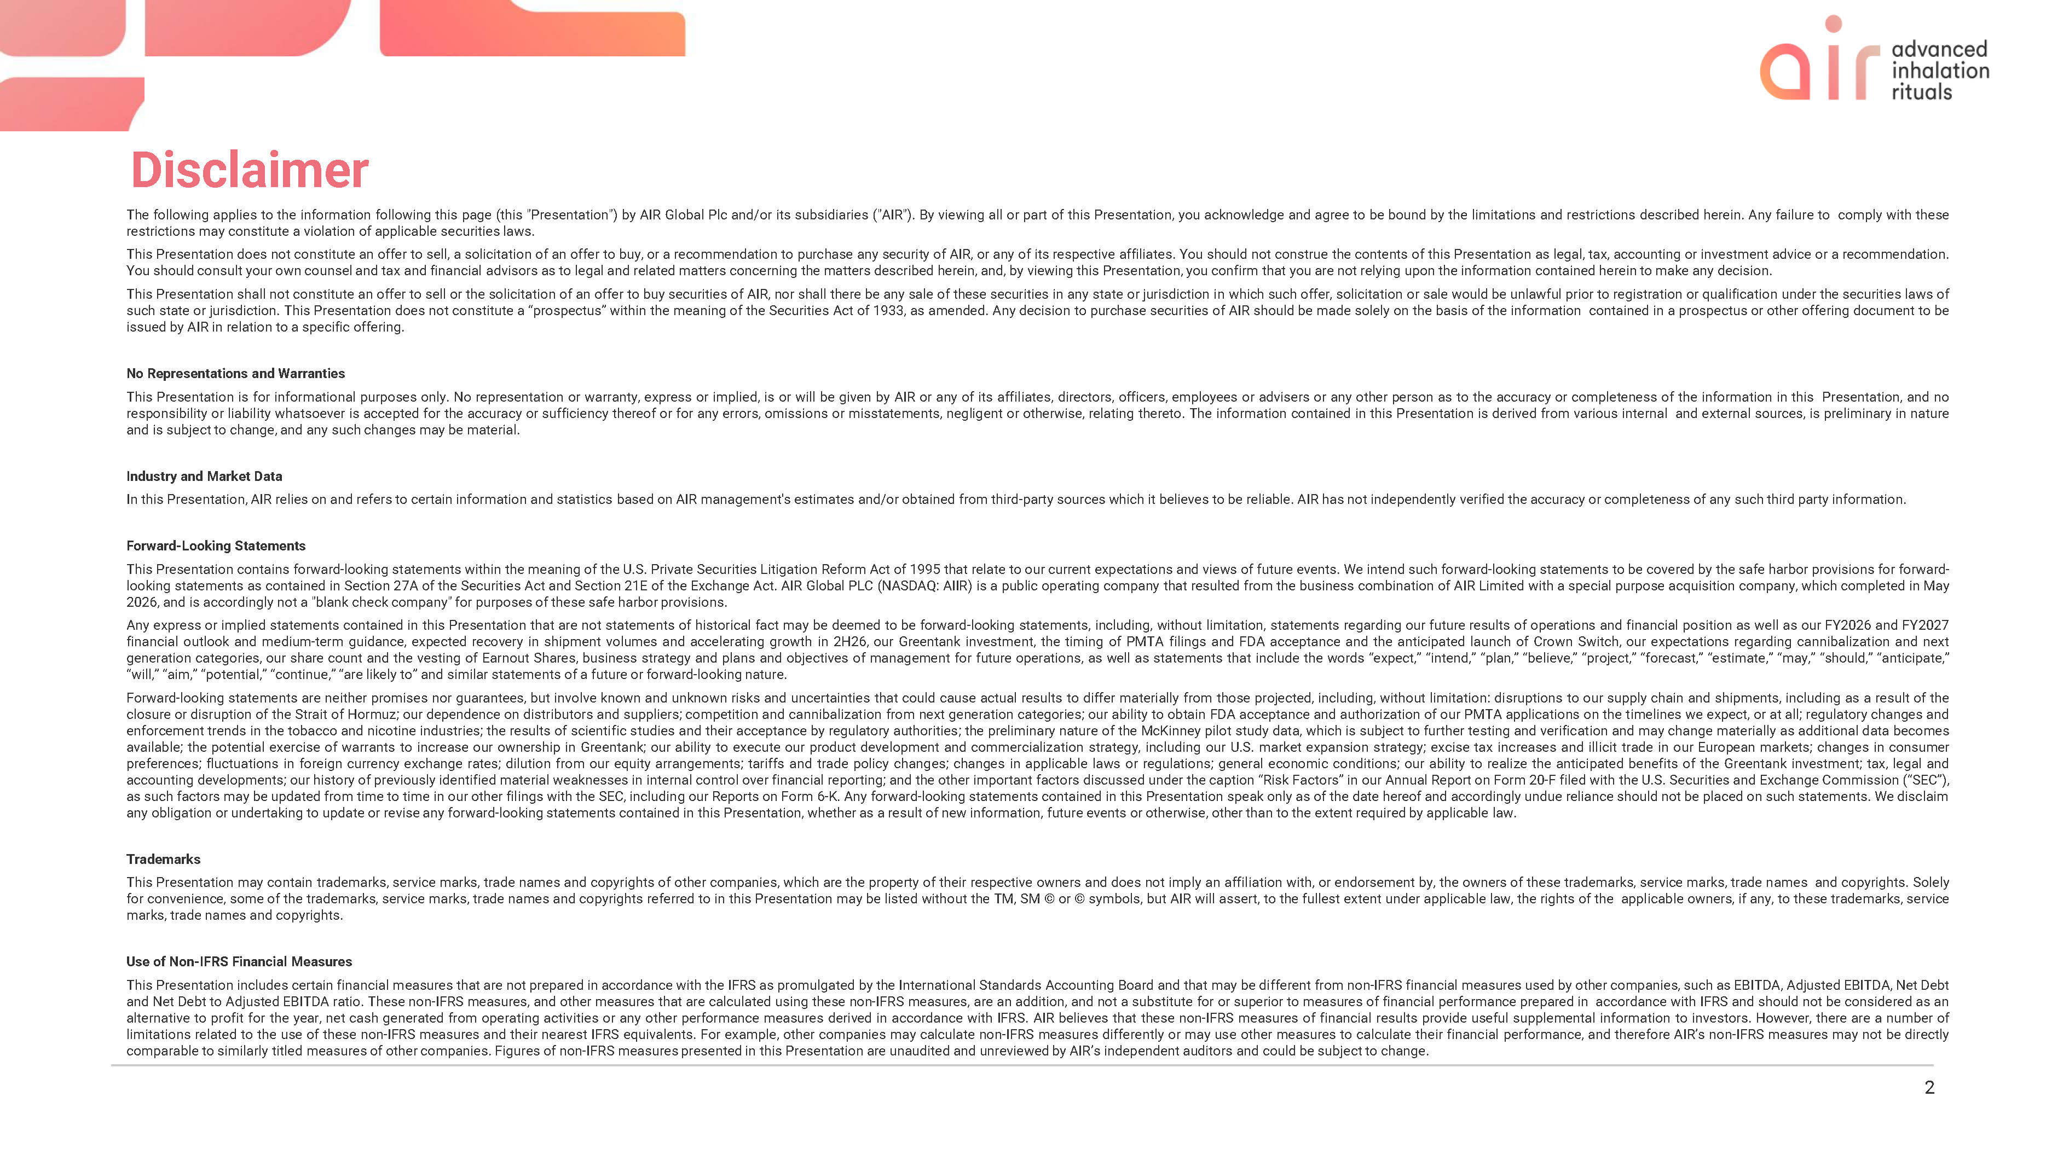
air advanced inhalation rituals Disclaimer The following applies to the information following this page (this "Presentation") by AIR Global Plc and/or its subsidiaries ("AIR"). By viewing all or part of this Presentation, you acknowledge and agree to be bound by the limitations and restrictions described herein. Any failure to comply with these restrictions may constitute a violation of applicable securities laws. This Presentation does not constitute an offer to sell, a solicitation of an offer to buy, or a recommendation to purchase any security of AIR, or any of its respective affiliates. You should not construe the contents of this Presentation as legal, tax, accounting or investment advice or a recommendation. You should consult your own counsel and tax and financial advisors as to legal and related matters concerning the matters described herein, and, by viewing this Presentation, you confirm that you are not relying upon the information contained herein to make any decision. This Presentation shall not constitute an offer to sell or the solicitation of an offer to buy securities of AIR, nor shall there be any sale of these securities in any state or jurisdiction in which such offer, solicitation or sale would be unlawful prior to registration or qualification under the securities laws of such state or jurisdiction. This Presentation does not constitute a “prospectus” within the meaning of the Securities Act of 1933, as amended. Any decision to purchase securities of AIR should be made solely on the basis of the information contained in a prospectus or other offering document to be issued by AIR in relation to a specific offering. No Representations and Warranties This Presentation is for informational purposes only. No representation or warranty, express or implied, is or will be given by AIR or any of its affiliates, directors, officers, employees or advisers or any other person as to the accuracy or completeness of the information in this Presentation, and no responsibility or liability whatsoever is accepted for the accuracy or sufficiency thereof or for any errors, omissions or misstatements, negligent or otherwise, relating thereto. The information contained in this Presentation is derived from various internal and external sources, is preliminary in nature and is subject to change, and any such changes may be material. Industry and Market Data In this Presentation, AIR relies on and refers to certain information and statistics based on AIR management's estimates and/or obtained from third-party sources which it believes to be reliable. AIR has not independently verified the accuracy or completeness of any such third party information. Forward-Looking Statements This Presentation contains forward-looking statements within the meaning of the U.S. Private Securities Litigation Reform Act of 1995 that relate to our current expectations and views of future events. We intend such forward-looking statements to be covered by the safe harbor provisions for forward-looking statements as contained in Section 27A of the Securities Act and Section 21E of the Exchange Act. AIR Global PLC (NASDAQ: AIIR) is a public operating company that resulted from the business combination of AIR Limited with a special purpose acquisition company, which completed in May 2026, and is accordingly not a "blank check company" for purposes of these safe harbor provisions. Any express or implied statements contained in this Presentation that are not statements of historical fact may be deemed to be forward-looking statements, including, without limitation, statements regarding our future results of operations and financial position as well as our FY2026 and FY2027 financial outlook and medium-term guidance, expected recovery in shipment volumes and accelerating growth in 2H26, our Greentank investment, the timing of PMTA filings and FDA acceptance and the anticipated launch of Crown Switch, our expectations regarding cannibalization and next generation categories, our share count and the vesting of Earnout Shares, business strategy and plans and objectives of management for future operations, as well as statements that include the words “expect,” “intend,” “plan,” “believe,” “project,” “forecast,” “estimate,” “may,” “should,” “anticipate,” “will,” “aim,” “potential,” “continue,” “are likely to” and similar statements of a future or forward-looking nature. Forward-looking statements are neither promises nor guarantees, but involve known and unknown risks and uncertainties that could cause actual results to differ materially from those projected, including, without limitation: disruptions to our supply chain and shipments, including as a result of the closure or disruption of the Strait of Hormuz; our dependence on distributors and suppliers; competition and cannibalization from next generation categories; our ability to obtain FDA acceptance and authorization of our PMTA applications on the timelines we expect, or at all; regulatory changes and enforcement trends in the tobacco and nicotine industries; the results of scientific studies and their acceptance by regulatory authorities; the preliminary nature of the McKinney pilot study data, which is subject to further testing and verification and may change materially as additional data becomes available; the potential exercise of warrants to increase our ownership in Greentank; our ability to execute our product development and commercialization strategy, including our U.S. market expansion strategy; excise tax increases and illicit trade in our European markets; changes in consumer preferences; fluctuations in foreign currency exchange rates; dilution from our equity arrangements; tariffs and trade policy changes; changes in applicable laws or regulations; general economic conditions; our ability to realize the anticipated benefits of the Greentank investment; tax, legal and accounting developments; our history of previously identified material weaknesses in internal control over financial reporting; and the other important factors discussed under the caption “Risk Factors” in our Annual Report on Form 20-F filed with the U.S. Securities and Exchange Commission (“SEC”), as such factors may be updated from time to time in our other filings with the SEC, including our Reports on Form 6-K. Any forward-looking statements contained in this Presentation speak only as of the date hereof and accordingly undue reliance should not be placed on such statements. We disclaim any obligation or undertaking to update or revise any forward-looking statements contained in this Presentation, whether as a result of new information, future events or otherwise, other than to the extent required by applicable law. Trademarks This Presentation may contain trademarks, service marks, trade names and copyrights of other companies, which are the property of their respective owners and does not imply an affiliation with, or endorsement by, the owners of these trademarks, service marks, trade names and copyrights. Solely for convenience, some of the trademarks, service marks, trade names and copyrights referred to in this Presentation may be listed without the TM, SM © or © symbols, but AIR will assert, to the fullest extent under applicable law, the rights of the applicable owners, if any, to these trademarks, service marks, trade names and copyrights. Use of Non-IFRS Financial Measures This Presentation includes certain financial measures that are not prepared in accordance with the IFRS as promulgated by the International Standards Accounting Board and that may be different from non-IFRS financial measures used by other companies, such as EBITDA, Adjusted EBITDA, Net Debt and Net Debt to Adjusted EBITDA ratio. These non-IFRS measures, and other measures that are calculated using these non-IFRS measures, are an addition, and not a substitute for or superior to measures of financial performance prepared in accordance with IFRS and should not be considered as an alternative to profit for the year, net cash generated from operating activities or any other performance measures derived in accordance with IFRS. AIR believes that these non-IFRS measures of financial results provide useful supplemental information to investors. However, there are a number of limitations related to the use of these non-IFRS measures and their nearest IFRS equivalents. For example, other companies may calculate non-IFRS measures differently or may use other measures to calculate their financial performance, and therefore AIR’s non-IFRS measures may not be directly comparable to similarly titled measures of other companies. Figures of non-IFRS measures presented in this Presentation are unaudited and unreviewed by AIR’s independent auditors and could be subject to change.

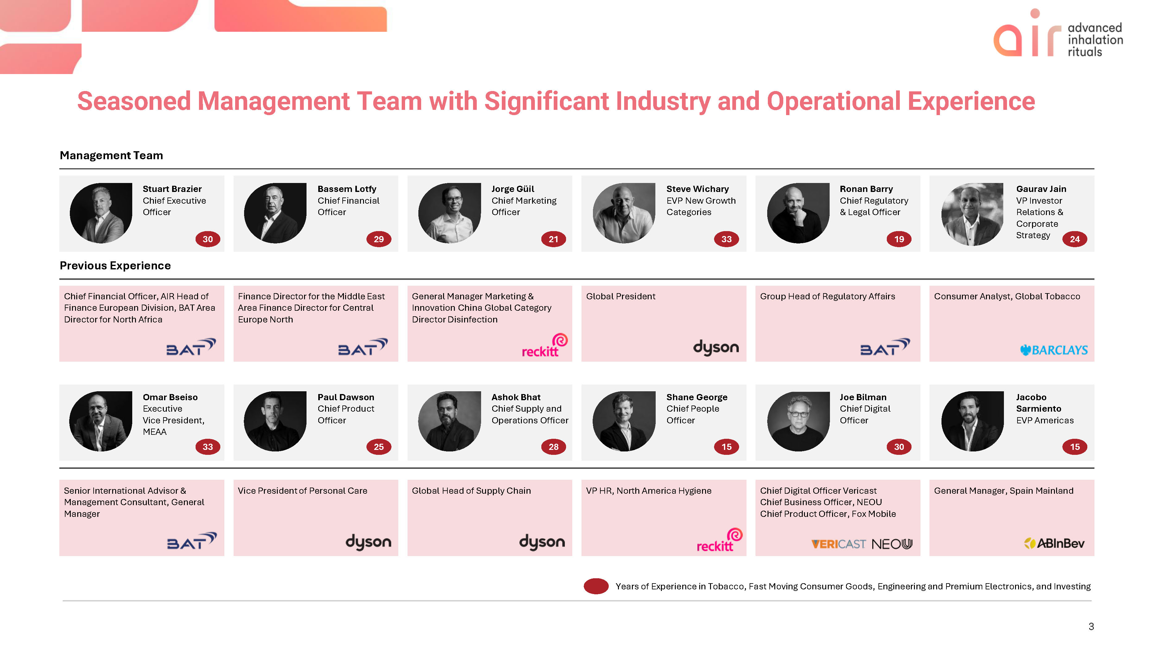
air advanced inhalation rituals Seasoned Management Team with Significant Industry and Operational Experience Management Team Stuart Brazier Chief Executive Officer Bassem Lotfy Chief Financial Officer Jorge Güil Chief Marketing Officer Steve Wichary EVP New Growth Categories Ronan Barry Chief Regulatory & Legal Officer Gaurav Jain VP Investor Relations & Corporate Strategy Previous Experience Chief Financial Officer, AIR Head of Finance European Division, BAT Area Director for North Africa Bat Finance Director for the Middle East Area Finance Director for Central Europe North Bat General Manager Marketing & Innovation China Global Category Director Disinfection reckitt Global President dyson Group Head of Regulatory Affairs Bat Consumer Analyst, Global Tobacco BARCLAYS Omar Bseiso Executive Vice President, MEAA 33 Paul Dawson Chief Product Officer 25 Ashok Bhat Chief Supply and Operations Officer 28 Shane George Chief People Officer 15 Joe Bilman Chief Digital Officer Jacobo Sarmiento EVP Americas 15 Senior International Advisor & Management Consultant, General Manager Bat Vice President of Personal Care dyson Global Head of Supply Chain dyson VP HR, North America Hygiene reckitt Chief Digital Officer Vericast Chief Business Officer, NEOU Chief Product Officer, Fox Mobile VERICAST NEO General Manager, Spain Mainland AblnBev Years of Experience in Tobacco, Fast Moving Consumer Goods, Engineering and Premium Electronics, and Investing 3

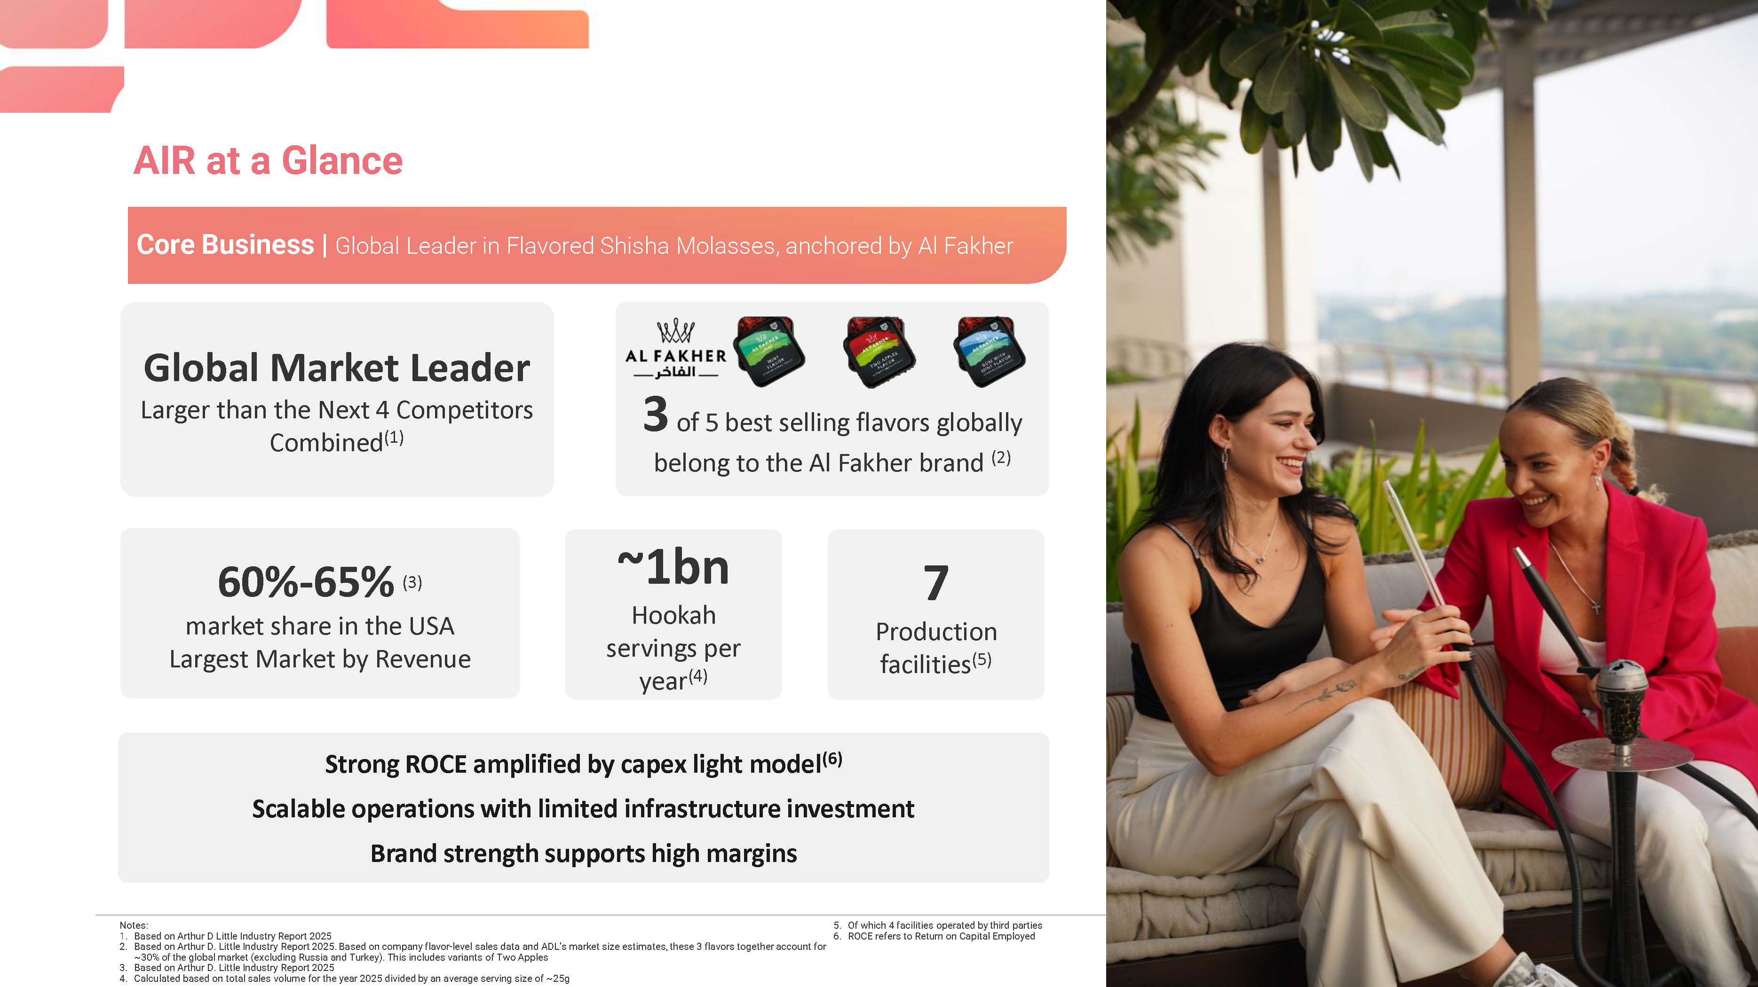
AIR at a Glance Core Business | Global Leader in Flavored Shisha Molasses, anchored by Al Fakher Global Market Leader Larger than the Next 4 Competitors Combined(1) 3 of 5 best selling flavors globally belong to the Al Fakher brand (2) 60%-65% (3) market share in the USA Largest Market by Revenue ~1bn Hookah servings per year(4) 7 Production facilities(5) Strong ROCE amplified by capex light model(6) Scalable operations with limited infrastructure investment Brand strength supports high margins Notes: 1. Based on Arthur D Little Industry Report 2025 2. Based on Arthur D. Little Industry Report 2025. Based on company flavor-level sales data and ADL’s market size estimates, these 3 flavors together account for ~30% of the global market (excluding Russia and Turkey). This includes variants of Two Apples 3.Based on Arthur D. Little Industry Report 2025 4. Calculated based on total sales volume for the year 2025 divided by an average serving size of ~25g 5. Of which 4 facilities operated by third parties 6. ROCE refers to Return on Capital Employed

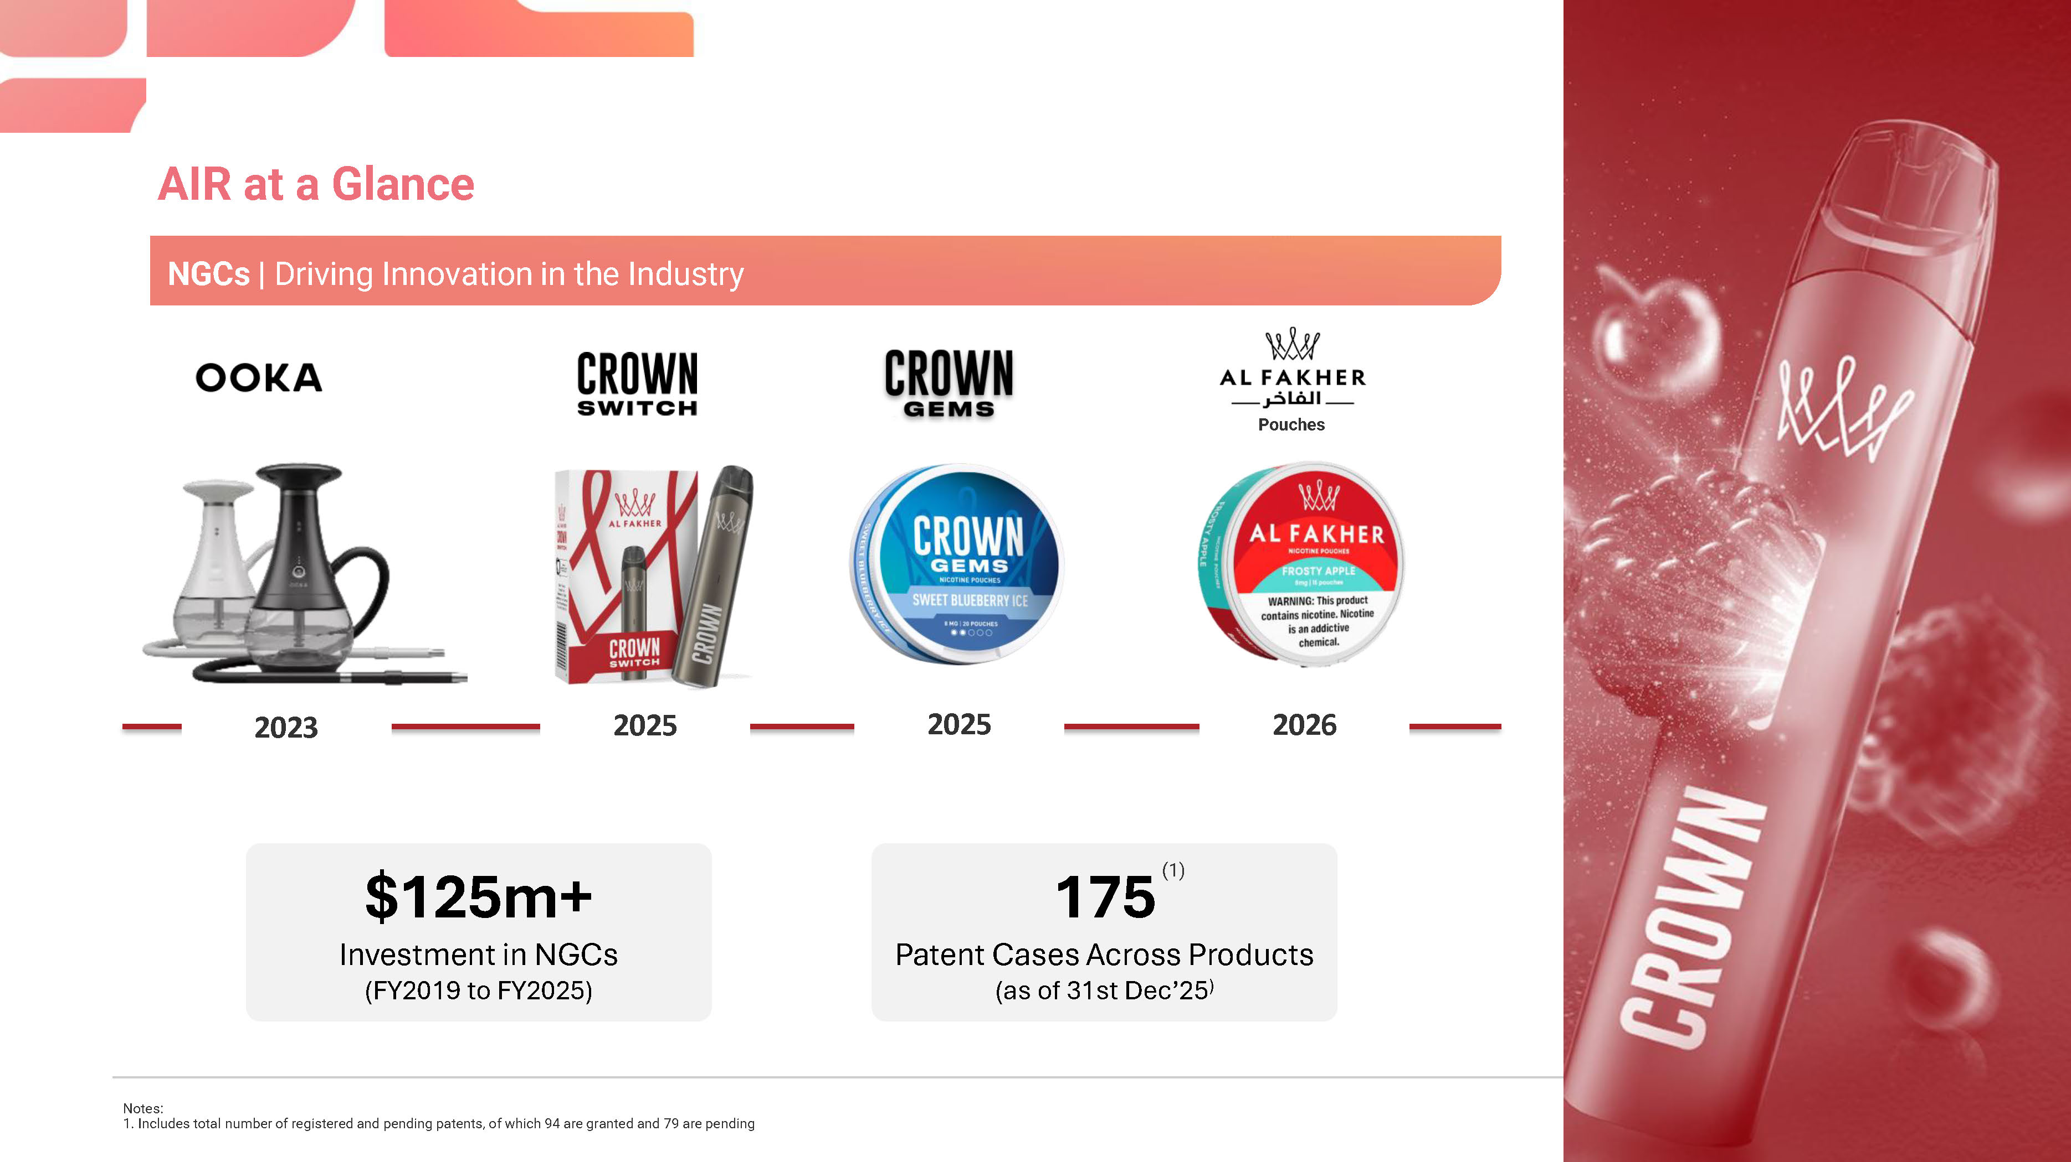
AIR at a Glance NGCs | Driving Innovation in the Industry OOKA 2023 CROWN SWITCH 2025 CROWN GEMS 2025 ALFAKHER Pouches 2026$125m+ Investment in NGCs (FY2019 to FY2025) 175(1) Patent Cases Across Products (as of 31st Dec’25) Notes: 1. Includes total number of registered and pending patents, of which 94 are granted and 79 are pending CROWN

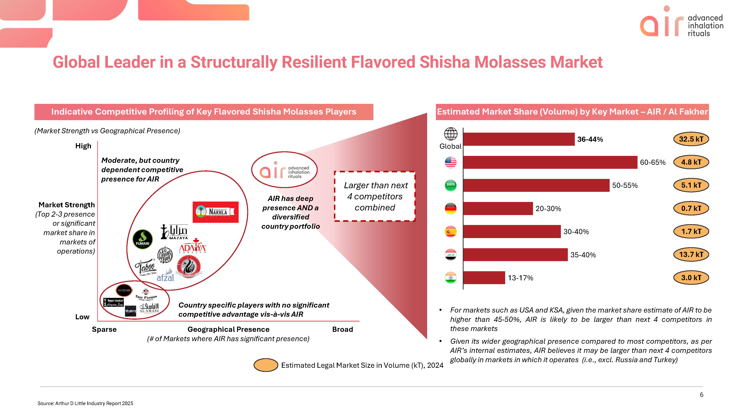
air advanced inhalation rituals Global Leader in a Structurally Resilient Flavored Shisha Molasses Market Indicative Competitive Profiling of Key Flavored Shisha Molasses Players (Market Strength vs Geographical Presence) High Moderate, but country dependent competitive presence for AIR Market Strength (Top 2-3 presence or significant market share in markets of operations) air advanced inhalation rituals AIR has deep presence AND a diversified country portfolio Larger than next 4 competitors combined Nakhla MAZAYA FUMARI ADAYA TOBACCO Taboo STARBUZZ TOBACCO SINCE 2005 afzal HOOKAIAI Royal Smokia TRUE PASSION Tobacco Khaleej ALAMASI Tobacco Country specific players with no significant competitive advantage vis-à-vis AIR Low Sparse Geographical Presence Broad (# of Markets where AIR has significant presence) Estimated Legal Market Size in Volume (kT), 2024 Estimated Market Share (Volume) by Key Market – AIR / Al Fakher Global 36-44% 32.5 kT 60-65% 4.8 kT 50-55% 5.1 kT 20-30% 0.7 kT 30-40% 1.7 kT 35-40% 13.7 kT 13-17% 3.0 kT  For markets such as USA and KSA, given the market share estimate of AIR to be higher than 45-50%, AIR is likely to be larger than next 4 competitors in these markets  Given its wider geographical presence compared to most competitors, as per AIR’s internal estimates, AIR believes it may be larger than next 4 competitors globally in markets in which it operates (i.e., excl. Russia and Turkey) 6 Source: Arthur D Little Industry Report 2025

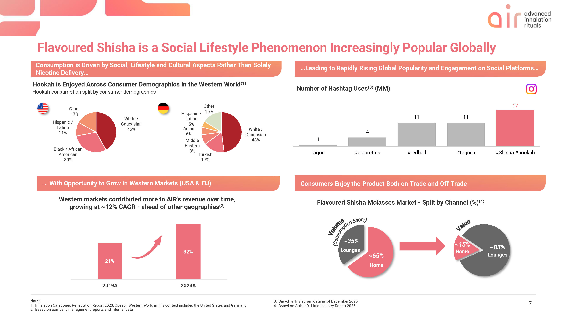
air advanced inhalation rituals Flavoured Shisha is a Social Lifestyle Phenomenon Increasingly Popular Globally Consumption is Driven by Social, Lifestyle and Cultural Aspects Rather Than Solely Nicotine Delivery Leading to Rapidly Rising Global Popularity and Engagement on Social Platforms Hookah is Enjoyed Across Consumer Demographics in the Western World(1) Hookah consumption split by consumer demographics Number of Hashtag Uses(3) (MM) Other 17% White / Caucasian 42% Hispanic / Latino 11% Black / African American 30% Other 16% Hispanic / Latino 5% Asian 6% Middle Eastern 8% Turkish 17% White / Caucasian 48% 1 #iqos 4 #cigarettes 11 #redbull 11 #tequila 17 #Shisha #hookah With Opportunity to Grow in Western Markets (USA & EU) Consumers Enjoy the Product Both on Trade and Off Trade Western markets contributed more to AIR's revenue over time, growing at ~12% CAGR - ahead of other geographies(2) Flavoured Shisha Molasses Market - Split by Channel (%)(4) 21% 2019A 32% 2024A Volume (Consumption Share) ~35% Lounges ~65% Home Value ~15% Home ~85% LoungesNotes: 1. Inhalation Categories Penetration Report 2023, Opeepl. Western World in this context includes the United States and Germany 2. Based on company management reports and internal data 3.Based on Instagram data as of December 2025 4. Based on Arthur D. Little Industry Report 2025 7

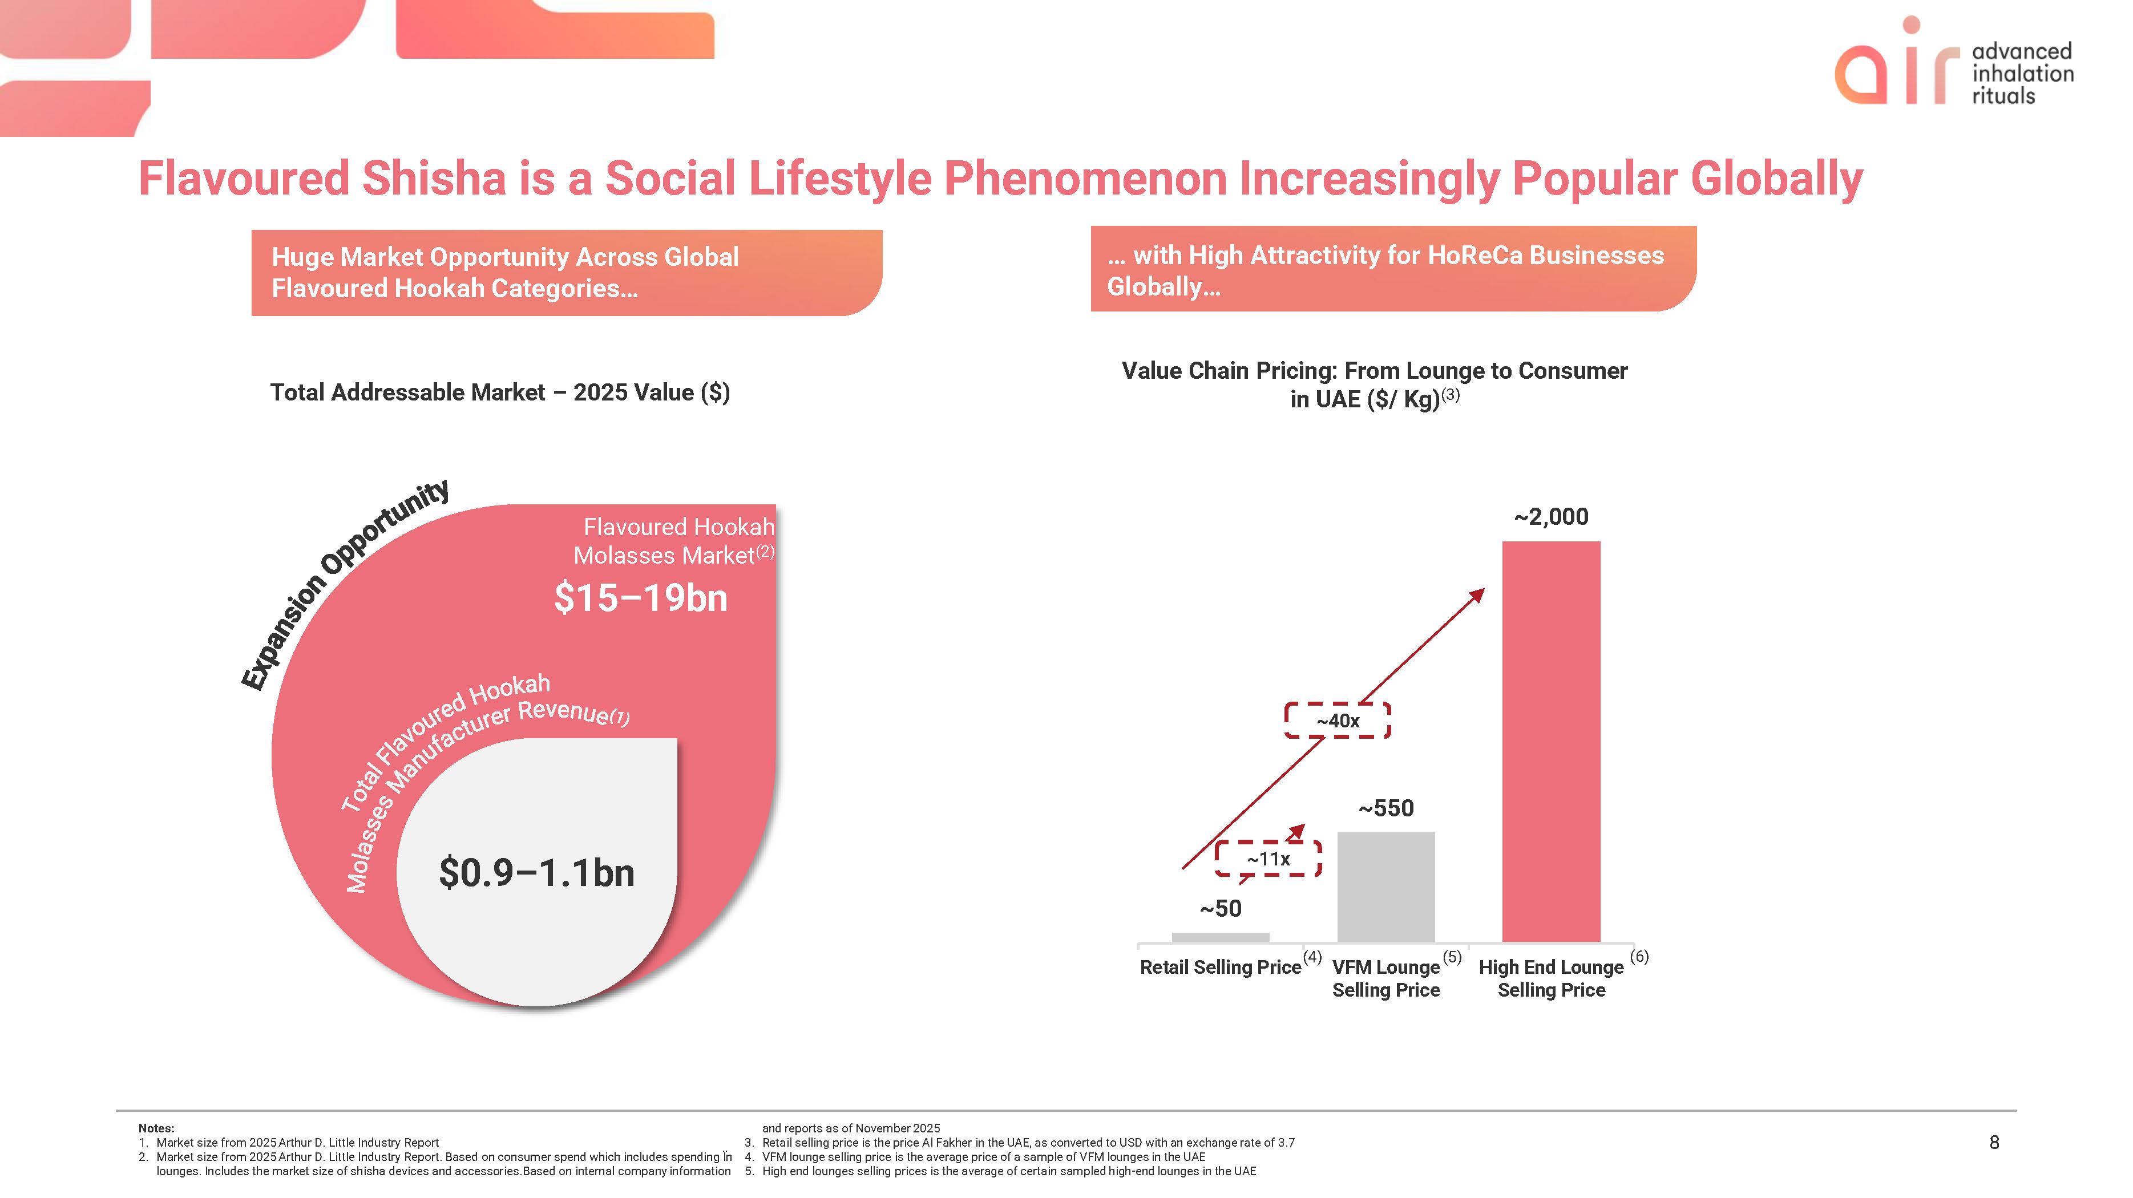
air advanced inhalation rituals Flavoured Shisha is a Social Lifestyle Phenomenon Increasingly Popular Globally Huge Market Opportunity Across Global Flavoured Hookah Categories with High Attractivity for HoReCa Businesses Globally Total Addressable Market – 2025 Value ($) Expansive Opportunity Flavoured Hookah Molasses Market (2) $15–19bn Total Flavoured Hookah Molasses Market Manufacturing Revenue (1) $0.9–1.1bn Value Chain Pricing: From Lounge to Consumer in UAE ($/ Kg)(3) ~2,000 ~40x ~550 ~11x ~50 Retail Selling Price(4) VFM Lounge (5) Selling Price High End Lounge (6) Selling PriceNotes: 1. Market size from 2025 Arthur D. Little Industry Report 2. Market size from 2025 Arthur D. Little Industry Report. Based on consumer spend which includes spending Ïn lounges. Includes the market size of shisha devices and accessories.Based on internal company information and reports as of November 2025 3. Retail selling price is the price Al Fakher in the UAE, as converted to USD with an exchange rate of 3.7 8 4. VFM lounge selling price is the average price of a sample of VFM lounges in the UAE 5. High end lounges selling prices is the average of certain sampled high-end lounges in the UAE 8

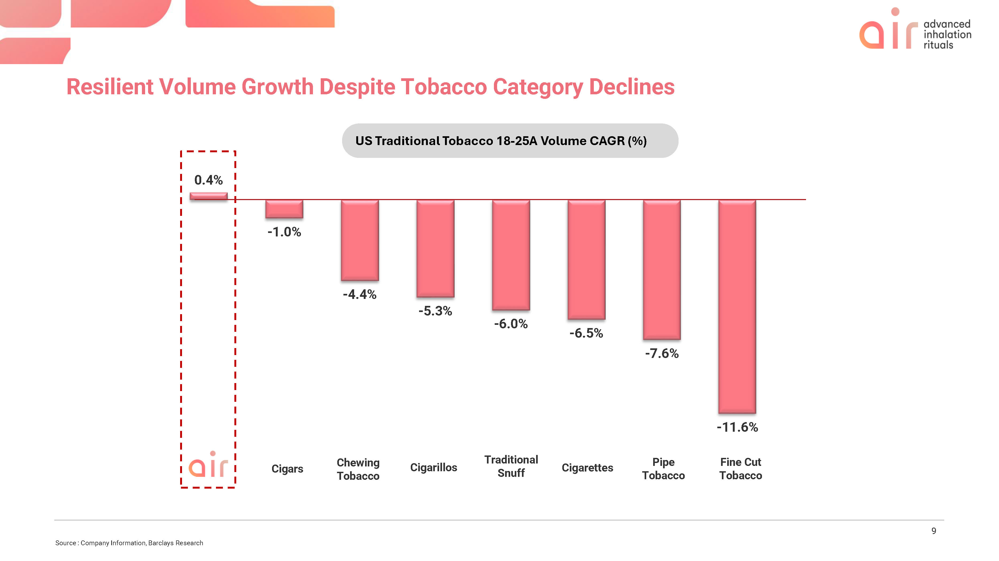
air advanced inhalation rituals Resilient Volume Growth Despite Tobacco Category Declines US Traditional Tobacco 18-25A Volume CAGR (%) 0.4% air -1.0% Cigars -4.4% Chewing Tobacco -5.3% Cigarillos -6.0% Traditional Snuff -6.5% Cigarettes -7.6% Pipe Tobacco -11.6% Fine Cut Tobacco Source : Company Information, Barclays Research 9

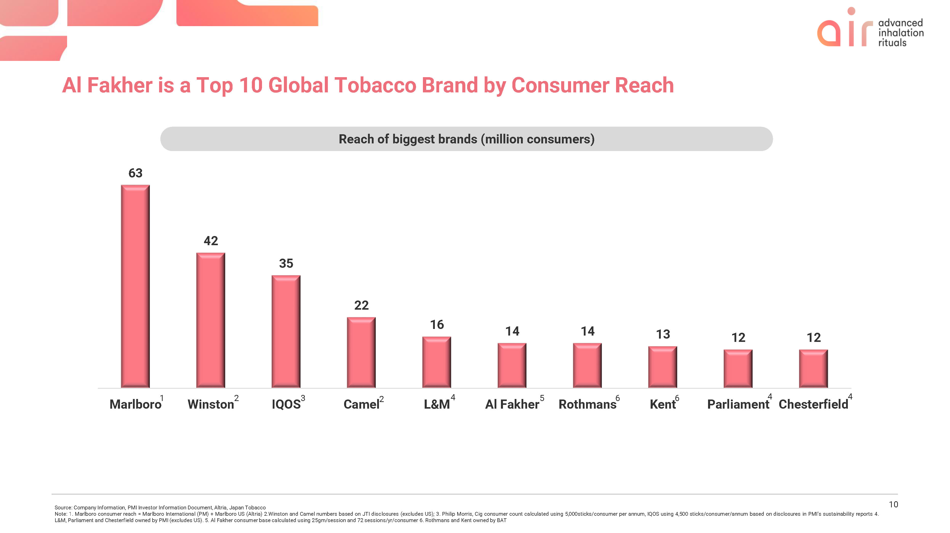
air advanced inhalation rituals Al Fakher is a Top 10 Global Tobacco Brand by Consumer Reach Reach of biggest brands (million consumers) 63 Marlboro1 42 Winston2 35 IQOS3 22 Camel2 16 L&M4 14 Al Fakher5 14 Rothmans6 13 Kent6 12 Parliament4 12 Chesterfield4 Source: Company Information, PMI Investor Information Document, Altria, Japan Tobacco Note: 1. Marlboro consumer reach = Marlboro International (PM) + Marlboro US (Altria) 2.Winston and Camel numbers based on JTI disclosures (excludes US); 3. Philip Morris, Cig consumer count calculated using 5,000sticks/consumer per annum, IQOS using 4,500 sticks/consumer/annum based on disclosures in PMI’s sustainability reports 4.L&M, Parliament and Chesterfield owned by PMI (excludes US). 5. Al Fakher consumer base calculated using 25gm/session and 72 sessions/yr/consumer 6. Rothmans and Kent owned by BAT 10

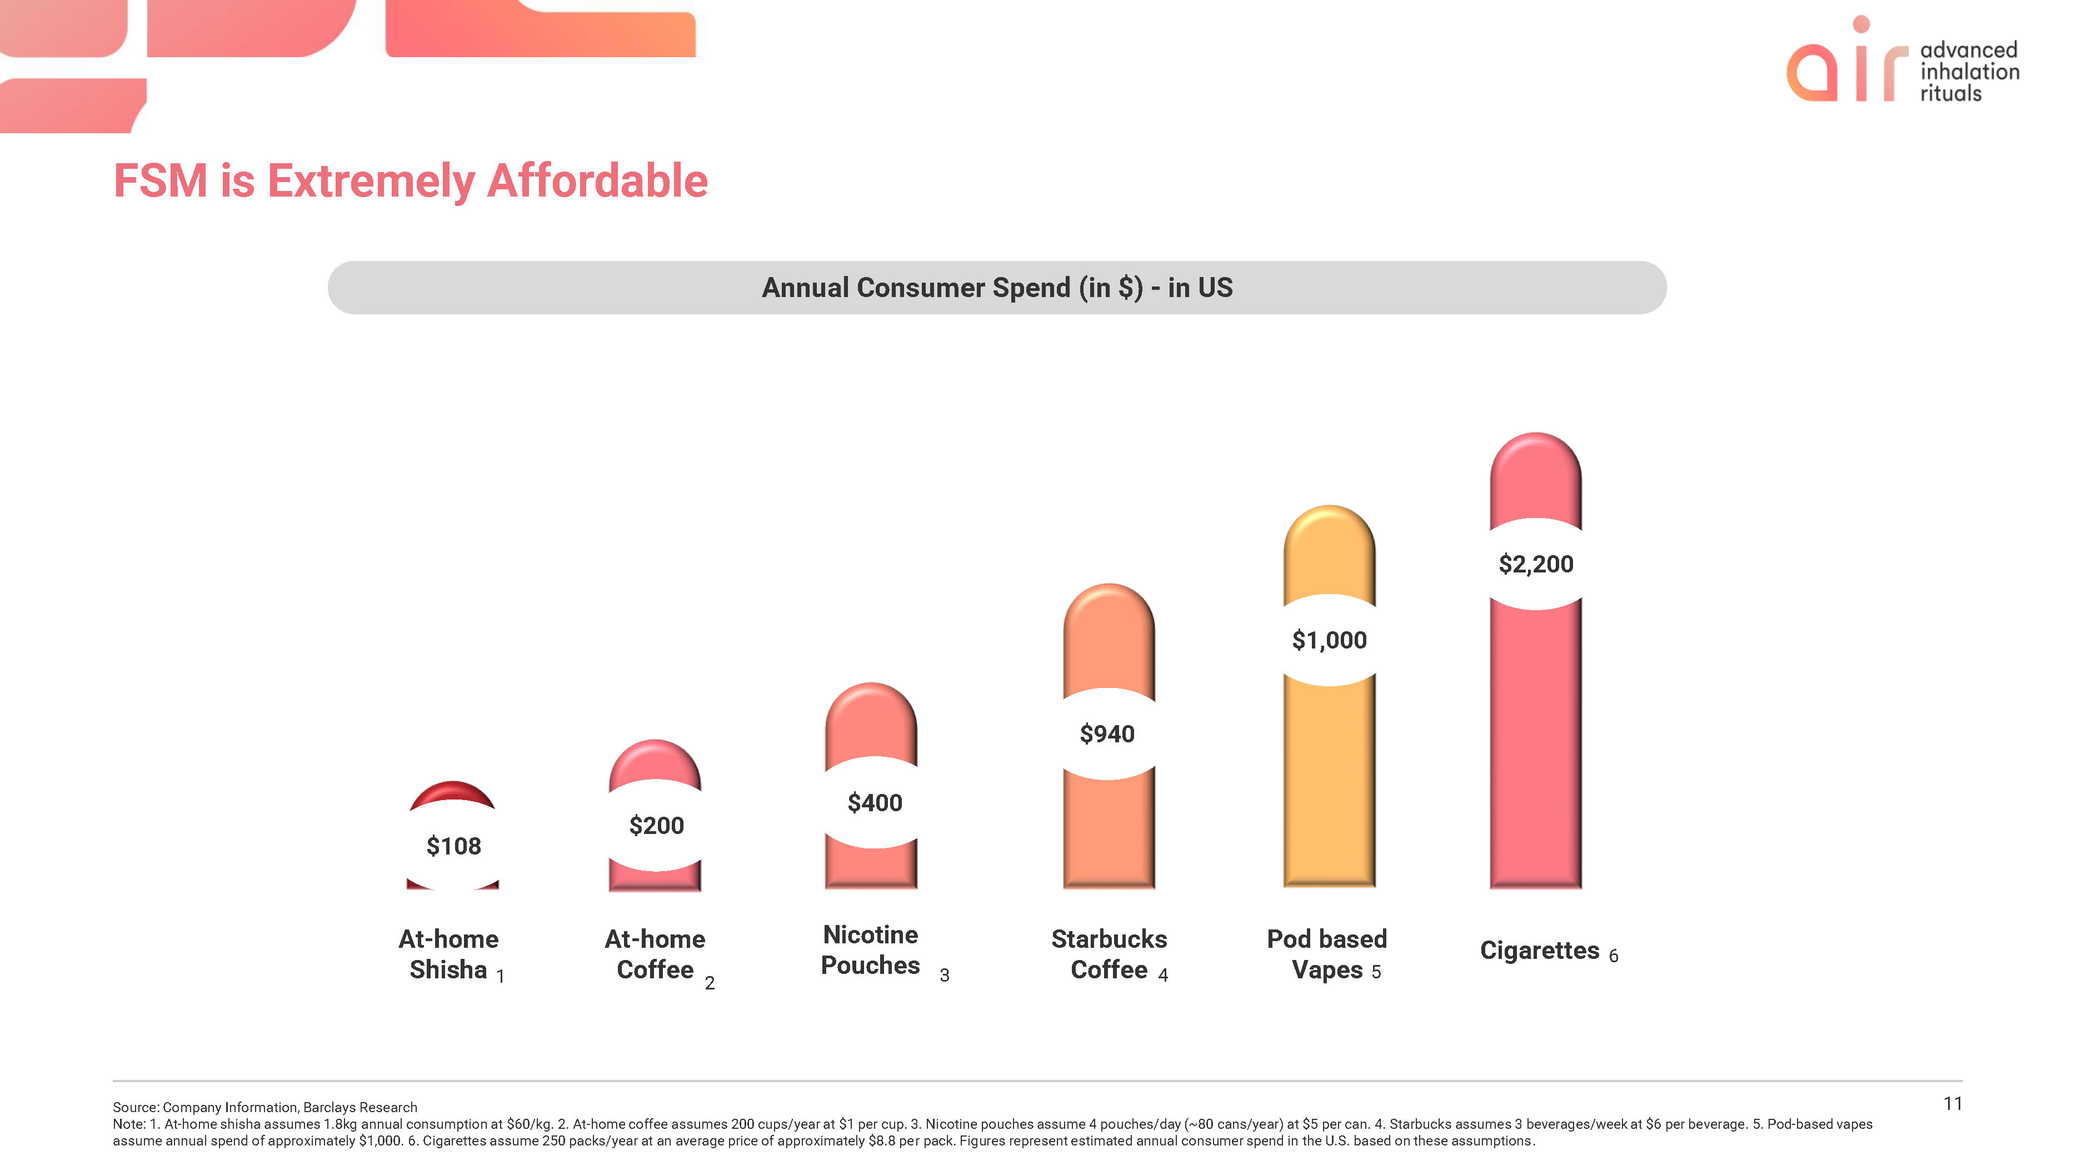
air advanced inhalation rituals FSM is Extremely Affordable Annual Consumer Spend (in $) - in US $108 At-home Shisha1 $200 At-home Coffee2 $400 Nicotine Pouches 3 $940 Starbucks Coffee 4 $1,000 Pod based Vapes 5 $2,200 Cigarettes 6 Source: Company Information, Barclays Research Note: 1. At-home shisha assumes 1.8kg annual consumption at $60/kg. 2. At-home coffee assumes 200 cups/year at $1 per cup. 3. Nicotine pouches assume 4 pouches/day (~80 cans/year) at $5 per can. 4. Starbucks assumes 3 beverages/week at $6 per beverage. 5. Pod-based vapes assume annual spend of approximately $1,000. 6. Cigarettes assume 250 packs/year at an average price of approximately $8.8 per pack. Figures represent estimated annual consumer spend in the U.S. based on these assumptions. 11

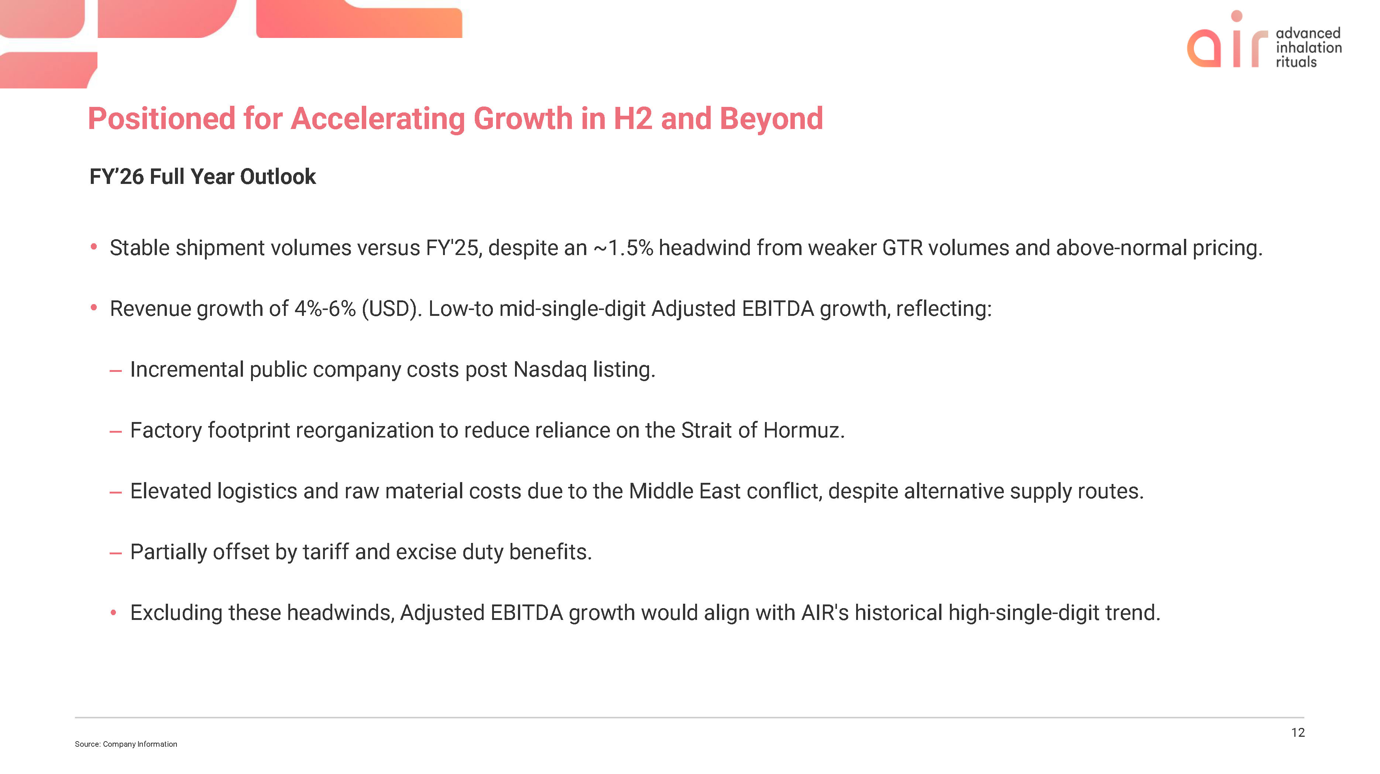
air advanced inhalation rituals Positioned for Accelerating Growth in H2 and Beyond FY’26 Full Year Outlook  Stable shipment volumes versus FY'25, despite an ~1.5% headwind from weaker GTR volumes and above-normal pricing. Revenue growth of 4%-6% (USD). Low-to mid-single-digit Adjusted EBITDA growth, reflecting: –Incremental public company costs post Nasdaq listing. – Factory footprint reorganization to reduce reliance on the Strait of Hormuz. – Elevated logistics and raw material costs due to the Middle East conflict, despite alternative supply routes. – Partially offset by tariff and excise duty benefits.  Excluding these headwinds, Adjusted EBITDA growth would align with AIR's historical high-single-digit trend. Source: Company Information 12

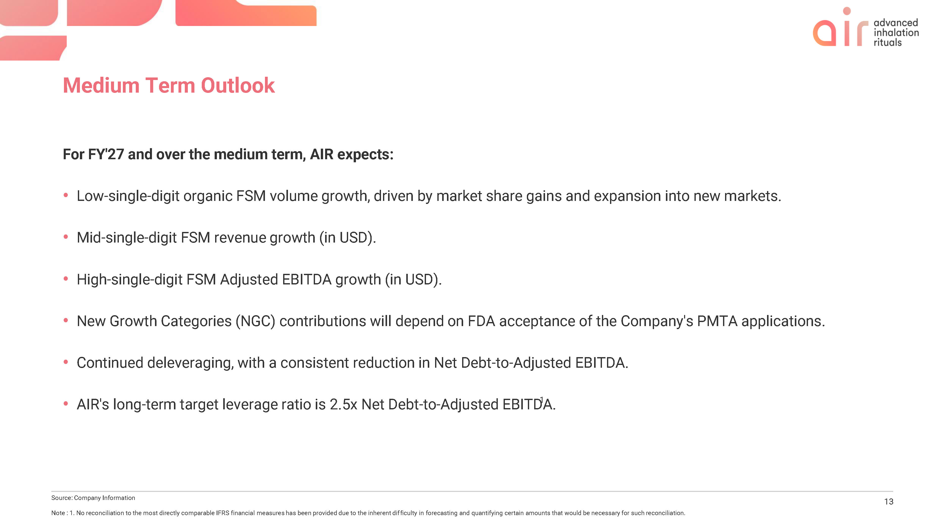
air advanced inhalation rituals Medium Term Outlook For FY'27 and over the medium term, AIR expects:  Low-single-digit organic FSM volume growth, driven by market share gains and expansion into new markets.  Mid-single-digit FSM revenue growth (in USD).  High-single-digit FSM Adjusted EBITDA growth (in USD).  New Growth Categories (NGC) contributions will depend on FDA acceptance of the Company's PMTA applications.  Continued deleveraging, with a consistent reduction in Net Debt-to-Adjusted EBITDA.  AIR's long-term target leverage ratio is 2.5x Net Debt-to-Adjusted EBITD1A. Source: Company Information Note : 1. No reconciliation to the most directly comparable IFRS financial measures has been provided due to the inherent difficulty in forecasting and quantifying certain amounts that would be necessary for such reconciliation. 13

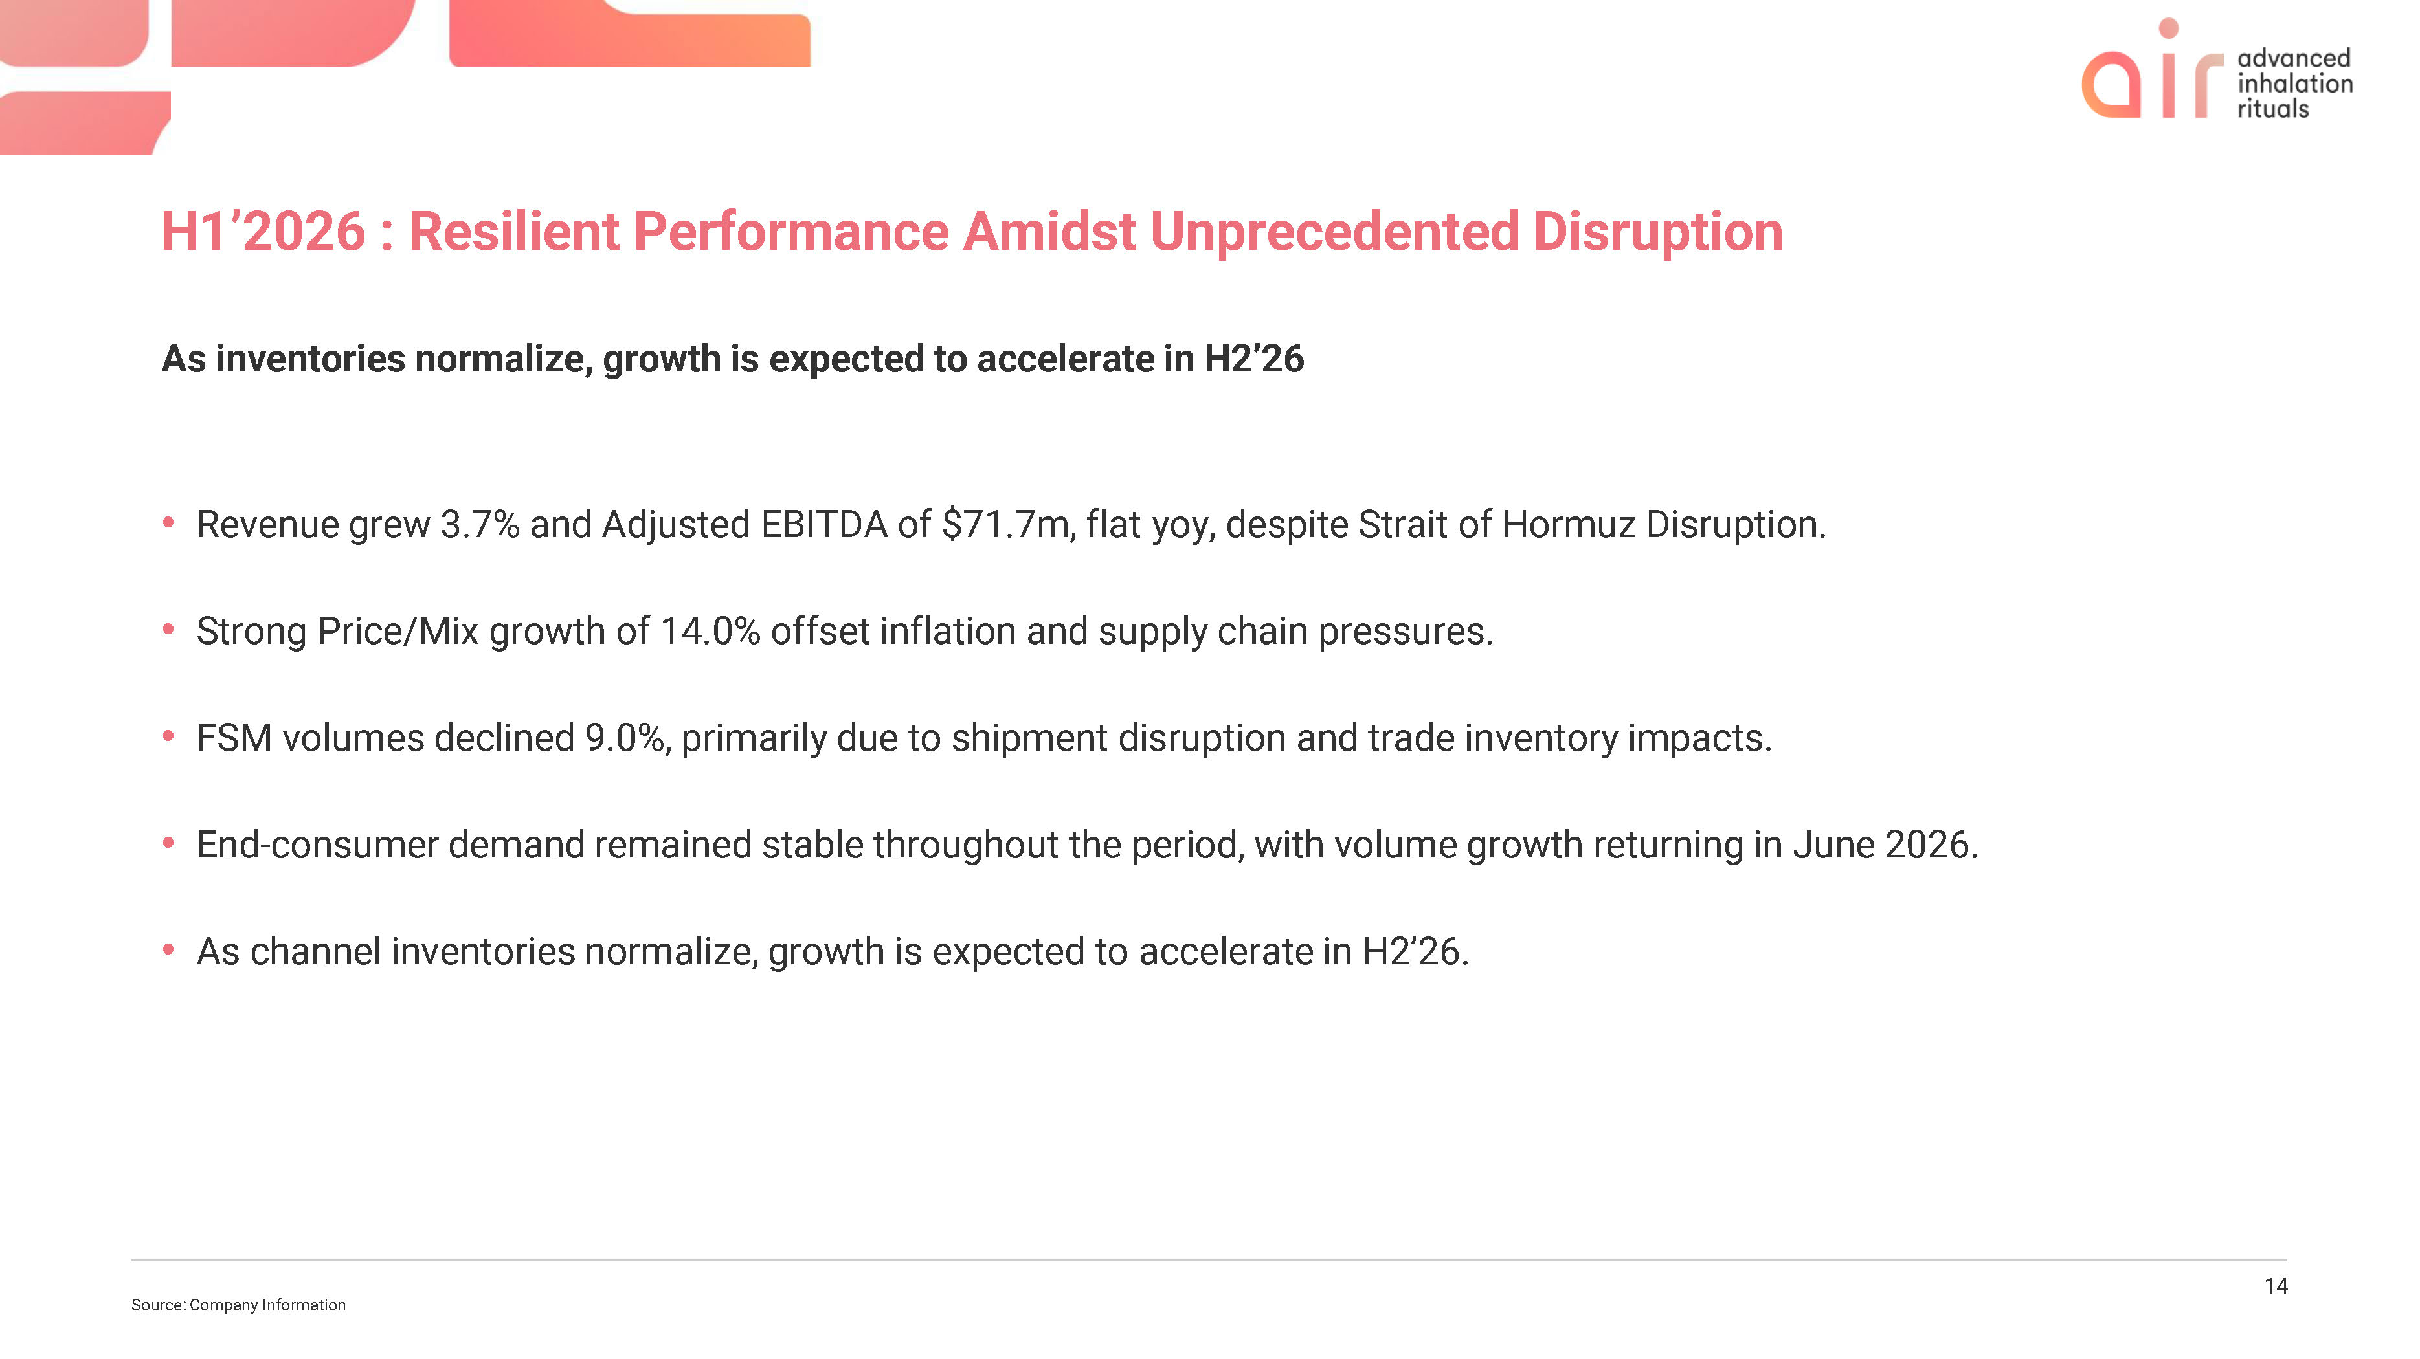
air advanced inhalation rituals H1’2026 : Resilient Performance Amidst Unprecedented Disruption As inventories normalize, growth is expected to accelerate in H2’26  Revenue grew 3.7% and Adjusted EBITDA of $71.7m, flat yoy, despite Strait of Hormuz Disruption.  Strong Price/Mix growth of 14.0% offset inflation and supply chain pressures.  FSM volumes declined 9.0%, primarily due to shipment disruption and trade inventory impacts.  End-consumer demand remained stable throughout the period, with volume growth returning in June 2026.  As channel inventories normalize, growth is expected to accelerate in H2’26. Source: Company Information 14

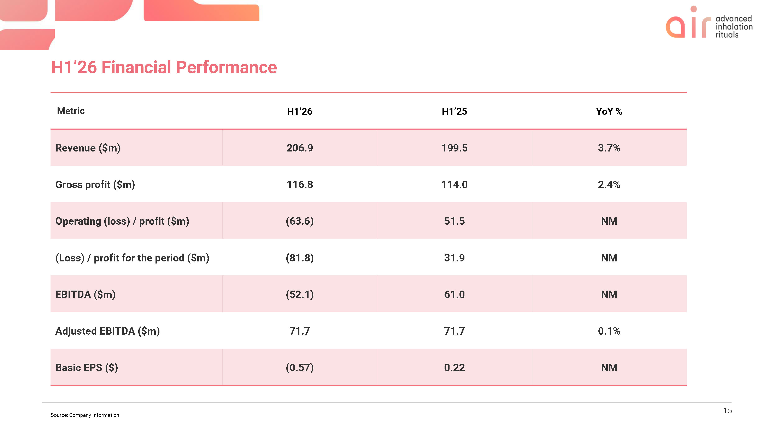
air advanced inhalation rituals H1’26 Financial Performance Metric H1’26 H1’25 YoY %Revenue ($m) 206.9 199.5 3.7%Gross profit ($m) 116.8 114.0 2.4%Operating (loss) / profit ($m) (63.6) 51.5 NM(Loss) / profit for the period ($m) (81.8) 31.9 NMEBITDA ($m) (52.1) 61.0 NM Adjusted EBITDA ($m) 71.7 71.7 0.1%Basic EPS ($) (0.57) 0.22 NM Source: Company Information 15

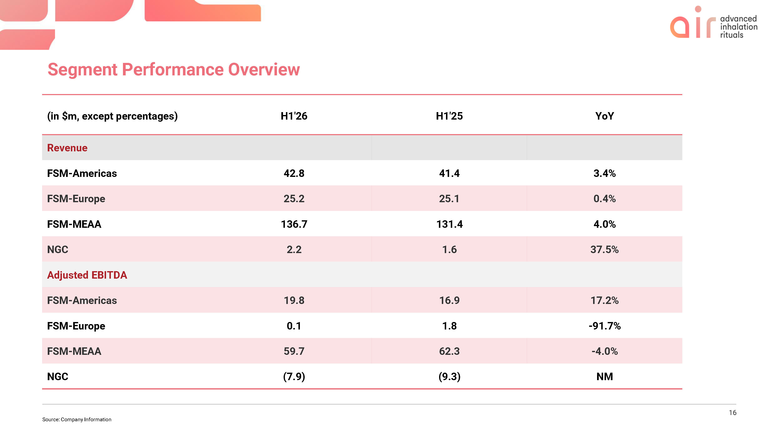
air advanced inhalation rituals Segment Performance Overview (in $m, except percentages) H1'26 H1'25 YoYRevenue FSM-Americas 42.8 41.4 3.4%FSM-Europe 25.2 25.1 0.4%FSM-MEAA 136.7 131.4 4.0%NGC 2.2 1.6 37.5%Adjusted EBITDA FSM-Americas 19.8 16.9 17.2%FSM-Europe 0.1 1.8 -91.7%FSM-MEAA 59.7 62.3 -4.0%NGC (7.9) (9.3) NM Source: Company Information 16

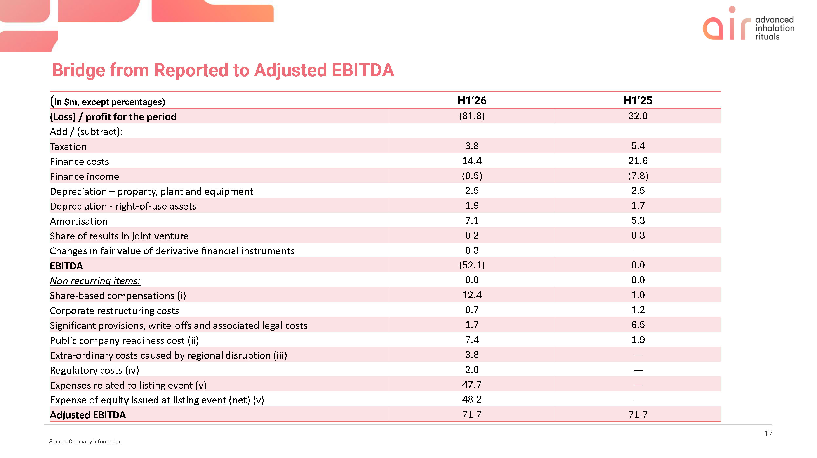
air advanced inhalation rituals Bridge from Reported to Adjusted EBITDA (in $m, except percentages) H1’26 H1’25 (Loss) / profit for the period (81.8) 32.0 Add / (subtract): Taxation 3.8 5.4 Finance costs 14.4 21.6 Finance income (0.5) (7.8) Depreciation – property, plant and equipment 2.5 2.5 Depreciation - right-of-use assets 1.9 1.7 Amortisation 7.1 5.3 Share of results in joint venture 0.2 0.3 Changes in fair value of derivative financial instruments 0.3 — EBITDA (52.1) 0.0 Non recurring items: 0.0 0.0 Share-based compensations (i) 12.4 1.0 Corporate restructuring costs 0.7 1.2 Significant provisions, write-offs and associated legal costs 1.7 6.5 Public company readiness cost (ii) 7.4 1.9 Extra-ordinary costs caused by regional disruption (iii) 3.8 — Regulatory costs (iv) 2.0 — Expenses related to listing event (v) 47.7 — Expense of equity issued at listing event (net) (v) 48.2 — Adjusted EBITDA 71.7 71.7 Source: Company Information 17

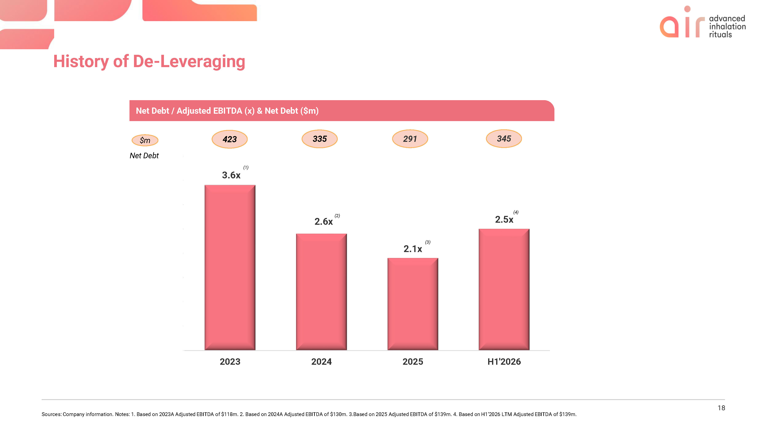
air advanced inhalation rituals History of De-Leveraging Net Debt / Adjusted EBITDA (x) & Net Debt ($m) $m Net Debt 423 335 291 345 3.6x(1) 2.6x(2) 2.1x(3) 2.5x(4) 2023 2024 2025 H1’2026 Sources: Company information. Notes: 1. Based on 2023A Adjusted EBITDA of $118m. 2. Based on 2024A Adjusted EBITDA of $130m. 3.Based on 2025 Adjusted EBITDA of $139m. 4. Based on H1’2026 LTM Adjusted EBITDA of $139m. 18

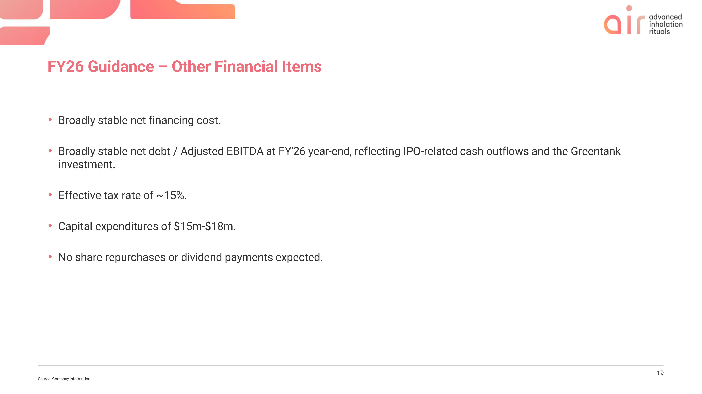
Air advanced inhalation rituals FY26 Guidance – Other Financial Items  Broadly stable net financing cost.  Broadly stable net debt / Adjusted EBITDA at FY'26 year-end, reflecting IPO-related cash outflows and the Greentank investment.  Effective tax rate of ~15%.  Capital expenditures of $15m-$18m.  No share repurchases or dividend payments expected. Source; Company Information 19

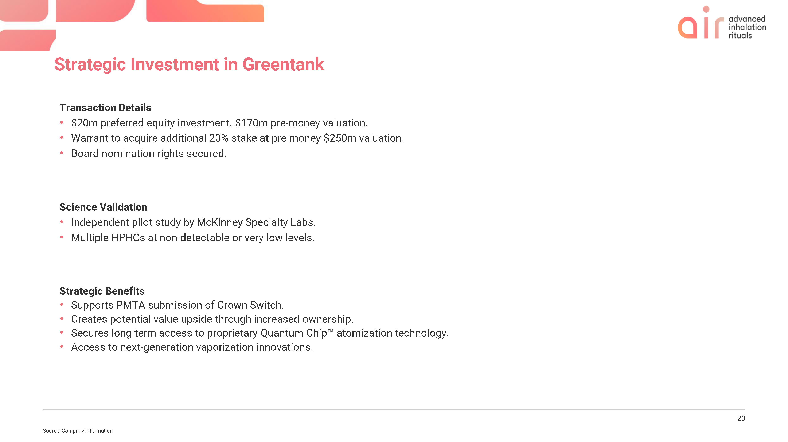
Air advanced inhalation rituals Strategic Investment in Greentank Transaction Details  $20m preferred equity investment. $170m pre-money valuation.  Warrant to acquire additional 20% stake at pre money $250m valuation.  Board nomination rights secured. Science Validation  Independent pilot study by McKinney Specialty Labs.  Multiple HPHCs at non-detectable or very low levels. Strategic Benefits  Supports PMTA submission of Crown Switch.  Creates potential value upside through increased ownership.  Secures long term access to proprietary Quantum Chip TM atomization technology.  Access to next-generation vaporization innovations. Source; Company Information 20

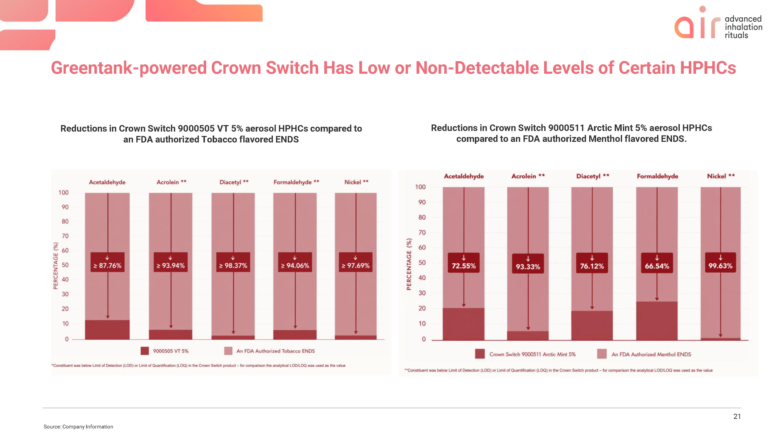
Air advanced inhalation rituals Greentank-powered Crown Switch Has Low or Non-Detectable Levels of Certain HPHCs Reductions in Crown Switch 9000505 VT 5% aerosol HPHCs compared to an FDA authorized Tobacco flavored ENDS Acetaldehyde Acrolein ** Diacetyl ** Formaldehyde ** Nickel ** percentage (%) 100 90 80 70 60 50 40 30 20 10 0 >= 87.76% >= 93.94% 98.37% >=94.06% >= 97.69% 9000505 VT 5% An FDA authorized Tobacco ENDS **Constituent was below Limit of Detection (LOD) or Limit of Qualification (LOQ) in the Crown Switch product – for comparison the analytical LOD/LOQ was used as the value Reductions in Crown Switch 9000511 Arctic Mint 5% aerosol HPHCs compared to an FDA authorized Menthol flavored ENDS. Acetaldehyde Acrolein ** Diacetyl ** Formaldehyde Nickel ** percentage (%) 100 90 80 70 60 50 40 30 20 10 0 72.55% 93.33% 76.12% 66.54% 99.63% Crown Switch 9000511 Arctic Mint 5% An FDA authorized Menthol ENDS **Constituent was below Limit of Detection (LOD) or Limit of Qualification (LOQ) in the Crown Switch product – for comparison the analytical LOD/LOQ was used as the value Source; Company Information 21


Air advanced inhalation rituals Glossary & Appendix

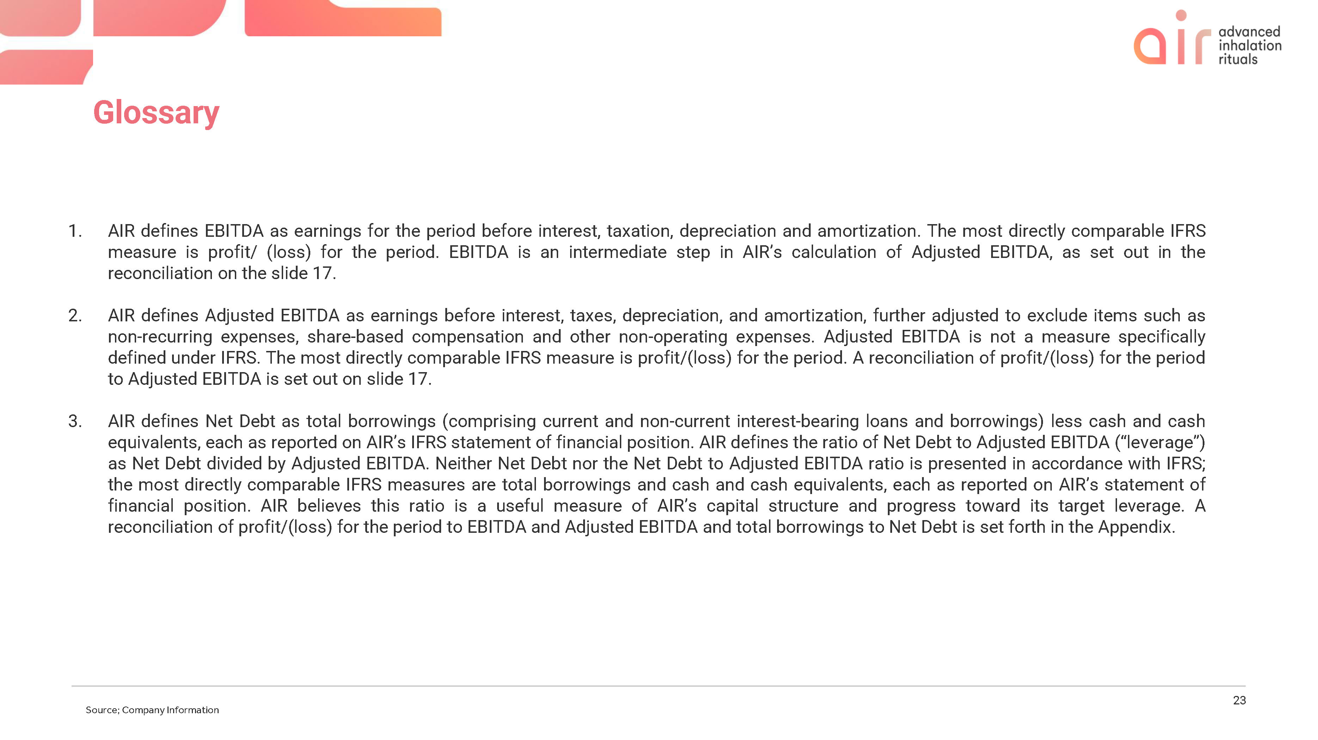
Air advanced inhalation rituals Glossary 1. AIR defines EBITDA as earnings for the period before interest, taxation, depreciation and amortization. The most directly comparable IFRS measure is profit/ (loss) for the period. EBITDA is an intermediate step in AIR’s calculation of Adjusted EBITDA, as set out in the reconciliation on the slide 17. 2. AIR defines Adjusted EBITDA as earnings before interest, taxes, depreciation, and amortization, further adjusted to exclude items such as non-recurring expenses, share-based compensation and other non-operating expenses. Adjusted EBITDA is not a measure specifically defined under IFRS. The most directly comparable IFRS measure is profit/(loss) for the period. A reconciliation of profit/(loss) for the period to Adjusted EBITDA is set out on slide 17. 3. AIR defines Net Debt as total borrowings (comprising current and non-current interest-bearing loans and borrowings) less cash and cash equivalents, each as reported on AIR’s IFRS statement of financial position. AIR defines the ratio of Net Debt to Adjusted EBITDA (“leverage”) as Net Debt divided by Adjusted EBITDA. Neither Net Debt nor the Net Debt to Adjusted EBITDA ratio is presented in accordance with IFRS; the most directly comparable IFRS measures are total borrowings and cash and cash equivalents, each as reported on AIR’s statement of financial position. AIR believes this ratio is a useful measure of AIR’s capital structure and progress toward its target leverage. A reconciliation of profit/(loss) for the period to EBITDA and Adjusted EBITDA and total borrowings to Net Debt is set forth in the Appendix. Source; Company Information 23

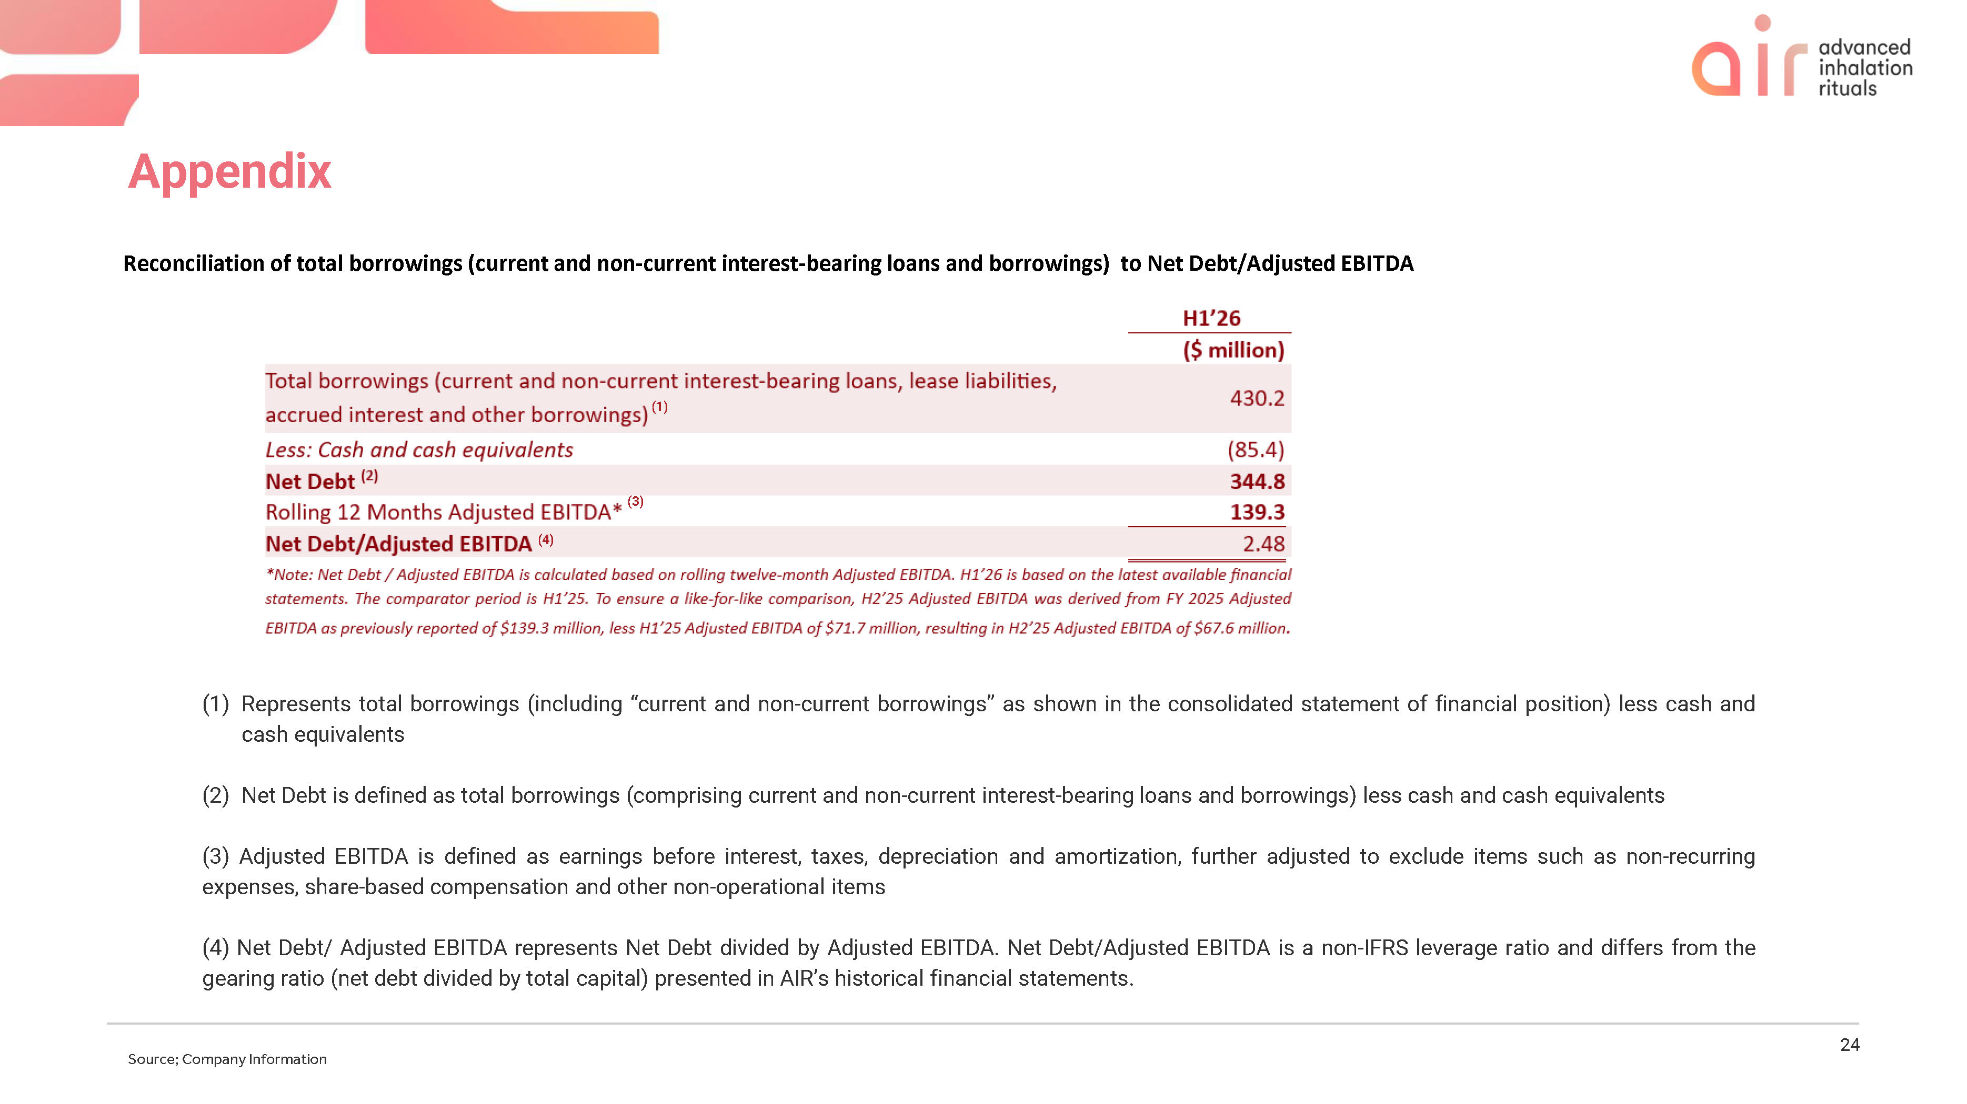
Air advanced inhalation rituals Appendix Reconciliation of total borrowings (current and non-current interest-bearing loans and borrowings) to Net Debt/Adjusted EBITDA H1’26 ($ million) Total borrowings (current and non-current interest-bearing loans, lease liabilities, accrued interest and other borrowings) (1) 430.2 Less: Cash and cash equivalents (85.4) Net Debt (2) 344.8 Rolling 12 Months Adjusted EBITDA* (3) 139.3 Net Debt/Adjusted EBITDA (4) 2.48 *Note: Net Debt / Adjusted EBITDA is calculated based on rolling twelve-month Adjusted EBITDA. H1’26 is based on the latest available financial statements. The comparator period is H1’25. To ensure a like-for-like comparison, H2’25 Adjusted EBITDA was derived from FY 2025 Adjusted EBITDA as previously reported of $139.3 million, less H1’25 Adjusted EBITDA of $71.7 million, resulting in H2’25 Adjusted EBITDA of $67.6 million. (1) Represents total borrowings (including “current and non-current borrowings” as shown in the consolidated statement of financial position) less cash and cash equivalents (2) Net Debt is defined as total borrowings (comprising current and non-current interest-bearing loans and borrowings) less cash and cash equivalents (3) Adjusted EBITDA is defined as earnings before interest, taxes, depreciation and amortization, further adjusted to exclude items such as non-recurring expenses, share-based compensation and other non-operational items (4) Net Debt/ Adjusted EBITDA represents Net Debt divided by Adjusted EBITDA. Net Debt/Adjusted EBITDA is a non-IFRS leverage ratio and differs from the gearing ratio (net debt divided by total capital) presented in AIR’s historical financial statements. Source; Company Information 24

Air advanced inhalation rituals 2026 First Half Results August 20, 2026

Exhibit 99.3

AIR GLOBAL PLC.

Shareholder Let

Shareholder Letter

AIR Global PLC is a unique company with no direct comparable in its Flavored Shisha Molasses (“FSM”) business. The purpose of this shareholder letter, and the ones that will follow each quarter, is to help investors better understand the company and its category and give an insight into the business and culture of AIR.
This shareholder letter is structured in a Q&A format to address the key questions that investors might have regarding our results.

Question 1: Consumers globally and particularly in the US have been under a lot of stress due to inflation pressures – as highlighted by many consumer exposed companies that have reported recently. What have you seen amongst your consumers?
Flavored shisha molasses trends have remained remarkably stable over time under varied macroeconomic conditions and H1’26 was no different. In our biggest market by revenue, which is the US, we expect FY26 revenue growth to accelerate to high single digits, driven by a stable market, our market share gains, and new product innovations such as Snoop Dogg that is premiumizing our US business.

Question 2: What gives you confidence that H2’26 will see accelerating growth, considering the first half of 2026 saw c9% volume decline?
During the month of March, our shipments were adversely impacted due to the closure of the Strait of Hormuz. However, our purchase orders have remained intact, leading to reduction in inventories at wholesalers. We expect H2’26 volume growth to accelerate as channel inventory normalizes back to historical levels. We have since established several alternative supply routes to bypass the Strait in case of future disruptions.

Question 3: Price-mix was very strong at 14.0% in H1’26. Is it normal for AIR to have delivered such strong price-mix?
Due to the significant cost inflation in our business, we front-loaded 2026 pricing into the first half of 2026, which is why our price-mix was very strong. Due to more difficult pricing comps in H2’26 vs H2’25 as well as adverse geographic mix, our price-mix wouldn’t be as strong in H2’26. But, in any normal year, investors should expect our FSM business to deliver 4-6%+ price-mix benefit due to our leadership position in the FSM category, stable volume share, and new product innovations.
Question 4: What have you seen in terms of cannibalization from NGCs like heated tobacco, e-cigs and nicotine pouches on FSM?
In the US, Al Fakher shipments have grown at a 1% volume CAGR between 2018 and 2025 despite significant pricing, well ahead of all other traditional tobacco categories such as cigarettes and traditional moist snuff (-8% CAGR each), in a period which has exhibited strong growth in nicotine vapes (3x) and pouches (40x) volume. So, we believe any cannibalization impact of next generation products on FSM has been quite limited so far.
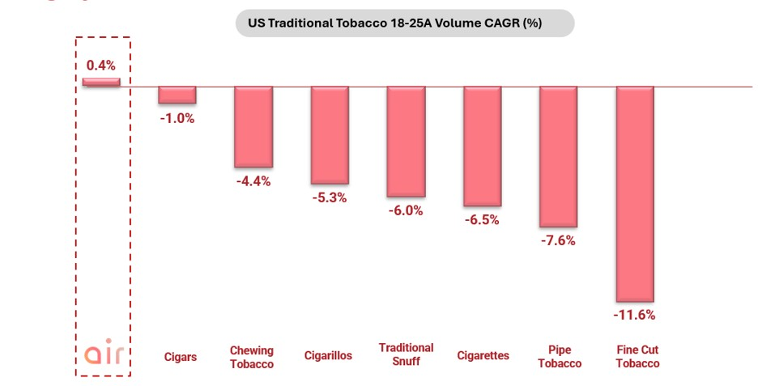
Source: Company Information, Barclays Research for other tobacco categories

Question 5: Saudi Arabia had seen a steep decline in 2025 revenue. What is the trajectory in 2026?
In 2025, our revenue in Saudi Arabia declined primarily due to change in distribution model in early 2024 that led to inventory movements that benefitted 2024 which then unwound in 2025 and overall market decline. We launched our value-for-money brand Al Aseel in the latter half of 2025, which has gained share steadily and also helped our premium brand Al Fakher compete more effectively against discount competitors. Due to this and easier 2025 comparators due to last year inventory movements, we expect strong growth in Saudi Arabia in 2026.

Question 6: Can you tell us more about the Greentank investment and your nicotine vape plans?
We believe we are still in the early days of the transition of tobacco industry to NGCs - of the 1 billion smokers in the world, less than 150 million have transitioned to NGC’s. There exist several challenges with existing vapes that reduce their appeal to smokers. Greentank’s innovative Quantum Chip atomization platform delivers a cleaner, more enjoyable inhalation experience, with substantially lower levels of several harmful and potentially harmful constituents (HPHCs) vs other leading vapes that have received PMTA authorization from the FDA.
As part of the transaction, AIR will gain the right to nominate a director to Greentank’s board, along with enhanced commercial terms, access to new technologies and long-term supply assurances. We are preparing to file our PMTA for our pod based vape Crown Switch later this year and will launch Crown Switch in the US once the FDA accepts our application.
Question 7:
The first half of 2026 has a lot of one-off items. Is AIR going to be one of those companies that have a significant difference between adjusted and reported numbers?
As a Nasdaq-listed company, AIR is required to follow the strict requirements of the PCAOB in the production of its financial statements, as well as the strict requirements of the SEC in respect of any non-IFRS financial measures AIR publishes. In keeping with the foregoing, AIR intends to report earnings of the highest quality where our adjusted numbers are a true reflection of our underlying earnings and free cash flow on an organic basis.
AIR completed its listing on the Nasdaq on May 18, 2026. The expenses associated with the listing are cumulatively $103 million, are non-recurring, and a large part of the adjusting items. The key adjusting items in H1’26 are:
•
$48.2 million expense mainly related to the 4.2 million shares issued to the SPAC sponsor at the time of listing (of which 2.7 million shares are vested and 1.5 million are unvested and subject to price-based earn-out provisions). The impact of these earnout shares is already included in our issued share count.
•
$47.7 million of IPO-related cash costs;
•
$12.4 million stock-based compensation, which is non-cash;
•
$7.4 million of other public company readiness costs;
•
$3.8 million of supply chain-related costs resulting from the Strait of Hormuz disruption;
•
$2 million costs due to the acceleration of PMTA filings in the US due to changed FDA enforcement guidance on nicotine vapes and pouches. We expect PMTA costs to step down materially in FY’27, so adjusting them out is a more accurate reflection of underlying growth.
•
Intangible amortization of $7.1 million – this is partly linked to past acquisitions, where cash has already largely been paid out.

Forward-Looking Statements
This press release contains forward-looking statements within the meaning of the U.S. Private Securities Litigation Reform Act of 1995 that relate to our current expectations and views of future events. We intend such forward-looking statements to be covered by the safe harbor provisions for forward-looking statements as contained in Section 27A of the Securities Act and Section 21E of the Exchange Act. AIR Global PLC is the public operating company that resulted from the business combination of AIR Limited with a special purpose acquisition company, which completed in May 2026, and is accordingly not a “blank check company” for purposes of these safe harbor provisions.

Any express or implied statements contained in this press release that are not statements of historical fact may be deemed to be forward-looking statements, including, without limitation, statements regarding our future results of operations and financial position as well as our FY2026 and FY2027 financial outlook and medium-term guidance, expected recovery in shipment volumes and accelerating growth in 2H26, our Greentank investment and the related option to increase our ownership stake, the timing of PMTA filings and FDA acceptance and the anticipated launch of Crown Switch, our expectations regarding cannibalization and next generation categories, our share count and the vesting of Earnout Shares, business strategy and plans and objectives of management for future operations, as well as statements that include the words “expect,” “intend,” “plan,” “believe,” “project,” “forecast,” “estimate,” “may,” “should,” “anticipate,” “will,” “aim,” “potential,” “continue,” “are likely to” and similar statements of a future or forward-looking nature.

Forward-looking statements are neither promises nor guarantees, but involve known and unknown risks and uncertainties that could cause actual results to differ materially from those projected, including, without limitation: disruptions to our supply chain and shipments, including as a result of the closure or disruption of the Strait of Hormuz; our dependence on distributors and suppliers; competition and cannibalization from next generation categories; our ability to obtain FDA acceptance and authorization of our PMTA applications on the timelines we expect, or at all; regulatory changes and enforcement trends in the tobacco and nicotine industries; the results of scientific studies and their acceptance by regulatory authorities; the preliminary nature of the McKinney pilot study data, which is subject to further testing and verification and may change materially as additional data becomes available; the potential exercise of warrants to increase our ownership in Greentank; our ability to execute our product development and commercialization strategy, including our U.S. market expansion strategy; excise tax increases and illicit trade in our European markets; changes in consumer preferences; fluctuations in foreign currency exchange rates; dilution from our Earnout Shares and other equity arrangements; tariffs and trade policy changes; changes in applicable laws or regulations; general economic conditions; our ability to realize the anticipated benefits of the Greentank investment; tax, legal and accounting developments; our history of previously identified material weaknesses in internal control over financial reporting; and the other important factors discussed under the caption “Risk Factors” in our Registration Statement on Form F-4, as amended, filed with the U.S. Securities and Exchange Commission (“SEC”), as such factors may be updated from time to time in our other filings with the SEC, including our Reports on Form 6-K. Any forward-looking statements contained in this press release speak only as of the date hereof and accordingly undue reliance should not be placed on such statements. We disclaim any obligation or undertaking to update or revise any forward-looking statements contained in this press release, whether as a result of new information, future events or otherwise, other than to the extent required by applicable law.

Use of Non-IFRS Financial Measures

This press release includes EBITDA, Adjusted EBITDA, Net Debt and the ratio of Net Debt to Adjusted EBITDA, each of which is a financial measure not presented in accordance with the International Financial Reporting Standards as issued by the International Accounting Standards Board (“IFRS”) and may be different from similarly titled measures used by other companies.

AIR defines EBITDA as earnings for the period before interest, taxation, depreciation and amortization. The most directly comparable IFRS measure is profit/(loss) for the period. EBITDA is an intermediate step in AIR’s calculation of Adjusted EBITDA, as set out in the reconciliation in Appendix D.

AIR defines Adjusted EBITDA as earnings before interest, taxes, depreciation, and amortization, further adjusted to exclude items such as non-recurring expenses, share-based compensation and other non-operating expenses. The most directly comparable IFRS measure is profit/(loss) for the period. AIR believes that Adjusted EBITDA is a useful measure as it allows investors and management to evaluate AIR’s operating performance on a consistent basis, excluding the impact of non-operational, non-cash, or one-time items that may obscure underlying trends, and facilitate comparison across periods and with peer companies. Adjusted EBITDA is not a presentation made in accordance with IFRS, and AIR’s use of the term may vary from its use by other companies. You should exercise caution in comparing AIR’s Adjusted EBITDA to similarly titled measures reported by other companies and should not consider it in isolation or as a substitute for analysis of AIR’s results as reported under IFRS.

Some of these limitations include that Adjusted EBITDA does not reflect cash expenditures or future requirements for capital investments or contractual commitments; does not reflect changes in, or cash requirements for, working capital needs; does not reflect interest expense or the cash requirements necessary to service interest or principal payments on debt; does not reflect any cash income taxes AIR may be required to pay; and, although depreciation and amortization are non-cash charges, the assets being depreciated and amortized will often need to be replaced in the future, which Adjusted EBITDA does not reflect. In addition, other companies in AIR’s industry may calculate this measure differently, limiting its usefulness as a comparative measure, and the adjustments made in calculating Adjusted EBITDA are those that management considers not representative of AIR’s core operations and are therefore subjective in nature. A reconciliation of profit/(loss) for the period to EBITDA and Adjusted EBITDA is set forth in Appendix D.

AIR defines Net Debt as total borrowings (comprising current and non-current interest-bearing loans and borrowings) less cash and cash equivalents, each as reported on AIR’s IFRS statement of financial position. AIR defines the ratio of Net Debt to Adjusted EBITDA (“leverage”) as Net Debt divided by Adjusted EBITDA. Neither Net Debt nor the Net Debt to Adjusted EBITDA ratio is presented in accordance with IFRS; the most directly comparable IFRS measures are total borrowings and cash and cash equivalents, each as reported on AIR’s statement of financial position. AIR believes this ratio is a useful measure of AIR’s capital structure and progress toward its target leverage. A reconciliation of total borrowings to Net Debt is set forth in Appendix D.

No Offer or Solicitation

This press release is for informational purposes only and does not constitute (and shall not be construed as) an offer to sell or the solicitation of an offer to buy any securities of AIR, nor shall there be any sale of securities in any state or jurisdiction in which such offer, solicitation, or sale would be unlawful prior to registration or qualification under the securities laws of any such state or jurisdiction.
Contacts
AIR Investor Relations: Gaurav Jain: Gaurav.jain@air.global; +971-56-439-4296
Anuja Shendye: a.shendye@air.global; +971-58-907-8782
investor@air.global
Follow AIR Global on X.
AIR Media Relations:
ICR for AIR
For more information, email inquiries to AIRglobal@icrinc.com

Exhibit 99.4

AIR Global PLC
Unaudited interim condensed consolidated financial statements

For the six-month period ended 30 June 2026

AIR Global PLC

Unaudited interim condensed consolidated financial statements
For the six-month period ended 30 June 2026

Contents | Pages
Unaudited interim condensed consolidated statement of financial position | 3
Unaudited interim condensed consolidated statement of comprehensive (loss) / income | 4
Unaudited interim condensed consolidated statement of changes in equity | 5
Unaudited interim condensed consolidated statement of cash flows | 7 -8
Notes to the unaudited interim condensed consolidated financial statements | 9 - 32

AIR Global PLC

Unaudited interim condensed consolidated statement of financial position

 |  |  |  | As at
 |  |  |  | 30 June |  |  |  | 31 December
 |  |  |  | 2026 |  |  |  | 2025
 |  | Note |  | $000 |  |  |  | $000
ASSETS
Non-current assets
Property, plant and equipment |  |  |  |  | 26,692 |  |  |  | 28,410
Right-of-use assets |  | 4 |  |  | 14,354 |  |  |  | 11,663
Intangible assets |  | 7 |  |  | 367,336 |  |  |  | 371,277
Trade and other receivables |  | 6 |  |  | 148 |  |  |  | 293
Investments in joint ventures |  |  |  |  | 2,015 |  |  |  | 2,255
Financial asset at FVOCI |  | 18 |  |  | 8,524 |  |  |  | —
Derivative financial instruments |  | 10, 18 |  |  | 2,646 |  |  |  | —
Deferred tax assets |  | 5 |  |  | 43,763 |  |  |  | 41,071
 |  |  |  |  | 465,478 |  |  |  | 454,969
Current assets
Inventories |  |  |  |  | 61,622 |  |  |  | 55,331
Trade and other receivables |  |  |  |  | 127,809 |  |  |  | 93,160
Restricted deposit |  | 13 |  |  | 18,200 |  |  |  | —
Advance tax |  |  |  |  | 430 |  |  |  | 274
Derivative financial instruments |  | 10 |  |  | 185 |  |  |  | —
Cash and cash equivalents |  |  |  |  | 85,411 |  |  |  | 119,456
 |  |  |  |  | 293,657 |  |  |  | 268,221
Total assets |  |  |  |  | 759,135 |  |  |  | 723,190
LIABILITIES
Non-current liabilities
Derivative financial instruments |  | 10 |  |  | — |  |  |  | 1,216
Other interest-bearing loans and borrowings |  | 8 |  |  | 338,525 |  |  |  | 357,679
Lease liabilities |  | 4 |  |  | 12,782 |  |  |  | 9,935
Employee benefits |  |  |  |  | 6,660 |  |  |  | 6,542
Deferred tax liabilities |  | 5 |  |  | 635 |  |  |  | 436
 |  |  |  |  | 358,602 |  |  |  | 375,808
Current liabilities
Other interest-bearing loans and borrowings |  | 8 |  |  | 67,338 |  |  |  | 29,852
Derivative financial instruments |  | 10, 18 |  |  | 339 |  |  |  | 558
Employee benefits |  |  |  |  | 1,344 |  |  |  | 1,320
Lease liabilities |  | 4 |  |  | 3,445 |  |  |  | 3,348
Trade and other payables |  |  |  |  | 127,033 |  |  |  | 99,121
Tax payable |  |  |  |  | 6,446 |  |  |  | 2,053
Payables relating to acquisitions |  |  |  |  | 1,760 |  |  |  | 1,760
 |  |  |  |  | 207,705 |  |  |  | 138,012
Total liabilities |  |  |  |  | 566,307 |  |  |  | 513,820
Net assets |  |  |  |  | 192,828 |  |  |  | 209,370
EQUITY
Capital and reserves
Share capital |  |  |  |  | 16 |  |  |  | 968,768
Treasury shares |  | 17 |  |  | (52,444 | ) |  |  | —
Share premium |  |  |  |  | 1,070,138 |  |  |  | 39,834
Merger reserve |  |  |  |  | (1,100,361 | ) |  |  | (1,100,361 | )
Cash flow hedge reserve |  |  |  |  | 1,367 |  |  |  | (1,614 | )
Translation reserve |  |  |  |  | 6,326 |  |  |  | 9,194
Other reserve |  |  |  |  | 42,658 |  |  |  | 31,101
Retained earnings |  |  |  |  | 225,128 |  |  |  | 262,448
Net equity |  |  |  |  | 192,828 |  |  |  | 209,370

The notes on pages 9 to 32 form an integral part of these unaudited interim condensed consolidated financial statements. | (3)

AIR Global PLC

Unaudited interim condensed consolidated statement of comprehensive (loss) / income

 |  |  |  | Three-month period  ended 30 June |  |  |  |  |  |  |  | Six-month period  ended 30 June
 |  |  |  | 2026 |  |  |  | 2025 |  |  |  | 2026 |  |  |  | 2025
 |  | Note |  | $000 |  |  |  | $000 |  |  |  | $000 |  |  |  | $000
Revenue |  | 2 |  |  | 135,690 |  |  |  | 109,891 |  |  |  | 206,898 |  |  |  | 199,467
Cost of sales |  |  |  |  | (58,917 | ) |  |  | (51,950 | ) |  |  | (90,134 | ) |  |  | (85,465 | )
Gross profit |  |  |  |  | 76,773 |  |  |  | 57,941 |  |  |  | 116,764 |  |  |  | 114,002
Distribution expenses |  |  |  |  | (11,615 | ) |  |  | (10,370 | ) |  |  | (23,504 | ) |  |  | (23,719 | )
General and administrative expenses |  |  |  |  | (38,185 | ) |  |  | (19,341 | ) |  |  | (67,073 | ) |  |  | (38,082 | )
Provision for expected credit losses on trade receivables |  |  |  |  | (632 | ) |  |  | (1,373 | ) |  |  | (991 | ) |  |  | (1,036 | )
Other operating (losses) / gains* |  |  |  |  | (89,357 | ) |  |  | 193 |  |  |  | (88,792 | ) |  |  | 373
Operating (loss) / profit |  |  |  |  | (63,016 | ) |  |  | 27,050 |  |  |  | (63,596 | ) |  |  | 51,538
Share of net loss of investments accounted for using the  equity method |  |  |  |  | (118 | ) |  |  | (181 | ) |  |  | (240 | ) |  |  | (329 | )
Changes in fair value of derivative financial instruments |  | 18 |  |  | (283 | ) |  |  | — |  |  |  | (283 | ) |  |  | —
Finance income |  |  |  |  | 85 |  |  |  | 5,277 |  |  |  | 547 |  |  |  | 7,811
Finance costs |  |  |  |  | (8,149 | ) |  |  | (8,067 | ) |  |  | (14,416 | ) |  |  | (21,616 | )
(Loss) / profit before taxation |  |  |  |  | (71,481 | ) |  |  | 24,079 |  |  |  | (77,988 | ) |  |  | 37,404
Taxation |  |  |  |  | (3,247 | ) |  |  | (2,965 | ) |  |  | (3,832 | ) |  |  | (5,431 | )
(Loss) / profit for the period |  |  |  |  | (74,728 | ) |  |  | 21,114 |  |  |  | (81,820 | ) |  |  | 31,973
Other comprehensive (loss) / income
Items that may be reclassified to profit or loss:
Foreign currency translation differences – foreign  operations |  |  |  |  | 144 |  |  |  | (306 | ) |  |  | (2,868 | ) |  |  | (454 | )
Changes in fair value of cash flow hedges |  |  |  |  | 1,115 |  |  |  | — |  |  |  | 2,771 |  |  |  | —
Amounts reclassified to profit or loss from cash  flow hedges |  |  |  |  | 71 |  |  |  | (627 | ) |  |  | 210 |  |  |  | (627 | )
Items that will not be reclassified to profit or loss:
Changes in fair value of financial asset at FVOCI |  | 18 |  |  | (35 | ) |  |  | — |  |  |  | (35 | ) |  |  | —
Other comprehensive income / (loss) for the period, net  of income tax |  |  |  |  | 1,295 |  |  |  | (933 | ) |  |  | 78 |  |  |  | (1,081 | )
Total comprehensive (loss) / income for the period |  |  |  |  | (73,433 | ) |  |  | 20,181 |  |  |  | (81,742 | ) |  |  | 30,892
Earnings per share for profit attributable to the
ordinary equity holders of the Company:
Basic (loss) / earnings per share |  | 16 |  |  | (0.511 | ) |  |  | 0.147 |  |  |  | (0.565 | ) |  |  | 0.223
Diluted (loss) / earnings per share |  | 16 |  |  | (0.511 | ) |  |  | 0.147 |  |  |  | (0.565 | ) |  |  | 0.223

* included in other operating (losses) / gains for three-month period ended and six-month period ended 30 June 2026 are expenses relating to BCA transaction amounting to $89,446 (Note 17).

The notes on pages 9 to 32 form an integral part of these unaudited interim condensed consolidated financial statements. | (4)

AIR Global PLC

Unaudited interim condensed consolidated statement of changes in equity

 |  | Share  capital |  |  |  | Share  premium |  |  |  | Treasury  shares |  |  |  | Merger  reserve |  |  |  | Cash flow  hedge reserve |  |  |  | Translation  reserve |  |  |  | Other  reserve |  |  |  | Retained  earnings |  |  |  | Net  equity
 |  | $000 |  |  |  | $000 |  |  |  | $000 |  |  |  | $000 |  |  |  | $000 |  |  |  | $000 |  |  |  | $000 |  |  |  | $000 |  |  |  | $000
Balance at 1 January 2026 |  |  | 968,768 |  |  |  | 39,834 |  |  |  | — |  |  |  | (1,100,361 | ) |  |  | (1,614 | ) |  |  | 9,194 |  |  |  | 31,101 |  |  |  | 262,448 |  |  |  | 209,370
Total comprehensive (loss) /
income for the period
Loss for the period |  |  | — |  |  |  | — |  |  |  | — |  |  |  | — |  |  |  | — |  |  |  | — |  |  |  | — |  |  |  | (81,820 | ) |  |  | (81,820 | )
Other comprehensive (loss) /
income:
Net profit on cash flow hedges -  net of tax |  |  | — |  |  |  | — |  |  |  | — |  |  |  | — |  |  |  | 2,771 |  |  |  | — |  |  |  | — |  |  |  | — |  |  |  | 2,771
Changes in fair value of financial  asset at FVOCI (Note 18) |  |  | — |  |  |  | — |  |  |  | — |  |  |  | — |  |  |  | — |  |  |  | — |  |  |  | — |  |  |  | (35 | ) |  |  | (35 | )
Amounts reclassified to profit or  loss from cashflow hedges |  |  | — |  |  |  | — |  |  |  | — |  |  |  | — |  |  |  | 210 |  |  |  | — |  |  |  | — |  |  |  | — |  |  |  | 210
Foreign exchange translation  difference – foreign operations |  |  | — |  |  |  | — |  |  |  | — |  |  |  | — |  |  |  | — |  |  |  | (2,868 | ) |  |  | — |  |  |  | — |  |  |  | (2,868 | )
Total comprehensive (loss) /  income for the period |  |  | — |  |  |  | — |  |  |  | — |  |  |  | — |  |  |  | 2,981 |  |  |  | (2,868 | ) |  |  | — |  |  |  | (81,855 | ) |  |  | (81,742 | )
Transactions with shareholders
Equity-settled share-based  payments (Note 9) |  |  | — |  |  |  | — |  |  |  | — |  |  |  | — |  |  |  | — |  |  |  | — |  |  |  | 14,709 |  |  |  | — |  |  |  | 14,709
Cancellation of forfeitable shares  (Note 15) |  |  | (4,711 | ) |  |  | (2,900 | ) |  |  | — |  |  |  | — |  |  |  | — |  |  |  | — |  |  |  | 2,610 |  |  |  | 5,001 |  |  |  | —
Share based awards vested in the  period |  |  | 3,162 |  |  |  | 2,600 |  |  |  | — |  |  |  | — |  |  |  | — |  |  |  | — |  |  |  | (5,762 | ) |  |  | — |  |  |  | —
Reorganization transaction  (Note 17) |  |  | (967,203 | ) |  |  | 1,030,604 |  |  |  | — |  |  |  | — |  |  |  | — |  |  |  | — |  |  |  | — |  |  |  | 39,534 |  |  |  | 102,935
Treasury shares arising from  forward purchase agreement  (Note 17) |  |  | — |  |  |  | — |  |  |  | (52,444 | ) |  |  | — |  |  |  | — |  |  |  | — |  |  |  | — |  |  |  | — |  |  |  | (52,444 | )
Balance at 30 June 2026 |  |  | 16 |  |  |  | 1,070,138 |  |  |  | (52,444 | ) |  |  | (1,100,361 | ) |  |  | 1,367 |  |  |  | 6,326 |  |  |  | 42,658 |  |  |  | 225,128 |  |  |  | 192,828

The notes on pages 9 to 32 form an integral part of these unaudited interim condensed consolidated financial statements. | (5)

AIR Global PLC

Unaudited interim condensed consolidated statement of changes in equity

 |  | Share  capital |  |  |  | Share  premium |  |  |  | Merger  reserve |  |  |  | Cash flow  hedge reserve |  |  |  | Translation  reserve |  |  |  | Other  reserve |  |  |  | Retained  earnings |  |  |  | Net  equity
 |  | $000 |  |  |  | $000 |  |  |  | $000 |  |  |  | $000 |  |  |  | $000 |  |  |  | $000 |  |  |  | $000 |  |  |  | $000
Balance at 1 January 2025 |  |  | 966,563 |  |  |  | 37,593 |  |  |  | (1,100,361 | ) |  |  | — |  |  |  | 8,976 |  |  |  | 22,489 |  |  |  | 217,019 |  |  |  | 152,279
Total comprehensive income for the
period
Profit for the period |  |  | — |  |  |  | — |  |  |  | — |  |  |  | — |  |  |  | — |  |  |  | — |  |  |  | 31,973 |  |  |  | 31,973
Other comprehensive (loss) / income:
Net profit on cash flow hedges - net of tax |  |  | — |  |  |  | — |  |  |  | — |  |  |  | (893 | ) |  |  | — |  |  |  | — |  |  |  | — |  |  |  | (893 | )
Amounts reclassified to profit or loss from  cashflow hedges |  |  | — |  |  |  | — |  |  |  | — |  |  |  | 266 |  |  |  | — |  |  |  | — |  |  |  | — |  |  |  | 266
Foreign exchange translation difference –  foreign operations |  |  | — |  |  |  | — |  |  |  | — |  |  |  | — |  |  |  | (454 | ) |  |  | — |  |  |  | — |  |  |  | (454 | )
Total comprehensive income for the  period |  |  | — |  |  |  | — |  |  |  | — |  |  |  | (627 | ) |  |  | (454 | ) |  |  | — |  |  |  | 31,973 |  |  |  | 30,892
Transactions with shareholders
Equity-settled share-based payments  (Note 9) |  |  | — |  |  |  | — |  |  |  | — |  |  |  | — |  |  |  | — |  |  |  | 2,522 |  |  |  | — |  |  |  | 2,522
Share based awards vested in the period |  |  | 164 |  |  |  | 137 |  |  |  | — |  |  |  | — |  |  |  | — |  |  |  | (301 | ) |  |  | — |  |  |  | —
Shares bought back from shareholders |  |  | (164 | ) |  |  | (158 | ) |  |  | — |  |  |  | — |  |  |  | — |  |  |  | — |  |  |  | — |  |  |  | (322 | )
Shares issued in respect of acquisitions |  |  | 461 |  |  |  | 445 |  |  |  | — |  |  |  | — |  |  |  | — |  |  |  | — |  |  |  | — |  |  |  | 906
Balance at 30 June 2025 |  |  | 967,024 |  |  |  | 38,017 |  |  |  | (1,100,361 | ) |  |  | (627 | ) |  |  | 8,522 |  |  |  | 24,710 |  |  |  | 248,992 |  |  |  | 186,277

The notes on pages 9 to 32 form an integral part of these unaudited interim condensed consolidated financial statements. | (6)

AIR Global PLC

Unaudited interim condensed consolidated statement of cash flows

Six-month period
ended 30 June
 |  |  |  | 2026 |  |  |  | 2025
 |  |  |  | $000 |  |  |  | $000
Cash flows from operating activities
(Loss) / profit for the period |  |  |  |  | (81,820 | ) |  |  | 31,973
Adjustments for:
Depreciation and amortisation |  |  |  |  | 11,502 |  |  |  | 9,499
Income tax expense |  |  |  |  | 3,832 |  |  |  | 5,431
Finance income |  |  |  |  | (240 | ) |  |  | (107 | )
Finance costs |  |  |  |  | 14,416 |  |  |  | 21,616
Gain on write off of payables for acquisitions |  |  |  |  | — |  |  |  | (140 | )
Gain on derecognition of right of use asset |  |  |  |  | — |  |  |  | (49 | )
Gain on disposal of property, plant and equipment |  |  |  |  | — |  |  |  | (77 | )
Expenses related to reorganization transaction |  |  |  |  | 95,885 |  |  |  | —
Loss on write-off of intangible assets |  |  |  |  | 675 |  |  |  | —
(Reversal of) / provision for slow moving items |  |  |  |  | (2,507 | ) |  |  | 6,635
Provision for expected credit losses on trade receivables |  |  |  |  | 991 |  |  |  | 1,036
Share of net loss of investments accounted for using the equity method |  |  |  |  | 240 |  |  |  | 329
Changes in fair value of derivative financial instruments |  |  |  |  | 283 |  |  |  | —
Equity settled share-based payments |  |  |  |  | 14,209 |  |  |  | 2,522
Exchange gain / (loss) – net |  |  |  |  | (1,661 | ) |  |  | (4,405 | )
Current service costs |  |  |  |  | 1,048 |  |  |  | 1,613
 |  |  |  |  | 56,853 |  |  |  | 75,876
Changes in working capital:
Increase in trade and other receivables |  |  |  |  | (58,832 | ) |  |  | (36,862 | )
Increase in inventories |  |  |  |  | (3,758 | ) |  |  | (12,614 | )
Increase / (decrease) in trade and other payables* |  |  |  |  | 9,111 |  |  |  | (9,984 | )
Operating cash flows before payments for employee benefits and  payments for income tax |  |  |  |  | 3,374 |  |  |  | 16,416
Income tax paid |  |  |  |  | (2,575 | ) |  |  | (6,511 | )
Employee benefits paid |  |  |  |  | (906 | ) |  |  | (896 | )
Cash (used in) / generated from operating activities |  |  |  |  | (107 | ) |  |  | 9,009

*Excluding accruals for expenses related to financing activity of reorganization transactions of $18,801 at 30 June 2026 (2025: nil).

The notes on pages 9 to 32 form an integral part of these unaudited interim condensed consolidated financial statements. | (7)

AIR Global PLC

Unaudited interim condensed consolidated statement of cash flows (continued)

Six-month period
ended 30 June
 |  |  |  | 2026 |  |  |  | 2025
 |  |  |  | $000 |  |  |  | $000
Cash flows from investing activities
Proceeds from sale of property, plant and equipment |  |  |  |  | 67 |  |  |  | 119
Payment made for acquisition of shares in joint venture |  |  |  |  | — |  |  |  | (155 | )
Acquisition of property, plant and equipment |  |  |  |  | (1,117 | ) |  |  | (1,509 | )
Acquisition of intangible assets |  |  |  |  | (4,162 | ) |  |  | (7,775 | )
Interest received on lease receivables |  |  |  |  | 144 |  |  |  | 93
Interest received |  |  |  |  | 233 |  |  |  | 100
Payment made for acquisitions |  |  |  |  | (5,000 | ) |  |  | (2,500 | )
Net cash used in investing activities |  |  |  |  | (9,835 | ) |  |  | (11,627 | )
Cash flows from financing activities
Interest paid on borrowings |  |  |  |  | (13,386 | ) |  |  | (15,585 | )
Proceeds from loans and borrowings |  |  |  |  | 27,500 |  |  |  | 405,200
Proceeds from interest rate swaps |  |  |  |  | 210 |  |  |  | 266
Repayment of borrowings |  |  |  |  | (10,130 | ) |  |  | (390,750 | )
Cash paid for expenses related to reorganization transactions |  |  |  |  | (28,933 | ) |  |  | —
Cash received related to reorganization transactions |  |  |  |  | 2,340 |  |  |  | —
Transactions with non-controlling interests |  |  |  |  | — |  |  |  | (1,680 | )
Payment of transaction costs related to loans |  |  |  |  | — |  |  |  | (10,375 | )
Employee shared based payments consideration received |  |  |  |  | 500 |  |  |  | —
Cash paid for shares bought back from shareholders |  |  |  |  | — |  |  |  | (322 | )
Interest paid on lease liabilities |  |  |  |  | (507 | ) |  |  | (378 | )
Proceeds from lease incentives |  |  |  |  | 162 |  |  |  | —
Principal payment of lease liabilities |  |  |  |  | (1,859 | ) |  |  | (1,655 | )
Net cash from / (used in) financing activities |  |  |  |  | (24,103 | ) |  |  | (15,279 | )
Net decrease in cash and cash equivalents |  |  |  |  | (34,045 | ) |  |  | (17,897 | )
Cash and cash equivalents at beginning of the period |  |  |  |  | 119,456 |  |  |  | 71,702
Cash and cash equivalents at the end of the period |  |  |  |  | 85,411 |  |  |  | 53,805
Non-cash transactions are as follows:
- Issuance of shares for BCA transactions (including share premium)  (Note 17) |  |  |  |  | 48,150 |  |  |  | —
- Utilization of prepayments for acquisitions of Greentank |  |  |  |  | 5,000 |  |  |  | —
Refer to Note 4 for non-cash transactions pertaining to additions of right-of-use assets, lease liabilities.

The notes on pages 9 to 32 form an integral part of these unaudited interim condensed consolidated financial statements. | (8)

AIR Global PLC
Notes to the unaudited interim condensed consolidated financial statements for the six-month period ended 30 June 2026

1.

General information and accounting policies

1.1.
General Information
AIR Global PLC (“AIR Global” or the “Company”), formerly AIR Holdings Limited, is a publicly traded company domiciled and registered in Jersey. AIR Holdings Limited was incorporated under the Companies (Jersey) Law 1991 (as amended) on 23 October 2025. Following completion of the transaction described below on 15 May 2026, the Company was renamed to AIR Global PLC and its common shares became listed on Nasdaq Stock Market LLC (“Nasdaq”), with the trading ticker AIIR. The registered number of the Company is 162485 and the registered address is 15 Esplanade, St. Helier, JE1 1RB, Jersey.
On 15 May 2026 (the “Closing Date”), AIR Holdings Limited, a, private limited company incorporated under the laws of Jersey (“AIR Holdings”), Cantor Equity Partners III, Inc., a Cayman Islands exempted company (“CAEP”), AIR Limited, a private limited company incorporated under the laws of Jersey (“AIR”), Genesis Cayman Merger Sub Limited, a Cayman Islands exempted company (“Cayman Merger Sub”) incorporated for the sole purpose of effectuating a merger, and Genesis Jersey Merger Sub Limited, a private limited company incorporated under the laws of Jersey (“Jersey Merger Sub”) incorporated for the sole purpose of effectuating a merger, completed the business combination agreement transactions ("BCA transaction”, “reorganization transaction”) pursuant to an agreement entered by the parties on 7 November 2025 (the “Business Combination Agreement”). Following the BCA transaction, the former shareholders of AIR obtained control of the combined company and renamed it to AIR Global PLC.
CAEP did not meet the definition of a “business” in accordance with IFRS 3 – Business Combinations (“IFRS 3”) as issued by the International Accounting Standards Board (“IASB”). As such, the BCA transaction has been accounted for as a capital reorganization where AIR Global PLC is considered a continuation of AIR Limited for financial reporting purposes, with AIR Limited identified as the accounting acquirer. Under this method of accounting, CAEP was treated as the “acquired” company for financial reporting purposes and the BCA transaction was treated as the equivalent of AIR issuing shares in exchange for the net assets of CAEP, accompanied by a recapitalization of AIR. Accordingly, the unaudited interim condensed financial statements represent a continuation of the financial position and results of AIR Limited, and comparative information reflects the historical financial information of AIR Limited. The identifiable assets acquired and liabilities assumed from CAEP were recognized and measured in accordance with the applicable IFRS Accounting Standards. No goodwill or other intangible assets were recognized.
Additional information regarding the BCA transaction is provided in Note 17.
These unaudited interim condensed consolidated financial statements include the accounts of the AIR Global and its subsidiaries (together referred to as the “Group”) for the six-month period ended 30 June 2026 and have been approved by the Board of Directors on 19 August 2026. The Group specializes in the manufacture and distribution of molasses.
1.2.
Basis of preparation
The unaudited interim condensed consolidated financial statements of the Group for the six-month period ended 30 June 2026 have been prepared in accordance with International Accounting Standard (“IAS”) 34 – Interim Financial Reporting as issued by the International Accounting Standards Board (“IASB”).
These unaudited interim condensed consolidated financial statements do not include all information and disclosures required in the annual financial statements and should be read in conjunction with the Group's consolidated financial statements for the year ended 31 December 2025.
1.3.
Basis of measurement
These unaudited interim condensed consolidated financial statements are prepared under the historical cost convention unless otherwise stated in the Group’s consolidated financial statements for the year ended 31 December 2025.

(9)

AIR Global PLC
Notes to the unaudited interim condensed consolidated financial statements for the six-month period ended 30 June 2026

1.4.
Functional and presentation currency
The unaudited interim condensed consolidated financial statements are presented in United States Dollar (“USD”), which is the Group’s presentational currency and the functional currency of the Company and majority of its subsidiaries. All amounts have been rounded to the nearest thousand, unless otherwise indicated.
1.5.
Material accounting policies
The accounting policies adopted in the preparation of the unaudited interim condensed consolidated financial statements are consistent with those followed in the preparation of the Group’s annual consolidated financial statements for the year ended 31 December 2025, adoption of new standards and amendments to the existing standards and interpretations effective as of 1 January 2026, as detailed below:
(a)
New and amended standards adopted by the Group
There are no new standards, amendments and interpretations of IFRS Accounting Standards that are effective that would be expected to have a material impact on the Group.
(b)
New standards and interpretations not yet adopted

In April 2024, the IASB issued IFRS 18, the new standard on presentation and disclosure in financial statements, with a focus on updates to the statement of profit or loss. The key new concepts introduced in IFRS 18 relate to:
•
the structure of the statement of profit or loss;
•
required disclosures in the financial statements for certain profit or loss performance measures that are reported outside an entity’s financial statements (that is, management-defined performance measures); and
•
enhanced principles on aggregation and disaggregation which apply to the primary financial statements and notes in general.
IFRS 18 will replace IAS 1; many of the other existing principles in IAS 1 are retained, with limited changes. IFRS 18 will not impact the recognition or measurement of items in the financial statements, but it might change what an entity reports as its ‘operating profit or loss’. IFRS 18 will apply for reporting periods beginning on or after 1 January 2027 and also applies to comparative information. The Group plans to adopt IFRS 18 on its effective date and is currently in the process of assessing the impact of the adoption.
There are no other new standards, amendments and interpretations of IFRS Accounting Standards that are not yet effective that would be expected to have a material impact on the Group.
1.6.
Significant accounting judgements, estimates and assumptions
The preparation of unaudited interim condensed consolidated financial statements requires management to make judgements, estimates and assumptions that affect the application of accounting policies and reported amounts of assets, liabilities, income and expenses. Actual results may differ from these estimates. Other than the BCA reorganization transaction disclosed in Note 17 and investments in Greentank Innovations Corp. disclosed in Note 18, the significant accounting judgments, estimates and assumptions applied during the preparation of the unaudited interim condensed consolidated financial statements are similar to those that were applied to the consolidated financial statements as at and for the year ended 31 December 2025.

(10)

AIR Global PLC
Notes to the unaudited interim condensed consolidated financial statements for the six-month period ended 30 June 2026

1.7. Going Concern
The unaudited interim condensed consolidated financial statements have been prepared on a going concern basis which the Directors consider to be appropriate for the following reasons:

•
The Group reported a loss for the period ended 30 June 2026 of $81,820, compared with a $31,973 profit in the period ended 30 June 2025, mainly caused by expenses incurred due to BCA transaction and listing process, had negative operating cashflows of $107 (30 June 2025: positive operating cash flows of $9,009), and net current assets of $85,952 as at 30 June 2026 (31 December 2025: net current assets of $130,209).
•
The Directors have prepared forecasts, including profitability, working capital, and cashflow expectations for a period of at least 12 months from the date of these unaudited interim condensed consolidated financial statements, and in addition have also prepared forecasts for the year 2027 which indicates that, taking account of reasonably possible downsides scenarios, the Group and Company will have sufficient funds to meet its liabilities as they fall due.
•
Forecasts have been prepared and consider a range of possible scenarios, including plausible downside scenarios. In such scenarios, the Group will continue to be profitable, cash generative and remain in compliance with all financial covenants over the forecast period. The Directors considered this appropriate, noting the Group’s continued growth, strong cash generation potential and the Group’s new business pipeline, while also remaining cognisant of the residual uncertainty in the macro-economic environment. After careful consideration of these downside scenarios, the Directors are satisfied that the Group’s existing resources are adequate to meet its requirements as they fall due.

Consequently, the Directors are confident that the Group and Company will have sufficient funds to continue to meet its liabilities as they fall due for at least 12 months from the date of approval of the unaudited interim condensed consolidated financial statements and therefore have prepared the unaudited interim condensed consolidated financial statements on a going concern basis.
1.8 Seasonality of operations
Results for the six-month period ended 30 June 2026 are not necessarily indicative of the results that may be expected for the full financial year ending 31 December 2026. The nature of the Group’s business is such that the income and expenditure are incurred in a manner, which is not impacted by any forms of seasonality generally.
1.9. Derivative financial instruments

The Group’s accounting policies are consistent with those disclosed in the consolidated financial statements for the year ended 31 December 2025.

During the period, the Group used currency swaps and foreign exchange forward contracts to manage long term or short-term currency exposures. These instruments are not designated in hedge relationships and are measured at fair value through profit or loss, with changes in fair value recognized in the unaudited interim condensed consolidated statement of comprehensive income.

(11)

AIR Global PLC
Notes to the unaudited interim condensed consolidated financial statements for the six-month period ended 30 June 2026

2.
Revenue
The Group generates revenue primarily from the sale of tobacco molasses and collection of royalty income generated from licensing of its brands for use in related industries. In the following table, revenue is disaggregated by major products / service lines, primary geographical markets and timing of revenue recognition.

 | Three-month period  ended 30 June |  |  |  |  |  |  |  | Six-month period  ended 30 June
 | 2026 |  |  |  | 2025 |  |  |  | 2026 |  |  |  | 2025
 | $000 |  |  |  | $000 |  |  |  | $000 |  |  |  | $000
Major products / service lines
Tobacco and related products |  | 113,455 |  |  |  | 92,737 |  |  |  | 174,993 |  |  |  | 165,563
Royalty from sales of tobacco and related products |  | 18,113 |  |  |  | 16,197 |  |  |  | 26,531 |  |  |  | 31,991
Logistics services |  | 4,122 |  |  |  | 957 |  |  |  | 5,374 |  |  |  | 1,913
 |  | 135,690 |  |  |  | 109,891 |  |  |  | 206,898 |  |  |  | 199,467
Primary geographical markets
MEAA |  | 92,814 |  |  |  | 73,009 |  |  |  | 137,265 |  |  |  | 132,033
Americas |  | 27,197 |  |  |  | 20,299 |  |  |  | 43,125 |  |  |  | 41,771
Europe |  | 15,679 |  |  |  | 16,583 |  |  |  | 26,508 |  |  |  | 25,663
 |  | 135,690 |  |  |  | 109,891 |  |  |  | 206,898 |  |  |  | 199,467
Timing of transfer of goods or services
Tobacco and related products transferred at a point in time |  | 113,455 |  |  |  | 92,737 |  |  |  | 174,993 |  |  |  | 165,563
Royalty income from sales of tobacco and related products  transferred at a point in time |  | 15,113 |  |  |  | 13,697 |  |  |  | 19,531 |  |  |  | 23,991
Royalty income from sales of tobacco and related products  transferred over time |  | 3,000 |  |  |  | 2,500 |  |  |  | 7,000 |  |  |  | 8,000
Logistics services transferred over time |  | 4,122 |  |  |  | 957 |  |  |  | 5,374 |  |  |  | 1,913
 |  | 135,690 |  |  |  | 109,891 |  |  |  | 206,898 |  |  |  | 199,467

In February 2026, escalations in geopolitical tensions between the United States, Israel and Iran resulted in increased regional instability across the Middle East, including the UAE and other GCC markets in which the Group operates. These developments have disrupted shipping through the Strait of Hormuz, leading many carriers to suspend transits and reroute vessels. To date, the Group has experienced some increases in shipping costs and delays in the delivery of raw materials and product distribution as alternative land-based routes are utilized.
The amount of revenue recognized in the current period that was included in the contract liability balance at the beginning of the period was $7,872 (2025: $377).
There are unsatisfied performance obligations of $12,905 as at 30 June 2026 (31 December 2025: $7,872).

(12)

AIR Global PLC
Notes to the unaudited interim condensed consolidated financial statements for the six-month period ended 30 June 2026

3.
Segment information
The Group's management has identified four reportable operating segments, as reviewed by the CODM, the Executive Committee.
During the period ended 30 June 2026, Management made the decision to re-name these segments to enable better understanding, changing ‘Core’ to ‘Flavored Shisha Molasses’ (‘FSM’). No other changes were made in respect of the segments or the revenues and Adjusted EBITDA that they represent. Accordingly, as at 30 June, 2026, the portfolio is organized as follows: (i) FSM Americas (formerly Core – Americas); (ii) FSM – Europe (formerly Core – Europe); FSM – MEAA (formerly Core – MEAA), and New Growth Categories (the “NGCs”) which remains.
For management purposes, the Group is organized into the following divisions
I.
Flavored Shisha Molasses ("FSM") (formerly called "Core") - Americas – Includes the production and sale of traditional shisha tobacco under the Al Fakher and other non-New Growth Categories (“non-NGC”) brands, distributed in the Americas through wholesale, retail, and direct-to-consumer channels.
II.
Flavored Shisha Molasses ("FSM") (formerly called "Core") - Europe – Includes the production and sale of traditional shisha tobacco under the Al Fakher and other non-NGC brands, distributed throughout Europe through wholesale, retail, and direct-to-consumer channels.
III.
Flavored Shisha Molasses ("FSM") (formerly called "Core") - MEAA – Includes the production and sale of traditional shisha tobacco under the Al Fakher and other non-NGC brands, distributed throughout the Middle East through wholesale, retail, and direct-to-consumer channels. FSM– MEAA also includes various royalty arrangements linked to the Al Fakher brand.
IV.
New Growth Categories ("NGCs") – This segment covers the Group’s offering under the OOKA brand (including proprietary devices and related consumables), modern oral nicotine pouches, and both nicotine and non-nicotine inhalation devices under the VANT and Crown Switch brands.
The CODM allocates resources based on adjusted EBITDA, which is reported and reviewed monthly. Adjusted EBITDA is defined as earnings before interest, taxes, depreciation, and amortization, further adjusted to exclude items such as non-recurring expenses, share-based compensation and other non operating expenses. Adjusted EBITDA is not a measure specifically defined under IFRS. Segmental asset information is not provided to the CODM.
Segmental information
Six-month period ended
30 June 2026
 |  | FSM - Americas |  |  |  | FSM - Europe |  |  |  | FSM - MEAA |  |  |  | New Growth  Categories |  |  |  | Total
 |  | $000 |  |  |  | $000 |  |  |  | $000 |  |  |  | $000 |  |  |  | $000
Revenue |  |  | 42,804 |  |  |  | 25,233 |  |  |  | 136,649 |  |  |  | 2,212 |  |  |  | 206,898
Adjusted EBITDA |  |  | 19,771 |  |  |  | 154 |  |  |  | 59,760 |  |  |  | (7,937 | ) |  |  | 71,748
Six-month period ended
30 June 2025
 |  | FSM - Americas |  |  |  | FSM - Europe |  |  |  | FSM - MEAA |  |  |  | New Growth  Categories |  |  |  | Total
 |  | $000 |  |  |  | $000 |  |  |  | $000 |  |  |  | $000 |  |  |  | $000
Revenue |  |  | 41,410 |  |  |  | 25,063 |  |  |  | 131,376 |  |  |  | 1,618 |  |  |  | 199,467
Adjusted EBITDA |  |  | 16,866 |  |  |  | 1,848 |  |  |  | 62,278 |  |  |  | (9,333 | ) |  |  | 71,659

(13)

AIR Global PLC
Notes to the unaudited interim condensed consolidated financial statements for the six-month period ended 30 June 2026

During the period, the Group had one external customer and one group of related party companies that in aggregate each comprised more than 10% of the Group’s revenues totaling $34,179 and $28,594 respectively, included in the FSM - MEAA segment (30 June 2025: one external customer and one group of related party companies totaling $24,134 and $55,181, respectively, included in the FSM - MEAA segment).
Reconciliation of operating (loss) / profit to adjusted EBITDA
Six-month period
ended 30 June
 |  | 2026 |  |  |  | 2025
 |  | $000 |  |  |  | $000
(Loss) / profit for the period |  |  | (81,820 | ) |  |  | 31,973
Add / (subtract):
Taxation |  |  | 3,832 |  |  |  | 5,431
Finance costs |  |  | 14,416 |  |  |  | 21,616
Finance income |  |  | (547 | ) |  |  | (7,811 | )
Depreciation – property, plant and equipment |  |  | 2,492 |  |  |  | 2,494
Depreciation - right-of-use assets |  |  | 1,904 |  |  |  | 1,659
Amortisation |  |  | 7,106 |  |  |  | 5,346
Share of results in joint venture |  |  | 240 |  |  |  | 329
Changes in fair value of derivative financial instruments |  |  | 283 |  |  |  | —
Non recurring items:
Share-based compensations (i) |  |  | 12,439 |  |  |  | 1,007
Corporate restructuring costs |  |  | 703 |  |  |  | 1,184
Significant provisions, write-offs and associated legal costs |  |  | 1,675 |  |  |  | 6,506
Public company readiness cost (ii) |  |  | 7,365 |  |  |  | 1,925
Extra-ordinary costs caused by regional disruption (iii) |  |  | 3,795 |  |  |  | —
Regulatory costs (iv) |  |  | 1,980 |  |  |  | —
Fees related to BCA transaction (v) |  |  | 47,735 |  |  |  | —
Expense of equity issued at BCA transaction date (net) (v) |  |  | 48,150 |  |  |  | —
Adjusted EBITDA |  |  | 71,748 |  |  |  | 71,659

(i) During the periods, the Group recognized $12,439 share-based expenses mainly in relation to the Milestone Incentive Plan, and the Retention Award, both being equity-settled share-based compensation arrangements established for senior management. Although these share-based arrangements are one-time programs linked to the completion, and period of time thus following an exit event respectively, and will not recur in future periods, the related share-based charges will continue to be recognized over the remaining vesting period in accordance with IFRS 2 “Share based payments.”

(ii) During the periods, the Group incurred a series of non-recurring costs amounting to $7,365 directly related to public company readiness activities. These expenditures were incurred to assess and implement the Group's key requirements as a public listed company, alongside other professional fees including, but not limited, to legal, tax, and accounting. These fees and costs would not otherwise be incurred.

(iii) During the six- month period ended 30 June 2026, as a result of regional disruption, the Group was forced to enter into contracts for air-freighting materials and finished goods where normal routes rendered supply temporarily impossible. Management does not normally sanction these solutions for its supply chain so considers these events as exceptional. Additionally, the Group was unable to procure glycerin, a key ingredient for its flavored shisha molasses, from contracted supply sources, and was obliged to enter into a short term contracts for continuity of supply at prices that were significantly misaligned to normal market conditions. Accordingly, management have adjusted the incremental cost of this specific ingredient. The exceptional cost recognized in respect of these matters amounted to $3,795. Incremental cost in respect of re-routing of land and sea based shipments, and other inflationary and situational increases has not been adjusted and is considered operational, and within the control of management.

(14)

AIR Global PLC
Notes to the unaudited interim condensed consolidated financial statements for the six-month period ended 30 June 2026

(iv) During the six-month period ended 30 June 2026, the Group incurred regulatory costs of $1,980 comprising consulting, advisory, and research fees to support the preparation and submission of a U.S. Premarket Tobacco Product Application (PMTA) for one of its strategic devices. Management considers PMTA applications to be infrequent and non-recurring in nature, with associated costs that are significant relative to the Group's normal operating activities. Accordingly, these costs have been adjusted for in management's assessment of underlying performance.

(v) During the six- month period ended 30 June 2026, as a result of the BCA transaction that took effect on 15 May 2026, the Group issued 4,408,369 shares (including 1,500,000 subject to earnout performance conditions) for an average fair value of $11.45 per share amounting to $50,490 in total share premium. While $2,340 of this share premium was received in cash (in consideration for 226,360 shares issued by the Group), $48,150 of issuance cost is taken as a charge to the unaudited interim condensed consolidated statement of comprehensive income in accordance with IFRS 2 "Share based payments".

Furthermore, during the six- month period ended 30 June 2026, as a result of the BCA transaction that took effect on 15 May 2026, the Group incurred expenses including sponsor marketing and advisory fees for a total of $32,635, satisfying redemption fees on shares redeemed of $4,106, and other advisory, legal and administrative fees of $10,994.

4.
Right-of-use assets and lease liabilities

4.1. Right-of-use assets

Right-of-use assets comprise leased land and buildings.
Six-month period
ended 30 June
 |  | 2026 |  |  |  | 2025
 |  | $000 |  |  |  | $000
Cost
Balance as at 1 January |  |  | 20,637 |  |  |  | 18,324
Additions* |  |  | 4,778 |  |  |  | 1,016
Effect due to lease modifications |  |  | 102 |  |  |  | 1,596
Lease incentives |  |  | (162 | ) |  |  | —
Disposals |  |  | (876 | ) |  |  | (1,348 | )
Impact of exchange rates |  |  | (225 | ) |  |  | 634
Total cost |  |  | 24,254 |  |  |  | 20,222
Accumulated Depreciation
Balance as at 1 January |  |  | 8,974 |  |  |  | 6,132
Depreciation charge for the year |  |  | 1,904 |  |  |  | 1,659
Disposals |  |  | (842 | ) |  |  | (582 | )
Impact of exchange rates |  |  | (136 | ) |  |  | 393
Total accumulated depreciation |  |  | 9,900 |  |  |  | 7,602
Balance at end of period |  |  | 14,354 |  |  |  | 12,620
*Mainly comprises of the new lease for a factory in Romania

4.2. Lease liabilities
 |  | 30 June  2026 |  |  |  | 31 December  2025
 |  | $000 |  |  |  | $000
Non-current of lease liabilities |  |  | 12,782 |  |  |  | 9,935
Current portion of lease liabilities |  |  | 3,445 |  |  |  | 3,348
 |  |  | 16,227 |  |  |  | 13,283

(15)

AIR Global PLC
Notes to the unaudited interim condensed consolidated financial statements for the six-month period ended 30 June 2026

The movement in lease liabilities is as follows:
Six-month period
ended 30 June
 |  | 2026 |  |  |  | 2025
 |  | $000 |  |  |  | $000
Balance as at 1 January |  |  | 13,283 |  |  |  | 12,933
Changes from financing cash flows
Interest paid |  |  | (507 | ) |  |  | (378 | )
Payment of principal elements of lease liabilities |  |  | (1,859 | ) |  |  | (1,655 | )
Total changes from financing cash flows |  |  | (2,366 | ) |  |  | (2,033 | )
Other changes
Interest expense |  |  | 580 |  |  |  | 378
Additions |  |  | 4,778 |  |  |  | 1,016
Disposal of right-of-use assets |  |  | (34 | ) |  |  | (29 | )
Effect due to lease modifications |  |  | 102 |  |  |  | 1,596
Impact of exchange rates |  |  | (116 | ) |  |  | 319
Total other changes |  |  | 5,310 |  |  |  | 3,280
Balance at end of period |  |  | 16,227 |  |  |  | 14,180

5.
Taxation
5.1.
Recognized in the unaudited interim condensed consolidated statement of comprehensive (loss) / income
Six-month period
ended 30 June
 |  | 2026 |  |  |  | 2025
 |  | $000 |  |  |  | $000
Current tax
Current tax on profits for the period |  |  | (6,812 | ) |  |  | (3,476 | )
Deferred tax
Origination and reversal of temporary differences |  |  | 2,980 |  |  |  | (1,955 | )
 |  |  | (3,832 | ) |  |  | (5,431 | )

The deferred tax benefit recognized in the unaudited interim condensed consolidated statement of comprehensive income amounted to $2,493 (30 June 2025: expense of $926), out of which deferred tax benefit of $2,980 (30 June 2025: expense of $1,955) was recognized in the unaudited interim condensed consolidated statement of comprehensive income and an expense of $487 (30 June 2025: benefit of $1,029) was recognized in other comprehensive income.

(16)

AIR Global PLC
Notes to the unaudited interim condensed consolidated financial statements for the six-month period ended 30 June 2026

5.2 Reconciliation of effective tax rate
The Company is a UK tax resident company and UK companies are subject to an average income tax rate of 25% (2025: 25%). Therefore, this rate is used for reconciliation purposes.
Six-month period
ended 30 June
 |  | 2026 |  |  |  | 2025
 |  | $000 |  |  |  | $000
(Loss) / profit for the period |  |  | (81,820 | ) |  |  | 31,973
Total tax expense |  |  | (3,832 | ) |  |  | (5,431 | )
(Loss) / profit before taxation |  |  | (77,988 | ) |  |  | 37,404
Tax expense / (benefit) using the UK corporation tax rate of 25% |  |  | (19,497 | ) |  |  | 9,351
Deferred tax on intangibles |  |  | 787 |  |  |  | 985
Current year losses for which no deferred tax asset was recognized |  |  | 1,737 |  |  |  | 2,225
Income in tax-free jurisdictions |  |  | (4,241 | ) |  |  | (5,845 | )
Effect of different tax rates in foreign jurisdictions |  |  | 4,146 |  |  |  | (2,070 | )
Withholding Tax on Foreign Dividend Income |  |  | — |  |  |  | 446
Non-deductible expenses – net* |  |  | 25,199 |  |  |  | —
Tax credit |  |  | (223 | ) |  |  | —
Over provision in prior years |  |  | 304 |  |  |  | 2
Origination / (reversal) of temporary differences |  |  | (2,668 | ) |  |  | 666
Utilisation of previously unrecognised tax loss carry forwards |  |  | (613 | ) |  |  | (633 | )
Movement of deferred tax on recognized tax losses |  |  | (1,099 | ) |  |  | 304
Total tax expense |  |  | 3,832 |  |  |  | 5,431
*Non-deductible expenses mainly relate to initial public offering related costs, non-deductible under the UK tax law.
5.3 Deferred tax assets and liabilities
The unused tax losses were incurred by group entities that are not likely to generate taxable income in the foreseeable future or that have not yet produced sufficient positive evidence to support the creation of a deferred tax asset.

The Group has unused tax losses of $123,445 (31 December 2025: $115,307) for which no deferred tax asset has been recognized, as it is not considered probable that sufficient taxable profits will be available against which these losses can be utilized. These losses were incurred by group entities that have not yet produced sufficient positive evidence to support creation of a deferred tax asset. The potential tax benefit of these losses, calculated at the applicable enacted tax rates, amounts to $23,963 (31 December 2025: $22,846). The unused tax losses can be carried forward indefinitely.

6. Trade and other receivables

Due to an increase in production volumes, the Group was required to provide a temporary excise duty escrow of $9,028 in favour of the Polish tax authorities. The escrow arrangement is expected to unwind during the second half of the year, upon its replacement with a local bank guarantee.

(17)

AIR Global PLC
Notes to the unaudited interim condensed consolidated financial statements for the six-month period ended 30 June 2026

7. Intangible assets
 |  | Goodwill |  |  |  | Distribution  rights |  |  |  | Customer  relationships |  |  |  | OOKA |  |  |  | Other  intangibles |  |  |  | Development  and IP under  construction |  |  |  | Domains |  |  |  | Total
 |  | $000 |  |  |  | $000 |  |  |  | $000 |  |  |  | $000 |  |  |  | $000 |  |  |  | $000 |  |  |  | $000 |  |  |  | $000
Cost
Balance at 1 January 2025 |  |  | 143,125 |  |  |  | 119,760 |  |  |  | 34,335 |  |  |  | 57,722 |  |  |  | 22,797 |  |  |  | 9,009 |  |  |  | 156 |  |  |  | 386,904
Additions – internally  developed |  |  | — |  |  |  | — |  |  |  | — |  |  |  | — |  |  |  | — |  |  |  | 1,108 |  |  |  | — |  |  |  | 1,108
Additions – externally  purchased |  |  | — |  |  |  | — |  |  |  | — |  |  |  | — |  |  |  | 265 |  |  |  | 3,842 |  |  |  | — |  |  |  | 4,107
Transfers |  |  | — |  |  |  | — |  |  |  | — |  |  |  | 858 |  |  |  | — |  |  |  | (858 | ) |  |  | — |  |  |  | —
Disposal of subsidiaries |  |  | (297 | ) |  |  | — |  |  |  | (210 | ) |  |  | — |  |  |  | (220 | ) |  |  | — |  |  |  | — |  |  |  | (727 | )
Impact of exchange rates |  |  | 1,962 |  |  |  | — |  |  |  | — |  |  |  | — |  |  |  | 430 |  |  |  | — |  |  |  | — |  |  |  | 2,392
Balance at 30 June 2025 |  |  | 144,790 |  |  |  | 119,760 |  |  |  | 34,125 |  |  |  | 58,580 |  |  |  | 23,272 |  |  |  | 13,101 |  |  |  | 156 |  |  |  | 393,784
Balance at 1 January 2026 |  |  | 144,786 |  |  |  | 119,760 |  |  |  | 34,125 |  |  |  | 60,106 |  |  |  | 44,145 |  |  |  | 6,218 |  |  |  | 156 |  |  |  | 409,296
Additions – internally  developed |  |  | — |  |  |  | — |  |  |  | — |  |  |  | — |  |  |  | — |  |  |  | 992 |  |  |  | — |  |  |  | 992
Additions – externally purchased |  |  | — |  |  |  | — |  |  |  | — |  |  |  | — |  |  |  | — |  |  |  | 3,432 |  |  |  | — |  |  |  | 3,432
Written off during the  period |  |  | — |  |  |  | — |  |  |  | — |  |  |  | — |  |  |  | — |  |  |  | (675 | ) |  |  | — |  |  |  | (675 | )
Transfers |  |  | — |  |  |  | — |  |  |  | — |  |  |  | 150 |  |  |  | 2,036 |  |  |  | (2,186 | ) |  |  | — |  |  |  | —
Impact of exchange rates |  |  | (481 | ) |  |  | — |  |  |  | — |  |  |  | — |  |  |  | (142 | ) |  |  | — |  |  |  | — |  |  |  | (623 | )
Balance at 30 June 2026 |  |  | 144,305 |  |  |  | 119,760 |  |  |  | 34,125 |  |  |  | 60,256 |  |  |  | 46,039 |  |  |  | 7,781 |  |  |  | 156 |  |  |  | 412,422
Amortisation and impairment
Balance at 1 January 2025 |  |  | — |  |  |  | 525 |  |  |  | 14,980 |  |  |  | 6,577 |  |  |  | 4,492 |  |  |  | — |  |  |  | 62 |  |  |  | 26,636
Amortisation for the period |  |  | — |  |  |  | 242 |  |  |  | 1,251 |  |  |  | 1,849 |  |  |  | 1,988 |  |  |  | — |  |  |  | 16 |  |  |  | 5,346
Disposal of subsidiaries |  |  | — |  |  |  | — |  |  |  | (61 | ) |  |  | — |  |  |  | (69 | ) |  |  | — |  |  |  | — |  |  |  | (130 | )
Impact of exchange rates |  |  | — |  |  |  | — |  |  |  | — |  |  |  | 120 |  |  |  | 2 |  |  |  | — |  |  |  | — |  |  |  | 122
Balance at 30 June 2025 |  |  | — |  |  |  | 767 |  |  |  | 16,170 |  |  |  | 8,546 |  |  |  | 6,413 |  |  |  | — |  |  |  | 78 |  |  |  | 31,974
Balance at 1 January 2026 |  |  | — |  |  |  | 1,010 |  |  |  | 17,421 |  |  |  | 10,470 |  |  |  | 9,025 |  |  |  | — |  |  |  | 93 |  |  |  | 38,019
Amortisation for the period |  |  | — |  |  |  | 242 |  |  |  | 1,251 |  |  |  | 2,157 |  |  |  | 3,440 |  |  |  | — |  |  |  | 16 |  |  |  | 7,106
Impact of exchange rates |  |  | — |  |  |  | — |  |  |  | — |  |  |  | — |  |  |  | (39 | ) |  |  | — |  |  |  | — |  |  |  | (39 | )
Balance at 30 June 2026 |  |  | — |  |  |  | 1,252 |  |  |  | 18,672 |  |  |  | 12,627 |  |  |  | 12,426 |  |  |  | — |  |  |  | 109 |  |  |  | 45,086
Net book amount
Balance at 30 June 2025 |  |  | 144,790 |  |  |  | 118,993 |  |  |  | 17,955 |  |  |  | 50,034 |  |  |  | 16,859 |  |  |  | 13,101 |  |  |  | 78 |  |  |  | 361,810
Balance at 30 June 2026 |  |  | 144,305 |  |  |  | 118,508 |  |  |  | 15,453 |  |  |  | 47,629 |  |  |  | 33,613 |  |  |  | 7,781 |  |  |  | 47 |  |  |  | 367,336

(18)

AIR Global PLC
Notes to the unaudited interim condensed consolidated financial statements for the six-month period ended 30 June 2026

8. Other interest-bearing loans and borrowings

On 14 May 2026, the Group drew down USD 27,500 under its Revolving Credit Facility (RCF) mainly for working capital purposes. The interest recognized on the drawdown was $297 for the period ended 30 June 2026.

The Group has various debt covenants related to its facilities which require maintaining certain financial ratios within stipulated limits. These financial ratios address the liquidity and capital structure of the Group. The Group was in compliance with the covenants as of 30 June 2026.

9. Employee benefits
Share-based payments
The Group operates multiple share-based payments plans for its senior management and junior employees. The schemes for the senior management are equity settled share-based payments whereby the senior management are entitled to receive shares in AIR Global PLC upon satisfying the relevant vesting conditions. The schemes for junior employees are cash settled share-based payments whereby these employees are entitled to receive cash amounts for the value of shares vested to them upon satisfying the vesting conditions.
The Group uses a valuation report provided by an external expert to determine the fair value of the equity settled and cash-settled shares. The valuation report considers various factors such as the current market price of the Company's shares, the expected volatility of the share price, and the expected dividend yield.
Share scheme charge:
Six-month period
ended 30 June
 |  | 2026 |  |  |  | 2025
 |  | $000 |  |  |  | $000
Long Term Incentive Scheme ("LTI Shares") |  |  | 1,413 |  |  |  | 1,010
Annual bonus scheme for senior management |  |  | 466 |  |  |  | 655
Milestone Incentive Plan ("MIP") |  |  | 8,829 |  |  |  | 837
Matched share awards |  |  | 500 |  |  |  | —
Retention award* |  |  | 3,501 |  |  |  | —
Sign on bonus shares |  |  | — |  |  |  | 20
Equity settled share-based payments charge |  |  | 14,709 |  |  |  | 2,522
Employee shared based payments consideration received |  |  | (500 | ) |  |  | —
Cash settled annual bonus plan for junior employees |  |  | 610 |  |  |  | 715
 |  |  | 14,819 |  |  |  | 3,237

*In 2025, the Group established a long-term incentive arrangement (the “Retention Award”) for 28 members of senior management and executive leadership. The Retention Award provides participants with rights to receive equity instruments of AIR Global PLC (formerly AIR Limited) and is accounted for as an equity-settled share-based payment arrangement in accordance with IFRS 2. The Retention Award comprises three tranches representing 12.5%, 12.5% and 75% of the maximum award, respectively. Tranches 1 and 2 are subject solely to service-based vesting conditions. Tranche 3 is subject to both a market-based performance condition, being Total Shareholder Return (“TSR”), and a service condition.

As at 30 June 2026, the specific TSR performance targets applicable to Tranche 3 had not been finalized or communicated to participants. Accordingly, management determined that the grant date for Tranche 3 had not occurred as of that date, as participants did not yet have a shared understanding of the relevant performance requirements. Notwithstanding the absence of a grant date for Tranche 3, employees commenced rendering services from 1 October 2025 pursuant to signed individual award letters. In accordance with IFRS 2, the Group recognized share-based compensation expense for services received. As at 30 June 2026 management performed assessment of the fair value of Tranche 3 in accordance with IFRS 2 requirements and concluded the change from most recent fair value assessment performed as at 31 March 2026 to be immaterial.

(19)

AIR Global PLC
Notes to the unaudited interim condensed consolidated financial statements for the six-month period ended 30 June 2026

10. Derivative financial instruments
 |  | 30 June  2026 |  |  |  | 31 December  2025
Assets |  | $000 |  |  |  | $000
Current
Derivative financial instruments - currency exchange contracts |  |  | 27 |  |  |  | —
Derivatives designated as a cash flow hedge - interest rate swaps |  |  | 158 |  |  |  | —
 |  |  | 185 |  |  |  | —
Non current
Derivative financial instruments - warrants (Note 18) |  |  | 1,301 |  |  |  | —
Derivatives designated as a cash flow hedge - interest rate swaps |  |  | 1,345
 |  |  | 2,646 |  |  |  | —
 |  |  | 2,831 |  |  |  | —
 |  | 30 June  2026 |  |  |  | 31 December  2025
Liabilities |  | $000 |  |  |  | $000
Current
Derivative financial instruments - foreign exchange forward contracts |  |  | 196 |  |  |  | —
Derivative financial instrument - Greentank forward purchase contract (Note 18) |  |  | 143 |  |  |  | —
Derivatives designated as a cash flow hedge - interest rate swaps |  |  | — |  |  |  | 558
 |  |  | 339 |  |  |  | 558
Non current
Derivatives designated as a cash flow hedge - interest rate swaps |  |  | — |  |  |  | 1,216
 |  |  | — |  |  |  | 1,216
 |  |  | 339 |  |  |  | 1,774
Interest rate swaps

During 2025, the Group entered into derivatives for economic hedging purposes and not as speculative investments. In particular, the Group uses interest rate swaps to minimise the effect of interest rate fluctuations on its borrowings. The contracts entered into by the Group are principally denominated in USD. The fair values of these contracts are recorded in the unaudited interim condensed consolidated statement of financial position and is determined by reference to valuations by reputable external financial institutions.
Interest rate swaps are commitments to exchange one set of cash flows for another. The swaps result in an economic exchange of interest rates, no exchange of principal takes place. These swap transactions entitle the Group to receive or pay amounts derived from interest rate differentials between an agreed fixed interest rate and the applicable floating rate prevailing at the beginning of each interest period.
 |  | 30 June  2026 |  |  |  | 31 December  2025
 |  | $000 |  |  |  | $000
Interest rate swaps
Carrying amount (current asset) |  |  | 158 |  |  |  | —
Carrying amount (non-current asset) |  |  | 1,345
Carrying amount (current liability) |  |  | — |  |  |  | 558
Carrying amount (non-current liability) |  |  | — |  |  |  | 1,216
Notional amount |  |  | 405,200 |  |  |  | 405,200
Maturity date |  | 10 Sept 2027 |  |  |  | 10 Sept 2027
Hedge ratio |  | 1:1 |  |  |  | 1:1

(20)

AIR Global PLC
Notes to the unaudited interim condensed consolidated financial statements for the six-month period ended 30 June 2026

At 30 June 2026, the fixed interest rates range from 3.59% to 3.60% per annum (31 December 2025: 3.59% to 3.60% per annum). The floating rates are linked to Secured Overnight Financing Rate (“SOFR”). Hedge effectiveness is determined at the inception of the hedge relationship, and through periodic prospective effectiveness assessments to ensure that an economic relationship exists between the hedged item and hedging instrument. Interest received for the period ended 30 June 2026 was $210 (30 June 2025: $266).

Hedge ineffectiveness for interest rate swaps is assessed using the following principles:
- the credit value / debit value adjustment on the interest rate swaps which is not matched by the loan, and
- differences in critical terms between the interest rate swaps and loans.

Movement in hedge reserve

The following table provides a reconciliation by risk category of components of equity and analysis of other comprehensive income items, net of tax, resulting from cash flow hedge accounting.
Six-month period
ended 30 June
 |  | $000 |  |  |  | $000
At 1 January |  |  | (1,614 | ) |  |  | —
Changes in fair value |  |  | 2,997 |  |  |  | (954 | )
Amounts reclassified to profit or loss from cash flow hedges |  |  | 210 |  |  |  | 266
Tax movements during the period |  |  | (226 | ) |  |  | 61
At 30 June |  |  | 1,367 |  |  |  | (627 | )

Changes in the fair market values of interest rate swaps that are considered effective and designated as cash flow hedges are recognized in the hedge reserve in other comprehensive income. Amounts are reclassified to profit or loss when the associated hedged transaction affects profit or loss. There was no ineffectiveness to be recorded from the cash flow hedges. The changes in fair values of interest rate swaps designated as cash flow hedges for the period ended 30 June 2026 amounted to a gain of $2,997 (30 June 2025: loss $954). The related tax benefit for the period was $226 (30 June 2025: charge $61), which has been recognized in other comprehensive (loss) / income and presented net against the fair value loss.

Currency swap contracts

During the six-month period ended 30 June 2026, the Group entered into a USD/PLN foreign exchange swap to manage short-term Polish Zloty (PLN) liquidity requirements. The original contract entered into on 17 April 2026 was settled on 26 June 2026 and simultaneously rolled forward into a new forward contract maturing on 27 July 2026 for the same notional amount of PLN 34,000. On settlement of the June 2026 leg, the Group received net cash of $230, which has been recognized in profit or loss within “net foreign exchange gains/(losses)”.

As at 30 June 2026, the Group held one outstanding USD/PLN forward contract. The contract was recognized as a derivative financial asset and measured at fair value through profit or loss. The fair value of the contract at 30 June 2026 was $27, and the resulting fair value gain of $27 was recognized in profit or loss during the period.

Foreign exchange forward contracts

During the six-month period ended 30 June 2026, the Group entered into a number of EUR/USD foreign exchange forward contracts to economically manage its exposure to fluctuations in foreign currency exchange rates. The contracts were entered into between May and June 2026 and have maturities ranging from July 2026 to December 2027.

As at 30 June 2026, the Group held outstanding EUR/USD forward contracts with an aggregate negative mark-to-market value of $196, which is measured at fair value through profit or loss and recognized as a derivative liability. The impact of fair value on the outstanding forward contract as at 30 June 2026 amounted to $196 and has been recognized in profit or loss during the period.

(21)

AIR Global PLC
Notes to the unaudited interim condensed consolidated financial statements for the six-month period ended 30 June 2026

11. Financial risk management

During the period, the Group was exposed to USD/PLN and USD/EUR exchange rate movements arising from future liquidity arrangements. The Group managed this exposure through foreign exchange derivatives, including currency swap and foreign exchange forward contracts. These instruments are not designated as hedging instruments and are accounted for at fair value through profit or loss.

The Group’s remaining risk management objectives and policies are consistent with those disclosed in the consolidated financial statements for the year ended 31 December 2025.

12. Fair value estimation
Financial instruments comprise financial assets and financial liabilities. Financial assets consist of trade and other receivables (excluding prepayments, VAT and tax receivable, prepayments for income tax, advance payments to suppliers and excise tax), financial asset at FVOCI, derivative financial instruments and assets, and cash and cash equivalents. Financial liabilities consist of trade and other payables (excluding advance payments from customers, staff bonus provision, excise tax and VAT payables), other interest-bearing loans and borrowings, derivative financial instruments, lease liabilities and payables relating to acquisitions. The fair values of financial instruments approximate their carrying values.

The table below analyses financial instruments, into a fair value hierarchy based on the valuation technique used to determine fair value.
•
Level 1: quoted prices (unadjusted) in active markets for identical assets or liabilities
•
Level 2: inputs other than quoted prices included within Level 1 that are observable for the asset or liability, either directly (i.e. as prices) or indirectly (i.e. derived from prices)
•
Level 3: inputs for the asset or liability that are not based on observable market data (unobservable inputs).
The fair value of financial instruments that are not traded in an active market is based on valuation techniques. These valuation techniques maximise the use of observable market data where it is available and rely as little as possible on entity specific estimates. If all significant inputs required to fair value an instrument are observable, these instruments are included in level 2. All derivative financial instruments held by the Group have been categorised as level 2 as shown below, where the fair valuation of such instruments has been determined based on discounting future cash flows using observable discount factors. Future cash flows are estimated based on forward interest rates. There is no change in the valuation technique in comparison to prior years. If one or more of the significant inputs is not based on observable market data, these instruments are included in level 3.
The following table presents the Group's assets and liabilities that are measured at fair value at 30 June 2026:
 |  | Carrying  amount |  |  |  | Fair value |  |  |  | Level 1 |  |  |  | Level 2 |  |  |  | Level 3
Assets |  | $000 |  |  |  | $000 |  |  |  | $000 |  |  |  | $000 |  |  |  | $000
Financial asset at FVOCI - Series 7 Preferred Shares of  Greentank (Note 18) |  |  | 8,524 |  |  |  | 8,524 |  |  |  | — |  |  |  | — |  |  |  | 8,524
Derivative financial instruments - warrants (Note 18) |  |  | 1,301 |  |  |  | 1,301 |  |  |  | — |  |  |  | — |  |  |  | 1,301
Derivative financial instruments - currency exchange  contracts (Note 10) |  |  | 27 |  |  |  | 27 |  |  |  | — |  |  |  | 27 |  |  |  | —
Derivatives designated as a cash flow hedge - Interest  rate swaps (Note 10) |  |  | 1,503 |  |  |  | 1,503 |  |  |  | — |  |  |  | 1,503 |  |  |  | —
 |  |  | 11,355 |  |  |  | 11,355 |  |  |  | — |  |  |  | 1,530 |  |  |  | 9,825

(22)

AIR Global PLC
Notes to the unaudited interim condensed consolidated financial statements for the six-month period ended 30 June 2026

 |  | Carrying  amount |  |  |  | Fair value |  |  |  | Level 1 |  |  |  | Level 2 |  |  |  | Level 3
Liabilities |  | $000 |  |  |  | $000 |  |  |  | $000 |  |  |  | $000 |  |  |  | $000
Derivative financial instruments - foreign exchange  forward contracts (Note 10) |  |  | 196 |  |  |  | 196 |  |  |  | — |  |  |  | 196 |  |  |  | —
Derivative financial instrument - Greentank forward  purchase contract (Note 18) |  |  | 143 |  |  |  | 143 |  |  |  | — |  |  |  | — |  |  |  | 143
 |  |  | 339 |  |  |  | 339 |  |  |  | — |  |  |  | 196 |  |  |  | 143
The following table presents the Group's assets and liabilities that are measured at fair value at 31 December 2025:

 |  | Carrying  amount |  |  |  | Fair value |  |  |  | Level 1 |  |  |  | Level 2 |  |  |  | Level 3
Liabilities |  | $000 |  |  |  | $000 |  |  |  | $000 |  |  |  | $000 |  |  |  | $000
Derivatives designated as a cash flow hedge (Note 10) |  |  | 1,774 |  |  |  | 1,774 |  |  |  | — |  |  |  | 1,774 |  |  |  | —
 |  |  | 1,774 |  |  |  | 1,774 |  |  |  | — |  |  |  | 1,774 |  |  |  | —

There were no transfers between the levels for recurring fair value measured during the year. The group’s policy is to recognise transfers into and out of fair value hierarchy levels as at the end of the reporting period. The group did not change any valuation techniques in determining the level 2 and level 3 fair values.
Level 2
Derivatives designated as a cash flow hedge - interest rate swaps
For 30 June 2026 and 31 December 2025, the Group applies valuation techniques based on the present value of estimated future cash flows, utilizing observable yield curves as the primary input to fair value the financial instrument.
For 30 June 2026 and 31 December 2025, management has assessed that the fair values of the Group’s financial instruments are estimated to approximate their carrying values since the financial instruments are either short term in nature or carry interest rates which are based on prevailing market interest rates and / or are expected to be realized at their current carrying values within twelve months from the date of the unaudited interim condensed consolidated statement of financial position.

Derivative financial instruments

In addition to interest rate swaps, the Group held a foreign exchange forward contract and currency swap contracts as at 30 June 2026, which is classified as a Level 2 financial instrument, with fair value determined using observable forward exchange rates.

Level 3

The Group measures its financial asset at FVOCI, and related warrants and Greentank forward purchase contract at fair value at each reporting date.

As the financial asset at FVOCI and derivative financial instruments are not traded in an active market, fair value is determined using valuation techniques incorporating both observable and unobservable market data. Significant judgment is required in determining the assumptions used in the valuation of the instruments. The valuations are therefore classified within Level 3 of the fair value hierarchy.

(23)

AIR Global PLC
Notes to the unaudited interim condensed consolidated financial statements for the six-month period ended 30 June 2026

i. Valuation Techniques

The following valuation techniques were used to measure the financial instruments categorized within Level 3 of the fair value hierarchy:
 |  | Valuation Technique
Financial asset at FVOCI - Series 7 Preferred Shares of Greentank |  | Option Pricing Method using a Black-Scholes framework to allocate Greentank's total equity value across its outstanding share classes at the breakpoints where returns shift between classes, reflecting each class's respective liquidation preferences and participation rights. The model was calibrated to the Series 7 investment as at the transaction date.
Derivative financial instruments - warrants |  | Option Pricing Method using a Black-Scholes framework. The warrants are valued within the same equity allocation as the preferred shares and represent the entitlement to value above the level at which they become economic to exercise, reflecting the contractual exercise price, expected volatility, remaining contractual term and the risk-free rate.
Derivative financial instrument - Greentank forward purchase contract |  | Forward valuation measured as the fair value of the underlying second-tranche Series 7 preferred shares and second tranche warrants, each derived from the Option Pricing Method, compared against the contractual subscription price discounted to the measurement date.

There were no changes in the valuation techniques used during the period.

ii. Valuation inputs and relationships to fair value
The following table summaries the quantitative information about the significant unobservable inputs used in level 3 fair value measurements (see (i) above for the valuation techniques adopted) and how reasonable change in the input would affect the fair value:
Un observable inputs |  | Financial asset at FVOCI - Series 7 Preferred Shares of Greentank |  |  |  | Derivative financial instruments - warrants |  |  |  | Derivative financial instrument - Greentank forward purchase contract
 |  | Asset / (Liability) |  |  |  | Asset / (Liability) |  |  |  | Asset / (Liability)
Balance as at 30 June 2026 |  |  | 8,524 |  |  |  | 1,301 |  |  |  | (143 | )
 |  | Sensitivity
 |  | Increase / (Decrease) |  |  |  | Increase / (Decrease) |  |  |  | Increase / (Decrease)
Volatility is estimated at 80%
10% increase in expected volatility from 80% to 88% |  |  | (388 | ) |  |  | 432 |  |  |  | 44
10% decrease in expected volatility from 80% to 72% |  |  | 393 |  |  |  | (402 | ) |  |  | (8 | )
Company equity value / market-movement
adjustment is estimated at -1.66%
10% increase in Greentank’s total equity value |  |  | 572 |  |  |  | 305 |  |  |  | 877
10% decrease in Greentank’s total equity value |  |  | (598 | ) |  |  | (277 | ) |  |  | (875 | )

Volatility: A higher volatility increases the value of the warrants and reduces value of the Series 7 Preferred Shares of Greentank. A 10% increase in the volatility increases the warrants by $432 and decreases the value of Series 7 Preferred Shares of Greentank by $388 and increases the value of the Greentank forward purchase contract by $44. A 10% decrease in the volatility decreases the warrants by $402 and increases the value of Series 7 Preferred Shares of Greentank by $393 and decreases the value of the Greentank forward purchase contract by $8.

Company equity value / market-movement adjustment: A 10% increase in the Company equity value / market-movement adjustment increases the warrants by $305 and increases the value of Series 7 Preferred Shares of Greentank by $572 and increases the value of the Greentank forward purchase contract by $877. A 10% decrease in the volatility decreases the warrants by $277 and decreases the value of Series 7 Preferred Shares of Greentank by $598 and decreases the value of the Greentank forward purchase contract by $875.

(24)

AIR Global PLC
Notes to the unaudited interim condensed consolidated financial statements for the six-month period ended 30 June 2026

iii. Valuation process

The Group's finance function includes a financial reporting team that responsible for the determination and review of fair values required for financial reporting purposes, including instruments classified within Level 3 of the fair value hierarchy. Management determined the fair values of the Series 7 Preferred Shares, First Warrant and Second Subscription Forward Contract with the assistance of an independent valuation specialist. The valuation techniques, significant assumptions and resulting fair values were reviewed by the Group’s finance function and management as part of the quarter-end financial reporting process.
13. Bank guarantees
As of 30 June 2026, the Group has provided performance guarantees of $26,266 (31 December 2025: $8,299) to various government authorities. These guarantees are issued to support the Group's contractual obligations.
A portion of this guarantee is withheld by the bank under the normal terms of business and at 30 June 2026, $19,170 (31 December 2025: $964) is included within refundable deposits.

Restricted deposits

The Group is involved in ongoing legal disputes with an individual who acted as the local sponsor to one of its UAE entities from 1999 to 2023, which is currently non-operational. Since 2024, that individual has initiated several legal proceedings against the Group and certain former employees. In January 2026, the Company issued a bank guarantee in favour of the UAE Courts in the amount of $18,200, which has been classified as a restricted deposit. The guarantee was provided as a precautionary measure to prevent any attachment of productive assets owned by the Group’s UAE subsidiary. Following this temporary disruption, the Group’s factory resumed operations and continues to operate in the ordinary course of business. The guarantee may only be called upon following the issuance of a final, non-appealable judgment. The status of the guarantee remains contingent on the findings and further hearings which are expected in the second half of 2026.

14. Related parties
Related parties include the ultimate controlling party, subsidiaries, joint ventures, key management personnel, and businesses which are controlled directly or indirectly by them or over which they exercise significant management influence (“affiliates”). In addition, members of the Board of Directors, executives with strategic responsibilities and their close family members are also considered related parties. Individuals that have the ability to exercise significant influence over the Group through share ownership, strategic relationships and significant commercial interactions with the Group, together with entities controlled by such individuals, are also considered as related parties. The Group carries out transactions with its related parties on commercial terms that are normal in the respective markets, considering the characteristics of the goods or services involved.
Transactions with key management personnel
Directors of the Group and their immediate relatives control 61.7% of the voting shares of the Group. During the period ended 30 June 2026, the Group had 19 individuals (2025: 17) identified as key management personnel, including 8 Directors (2025: 5). The compensation of key management personnel (including Directors) is as follows:

 |  | Three-month period  ended 30 June |  |  |  |  |  |  |  | Six-month period  ended 30 June
 |  | 2026 |  |  |  | 2025 |  |  |  | 2026 |  |  |  | 2025
 |  | $000 |  |  |  | $000 |  |  |  | $000 |  |  |  | $000
Share-based payments |  |  | 5,918 |  |  |  | 791 |  |  |  | 11,693 |  |  |  | 1,771
Short term employee benefits |  |  | 1,860 |  |  |  | 1,553 |  |  |  | 3,830 |  |  |  | 3,449
Post employment benefits |  |  | 129 |  |  |  | 62 |  |  |  | 180 |  |  |  | 128
 |  |  | 7,907 |  |  |  | 2,406 |  |  |  | 15,703 |  |  |  | 5,348

(25)

AIR Global PLC
Notes to the unaudited interim condensed consolidated financial statements for the six-month period ended 30 June 2026

Other related party transactions
During the period, the Group made sales on mutually agreed terms to a number of customers which are deemed to be related parties on the basis that they are owned and controlled by Mr. Khaleel Mamoori who is a shareholder of the ultimate parent undertaking, AIR Global PLC, and the former board member of AIR Limited, or those entities which are held as joint ventures by the Group. The amounts due from related parties are interest free and are classified as current based on agreed payment terms. The sales to these related parties were as follows:
Sales to related parties
Entity |  | Nature of  the transaction |  | Six-month period  ended 30 June
 |  |  |  | 2026 |  |  |  | 2025
 |  |  |  | $000 |  |  |  | $000
Al Fakher Al Mithaliya for Manufacturing Tobacco |  | Royalty revenue |  |  | 14,592 |  |  |  | 23,158
KM Tobacco General Trading FZ-LLC |  | Raw material sales |  |  | 7,702 |  |  |  | 10,626
United General Trading FZ-LLC |  | Raw material sales |  |  | 2,435 |  |  |  | 2,483
KMMS General Trading FZ-LLC |  | Finished goods sales |  |  | 2,352 |  |  |  | —
United General Trading FZ-LLC |  | Royalty revenue |  |  | 1,412 |  |  |  | 1,260
ZeroSmoke F.Z.C.* |  | Finished goods sales |  |  | 101 |  |  |  | —
Al Raed General Trading (FZE) |  | Finished goods sales |  |  | — |  |  |  | 9,684
Expert Global General Trading FZ-LLC |  | Finished goods sales |  |  | — |  |  |  | 7,970
 |  |  |  |  | 28,594 |  |  |  | 55,181
Subsequent to the period end, ZeroSmoke has been fully acquired by the Group. (Note 19).

Related party balances
The amounts due from related parties were as follows:
Amounts due from related parties (Note 12)
 |  | 30 June  2026 |  |  |  | 31 December  2025
 |  | $000 |  |  |  | $000
KM Tobacco General Trading FZ-LLC |  |  | 16,192 |  |  |  | 9,075
Al Fakher Al Mithaliya for Manufacturing Tobacco |  |  | 7,869 |  |  |  | 10,459
United General Trading FZ-LLC |  |  | 2,765 |  |  |  | 2,372
Expert Global General Trading FZ-LLC |  |  | 774 |  |  |  | 1,908
ZeroSmoke F.Z.C. |  |  | 362 |  |  |  | 253
Cloudz Holding Ltd |  |  | 204 |  |  |  | 252
KMMS General Trading FZ-LLC |  |  | — |  |  |  | 533
 |  |  | 28,166 |  |  |  | 24,852

(26)

AIR Global PLC
Notes to the unaudited interim condensed consolidated financial statements for the six-month period ended 30 June 2026

15. Capital and reserves
Share capital
 |  | Ordinary shares
 |  | 30 June  2026 |  |  |  | 31 December  2025
On issue at beginning of the year |  |  | 49,774,855 |  |  |  | 49,620,534
Share-based payment compensation |  |  | 160,164 |  |  |  | 104,111
Purchase consideration |  |  | — |  |  |  | 66,009
Shares repurchased |  |  | — |  |  |  | (15,799 | )
Share cancellations* |  |  | (238,577 | ) |  |  | —
Shares converted as a part of the BCA transaction (Note 17) |  |  | (49,696,442 | ) |  |  | —
Shares issued for the Company as a part of the BCA transaction  (Note 17) |  |  | 160,386,602 |  |  |  | —
As at reporting date |  |  | 160,386,602 |  |  |  | 49,774,855

*Cancellation of forfeitable shares previously granted under the Group's share-based payment scheme as a result of the relevant market performance condition not being satisfied.
 |  | 30 June  2026 |  |  |  | 31 December  2025
 |  | $000 |  |  |  | $000
Authorized capital: 253,220,000 shares of $19.7456 each |  |  | — |  |  |  | 4,999,981
Authorized capital: 600,000,000 shares of $0.0001 each |  |  | 60 |  |  |  | —
 |  |  | 60 |  |  |  | 4,999,981
Allotted, called up and fully paid:
49,774,855 ordinary shares of $19.7456 each |  |  | — |  |  |  | 982,834
1 Ordinary share of $19.7456 each issued at a discount of $18.7456 |  |  | — |  |  |  | —
712,748 Ordinary shares of $19.7456 each issued at a discount of $19.7356 |  |  | — |  |  |  | (14,066 | )
160,386,602 ordinary shares of $0.0001 each |  |  | 16 |  |  |  | —
As at reporting date |  |  | 16 |  |  |  | 968,768

16. (Loss) / earnings per share
 |  | Three-month period  ended 30 June |  |  |  |  |  |  |  | Six-month period  ended 30 June
 |  | 2026 |  |  |  | 2025 |  |  |  | 2026 |  |  |  | 2025
(Losses) / earnings for the purposes of basic and diluted  earnings per share as profit for the period attributable  to the ordinary equity holders of the parent  company ($000) |  |  | (74,728 | ) |  |  | 21,114 |  |  |  | (81,820 | ) |  |  | 31,973
Average of ordinary shares outstanding |  |  | 146,147,022 |  |  |  | 143,619,180 |  |  |  | 144,808,913 |  |  |  | 143,416,948
Basic (loss) / earnings per share attributable ($) |  |  | (0.511 | ) |  |  | 0.147 |  |  |  | (0.565 | ) |  |  | 0.223
Average of diluted shares outstanding |  |  | 146,147,022 |  |  |  | 143,646,993 |  |  |  | 144,808,913 |  |  |  | 143,633,238
Diluted (loss) / earnings per share attributable ($) |  |  | (0.511 | ) |  |  | 0.147 |  |  |  | (0.565 | ) |  |  | 0.223
Weighted average number of shares used as the
denominator:
Weighted average number of ordinary shares used as the  denominator in calculating basic earnings per share |  |  | 146,147,022 |  |  |  | 143,619,180 |  |  |  | 144,808,913 |  |  |  | 143,416,948
Adjustments for calculation of diluted earnings per share:
Employee share options plans |  |  | — |  |  |  | 27,813 |  |  |  | — |  |  |  | 216,291
Weighted average number of ordinary shares and  potential ordinary shares used as the denominator  in calculating diluted earnings per share |  |  | 146,147,022 |  |  |  | 143,646,993 |  |  |  | 144,808,913 |  |  |  | 143,633,238

(27)

AIR Global PLC
Notes to the unaudited interim condensed consolidated financial statements for the six-month period ended 30 June 2026

17. BCA transaction
On 15 May 2026, AIR Holdings Limited (now AIR Global PLC), CAEP, AIR, Cayman Merger Sub and Jersey Merger Sub completed the BCA transaction, which consisted of, among other things, the following transactions:
•
The Cayman Merger Sub merged with and into CAEP, as a result of which (i) the separate corporate existence of Cayman Merger Sub ceased and CAEP continued as the surviving entity in the Cayman Merger and a wholly owned direct subsidiary of AIR Holdings, and (ii) each issued and outstanding CAEP Class A Ordinary Share, including those converted from CAEP Class B Ordinary Shares (other than those surrendered by the Sponsor) but excluding any CAEP shares held in treasury (“CAEP Excluded Shares”), CAEP shares for which the applicable holder exercised their redemption right (“CAEP Redeeming Shares”) or CAEP shares for which holders exercised their dissenters’ rights (“CAEP Dissenting Shares”), are no longer outstanding and have been cancelled, in exchange for the Per Share Cayman Consideration equal to one ordinary share of AIR Holdings.
•
Each CAEP Excluded Share, CAEP Redeeming Share and CAEP Dissenting Share has been cancelled and has ceased to exist.
•
1,500,000 of the ordinary shares of AIR Holdings received by Cantor EP Holdings III, LLC (“Sponsor”) have been designated as “Sponsor Earnout Shares” and are subject to redesignation, redemption and cancellation by AIR Holdings if a release event has not occurred on or prior to the date which is five years following the transaction date (“Termination Date”). A release event includes the following: (a) an Early Release Event as defined in the Sponsor Support Agreement, (b) for 750,000 of the Sponsor Earnout Shares, a closing price of the AIR Holdings ordinary shares on the principal exchange on which such securities are then listed or quoted is at or above $12.50 for 20 trading days (which need not be consecutive) over a consecutive 30 trading day period at any time after the transaction date and on or prior to the Termination Date, and (c) for the remaining 750,000 of the Sponsor Earnout Shares, a closing price of the AIR Holdings ordinary shares on the principal exchange on which such securities are then listed or quoted is at or above $15.00 for 20 trading days (which need not be consecutive) over a consecutive 30 trading day period at any time after the transaction date and on or prior to the Termination Date.
•
Each share of Cayman Merger Sub continues to exist and is being held by AIR Holdings and constitutes the only issued and outstanding shares in the capital of CAEP as the surviving Cayman entity.
•
Jersey Merger Sub merged with and into AIR, as a result of which (i) the separate corporate existence of Jersey Merger Sub ceased and AIR continued as the surviving entity and a wholly owned subsidiary of AIR Holdings, and (ii) each issued and outstanding ordinary share of AIR was transferred to AIR Holdings in exchange for the right of the holder thereof to receive the ordinary shares of AIR Holdings at a specified exchange ratio.
•
A portion of the AIR Holdings ordinary shares issuable in respect of AIR ordinary shares were designated as “AIR Earnout Shares” and are subject to redesignation, redemption and cancellation until the earlier of (a) an Early Release Event as defined in the Business Combination Agreement and (b) the last trading date of the period in which the closing price of the AIR Holdings ordinary shares on the principal exchange which such securities are then listed or quoted is at or above $12.50 for 20 trading days (which need not be consecutive) over a consecutive 30 trading day period at any time during the period of five years following the transaction date. In the event that the conditions described above have not occurred on or prior to the date which is 5 years following the transaction date, the AIR Earnout Shares will be automatically redesigned, redeemed, and cancelled.
•
Each party to the Business Combination Agreement ensured that the AIR Holdings board of directors initially comprised of, and the officers of AIR Holdings were initially, the individuals designated by AIR, subject to applicable listing requirements, prior to the transaction date.
•
Pursuant to a special resolution of the holders of AIR Holdings ordinary shares, the AIR Holdings shareholders approved the adoption of the A&R AIR Holdings Articles of Incorporation.

(28)

AIR Global PLC
Notes to the unaudited interim condensed consolidated financial statements for the six-month period ended 30 June 2026

•
AIR Holdings adopted the A&R AIR Holdings Articles of Incorporation and converted from a private limited company into a public limited company and the ordinary shares in the capital of AIR Holdings which were issued to the AIR Holdings nominees on the incorporation of AIR Holdings were redesignated as redeemable deferred shares and then immediately redeemed and cancelled.
•
Subsequent to the Closing Date, AIR Global will issue the Company Top Up Awards under the AIR Global Equity Incentive Plan, which will vest and be settled following the expiration of the six-month lock-up period after the Closing Date.
•
Subsequent to the Closing Date, AIR Global will issue to each holder of a vested AIR equity award who remains employed by AIR Global or one of its subsidiaries an AIR Global Earnout RSU award under the AIR Global Equity Incentive Plan. Each such holder will be entitled to receive the number of AIR Global Earnout RSUs equal to the number of AIR Earnout Shares such holder would have received if he or she had held the number of AIR ordinary shares exercisable under a vested AIR equity award. The AIR Global Earnout RSUs will be subject to the same vesting requirements as the AIR Earnout Shares, provided that the vesting of such AIR Global Earnout RSUs will also be subject to such recipient’s continuous employment or service through the applicable vesting date of such AIR Global Earnout RSUs.
Prior to closing, a total of 22,373,640 CAEP Class A ordinary shares were redeemed for an aggregate redemption value of approximately $234,700, resulting in a total of 5,226,360 CAEP Class A ordinary shares remaining issued and outstanding as of the Closing Date. As of the Closing Date, after giving effect to the transactions noted above, there were 160,386,602 AIR Global ordinary shares issued and outstanding.

Accounting for the BCA transaction

AIR was determined to be the accounting acquirer, for financial reporting purposes, based on evaluation of the following facts and circumstances:
•
AIR Shareholders have the largest voting interest in AIR Global;
•
The AIR Global Board has eight members, all of whom have been nominated by AIR;
•
AIR’s senior management is the senior management of AIR Global;
•
The business of AIR comprises the ongoing operations of AIR Global; and
•
AIR is the larger entity, in terms of substantive operations and employee base.

The exchange of AIR Limited shares for AIR Global ordinary shares, including the AIR Earnout Shares, was accounted for as part of the capital reorganization and recapitalization of AIR Limited’s equity. The AIR Earnout Shares have been classified within equity as the number of AIR Global ordinary shares issued in exchange for AIR’s ordinary shares were fixed and known at the Closing Date and there will be no cash settlement if AIR Earnout Shares are redeemed subject to the earnout conditions. Accordingly, the exchange of such shares has been recognized as a recapitalization transaction within AIR Global’s equity, with no impact to AIR Global’s consolidated statement of comprehensive loss for the six months ended 30 June 2026.

The excess of fair value of AIR Global ordinary shares issued over the fair value of CAEP’s identifiable net assets acquired represents compensation for the service of a stock exchange listing for AIR Global shares and has been expensed as incurred in accordance with IFRS 2. In addition, as the Sponsor Earnout Shares are included in the share-based consideration paid to CAEP Shareholders in exchange for the listing service, they have also been accounted for in accordance with IFRS 2 and recorded at fair value as a listing expense with an increase to AIR Global’s equity. The Sponsor Earnout Shares have been classified in equity because they have been settled by delivering a fixed number of AIR Global ordinary shares in exchange for a fixed number of CAEP’s Class A Ordinary Shares that were known at the date of the BCA transaction and there will be no cash settlement if Sponsor Earnout Shares are redeemed subject to the earnout considerations.

(29)

AIR Global PLC
Notes to the unaudited interim condensed consolidated financial statements for the six-month period ended 30 June 2026

As of 15 May 2026, the fair value of the consideration transferred, fair value of the net liabilities acquired, and resulting expense recognized by AIR Global are as follows:
 |  | $000
Fair value of AIR Global ordinary shares excluding Sponsor Earnout Shares (i) |  |  | 36,937
Fair value of Sponsor Earnout Shares (ii) |  |  | 13,553
Total consideration transferred |  |  | 50,490
Fair value of CAEP identifiable net assets (cash related to reorganization transaction) |  |  | (2,340 | )
IFRS 2 listing expense |  |  | 48,150
CAEP transaction costs (iii) |  |  | 41,296
Expenses relating to BCA transaction |  |  | 89,446
i. The fair value of AIR Global ordinary shares issued was estimated based on a market price of $12.70 per share as of 15 May 2026.
ii. The fair value of Sponsor Earnout Shares was estimated as of 15 May 2026 based on a per share value of $9.04, which was calculated using a Monte Carlo approach taking into account the sponsor earnout conditions.
iii Out of the $41,296 transaction costs, $28,933 has been paid, and $12,363 is accrued.

The IFRS 2 listing expense recorded by the Group is recorded within other expenses in the unaudited interim condensed consolidated statement of comprehensive loss for the three month period ended and six months period ended 30 June 2026. Company Top Up Awards to be issued by AIR Global are accounted for as equity-classified share-based payments under IFRS 2 as these awards will be settled by issuing AIR Global ordinary shares and there is no cash settlement option or alternative.

AIR Global Earnout RSUs to be issued by AIR Global are accounted for as equity-classified share-based payments under IFRS 2 as these awards will be settled by issuing AIR Global Ordinary Shares and there is no cash settlement option or alternative. These awards will be granted and will begin vesting in the second half of 2026 following the Board approval of the final terms and conditions of the AIR Global Equity Incentive Plan.

As result of the reorganization, historical equity balances of AIR Limited were adjusted to reflect the new capital structure of Air Global PLC. Consequently, share capital of $967,203, representing the change in par value of the Company's shares, was reclassified to share premium. In addition, share premium of $39,534 attributable to AIR Limited prior to BCA transaction was transferred to retained earnings.Following the reorganization, the issuance of shares by Air Global PLC resulted in the recognition of additional share premium of $102,035, representing the excess of the issue price over the par value of the shares issued.

Forward Purchase Agreement
On 11 May 2026, CAEP, and, following the BCA transaction, AIR Global and CAEP entered into an agreement (the “Forward Purchase Agreement”) with Harraden Circle Investors, LP, Harraden Circle Special Opportunities, LP, Harraden Circle Strategic Investments, LP and Harraden Circle Concentrated, LP (collectively, the “Seller”). Under the Forward Purchase Agreement, the Seller purchased 5,000,000 CAEP Class A Ordinary Shares, par value $0.0001 per share, in accordance with the terms and conditions therein. On the prepayment date, AIR Global paid the Seller from CAEP’s trust account an amount equal to the number of shares subject to the transaction multiplied by the redemption price at the closing of the BCA transaction, totaling $52,444 (the “Prepayment Amount”).
The transaction will settle physically, with the Seller permitted to sell subject shares after closing subject to a minimum sale price of $10.00 per share, a daily volume cap of 15% of trading volume, and mandatory early termination and payment provisions for shares sold, including additional payments to AIR Global if shares are sold above $15.00 per share. Any shares not sold by the valuation date (“FPA Closing Date”), which is six months after closing unless accelerated or extended under the agreement, must be returned to AIR Global while the Seller will retain the related Prepayment Amount

(30)

AIR Global PLC
Notes to the unaudited interim condensed consolidated financial statements for the six-month period ended 30 June 2026

The Forward Purchase Agreement is accounted for as an own-share / treasury share arrangement under IAS 32 – Financial Instruments: Presentation (“IAS 32”) as the Seller does not have substantive rights (in terms of restriction of selling the AIR Global Ordinary Shares under $10 per share, pledging and limited duration of AIR Global ordinary share ownership) of an unrestricted shareholder for securities acquired under this arrangement. Although legally issued to the Seller, the subject shares were accounted for as treasury shares from the Closing Date because the Seller did not obtain substantive rights equivalent to those of an unrestricted shareholder. Accordingly, the Group recognized a $52,444 adjustment to share capital and share premium to reflect the legal issuance of the subject AIR Global ordinary shares and a corresponding adjustment to recognize a treasury share reserve to reflect a potential legal transfer of the subject AIR Global ordinary shares to AIR Global at the FPA Closing Date in case the Seller is unable to sell the AIR Global ordinary shares during the six months subsequent to the FPA Closing Date. Therefore, the transaction has been recorded as a movement between equity to recognize a treasury share reserve. No financial asset or financial liability was recognized in respect of the Forward Purchase Agreement.

18. Investment in Greentank Innovation Corp.

On 3 June 2026, AIR Group Ventures Limited ("AGV"), a wholly owned subsidiary of the Group, subscribed for an aggregate of 2,450,980 Series 7 Preferred Shares of Greentank Innovations Corp. ("Greentank") for total consideration of $10,000 ("First subscription agreement"). AGV also received freestanding warrant providing the right to acquire additional Series 7 Preferred Shares of Greentank at a predetermined exercise price during the contractual exercise period. As at 30 June 2026, there are no outstanding consideration payable in relation to the first subscription agreement. The investment was undertaken for strategic purposes and does not provide the Group with control, joint control or significant influence over Greentank. Accordingly, the investment is accounted for as a financial asset in accordance with IFRS 9 "Financial Instruments".

At initial recognition, the Group made an irrevocable election to present subsequent changes in the fair value of the Series 7 Preferred Shares in other comprehensive income (“FVOCI”), as the investment is held for long-term strategic purposes and is not held for trading. Subsequent changes in fair value are recognized in other comprehensive income and are not subsequently reclassified to profit or loss upon derecognition. Dividends are recognized in profit or loss when the Group's right to receive payment is established. No dividend income was recognized in relation to the investment during the period.

The warrants are accounted for as derivative financial instruments measured at fair value through profit or loss ("FVTPL"), with changes in fair value recognized within unaudited interim condensed consolidated statement of comprehensive income.

Greentank forward purchase contract

On 18 June 2026, AGV entered into an agreement to subscribe for an additional 2,450,980 Series 7 Preferred Shares of Greentank for total consideration of $10,000 ("Second subscription agreement"). Under the terms of the agreement, AGV will also receive freestanding warrant to acquire additional Series 7 Preferred Shares of Greentank at a predetermined exercise price during the contractual exercise period. The allotment of the Series 7 Preferred Shares and issuance of the warrants contractually occurred on 24 July 2026, which was also the date on which the subscription consideration became payable and was settled. As at 30 June 2026, neither the Series 7 Preferred Shares nor the warrants had been issued and no consideration has been paid in relation to the second subscription agreement. Consequently, the agreement did not give rise to ownership of the underlying financial instruments at the reporting date. The contract was therefore recognized as a forward purchase agreement and accounted for as a derivative financial instrument in accordance with IFRS 9.

The Greentank forward purchase contract is measured at fair value through profit or loss. At 30 June 2026, the fair value of the derivative financial instrument amounted to a liability position of $143. The fair value loss recognized on the Greentank forward purchase contract during the six-month period ended 30 June 2026 amounted to $169 and is presented within changes in fair value of derivative financial instruments within the unaudited interim condensed consolidated statement of comprehensive income.

The Greentank forward purchase contract is classified within Level 3 of the fair value hierarchy as defined by IFRS 13 due to the use of significant unobservable inputs in the valuation.(Note 12).

(31)

AIR Global PLC
Notes to the unaudited interim condensed consolidated financial statements for the six-month period ended 30 June 2026

The carrying value and the movement of the financial asset at FVOCI and derivative financial instruments as at 30 June 2026 is as follows:

Six-month period
ended 30 June
 |  | 2026 |  |  |  | 2025
Financial asset at FVOCI - Series 7 Preferred Shares of Greentank |  | $000 |  |  |  | $000
Balance as of 1 January |  |  | — |  |  |  | —
Additions during the period |  |  | 8,559 |  |  |  | —
Changes in fair value during the period recognized in OCI |  |  | (35 | ) |  |  | —
Balance at end of period |  |  | 8,524 |  |  |  | —
Derivative financial instrument - Greentank forward purchase contract |  | $000 |  |  |  | $000
Balance as of 1 January |  |  | — |  |  |  | —
Additions during the period |  |  | 26 |  |  |  | —
Changes in fair value during the period recognised in profit or loss |  |  | (169 | ) |  |  | —
Balance at end of period |  |  | (143 | ) |  |  | —
Derivative financial instrument - warrants |  | $000 |  |  |  | $000
Balance as of 1 January |  |  | — |  |  |  | —
Additions during the period |  |  | 1,415 |  |  |  | —
Changes in fair value during the period recognised in profit or loss |  |  | (114 | ) |  |  | —
Balance at end of period |  |  | 1,301 |  |  |  | —

19. Subsequent events

The Group previously held a 50% equity interest in ZeroSmoke F.Z.C (“ZeroSmoke”), a joint venture established with Pioneer Delivery Systems Holdings L.L.C-FZ (“Pioneer”) to commercialize the category of nicotine pouches in worldwide markets (excluding certain restricted markets) under some of the Group’s proprietary owned brands, within the United Arab Emirates. Subsequent to 30 June 2026, the Group entered into a termination and release agreement which became effective on 7 July 2026, pursuant to which it acquired the remaining 50% interest in Zerosmoke for consideration of approximately $800, resulting in full ownership of the entity upon completion of the share transfer.

(32)

